Star Wars is a much beloved franchise. Some characters and plots however are more beloved than others by the fan base. A researcher decided to conduct a quick social media poll on the level of agreement with a number of Star Wars opinions known to have varying levels of acceptance or incredulity to die-hard fans. She was particularly interested in whether the extent of belief in one unpopular opinion could predict the extent to which another unpopular opinion is held. A total of 100 survey respondents rated their agreement with these opinions on a 5-point scale where 1 is strongly disagree and 5 is strongly agree.

The Star Wars opinions rated were:
- JarJar Binks is awesome.
- The Kylo Ren and Rey romance makes sense.
- Han and Chewie rock.
- Boba Fett is over-rated.

The opinion that JarJar Binks is awesome was selected as the dependent or criterion variable and the opinion that The Kylo Ren and Rey romance makes sense was selected as the predictor variable.

Step 1 – Taking a look at the data.
Our four variables have been specified as ordinal variables in Measure type. The anchor points of the Likert scale (1 = strongly disagree, 5 = strongly agree) have also been entered

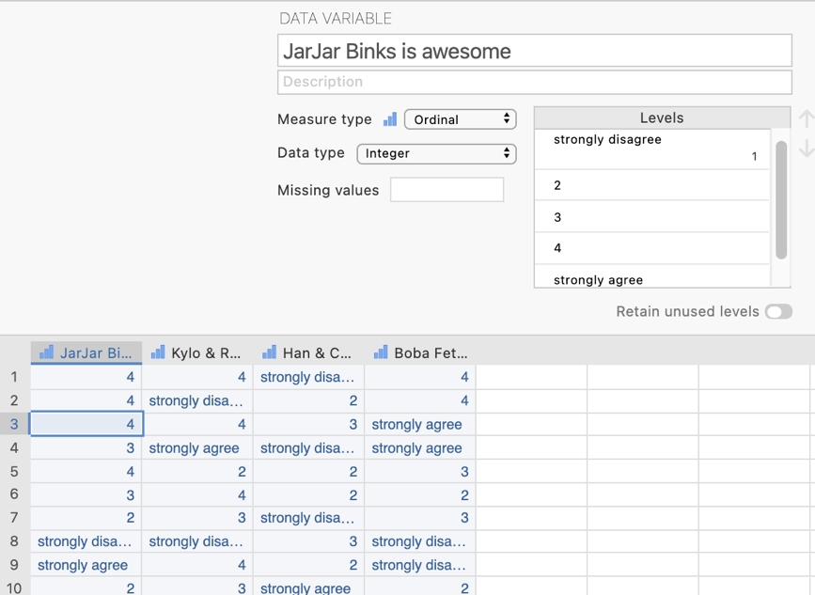
In the data spreadsheet are four columns of data representing the agreement ratings given to each of the four Star Wars opinions. Each row represents a person who has rated each of the four opinions.

Step 2 – Navigating to the linear regression menu.

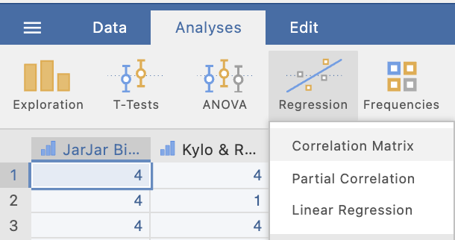
On the Analyses tab select the Regression menu, then select Linear Regression.

Step 3 – Selecting analysis options

When you first select Linear Regression the following screen will appear. The analysis options appear on the left and the empty results appears on the right, ready to update as you select the analysis options.

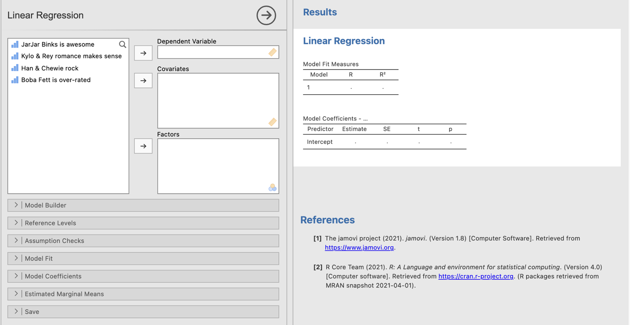

In order to run our bivariate regression we need to shift our dependent/criterion variable and our predictor variable across to the relevant boxes on the right hand side.
The spot for the dependent/criterion variable is straight forward.

However, we need to think carefully about where to move our predictor variable. In jamovi predictor variables that are continuous are referred to as covariates and predictor variables that are categorical are referred to as factors. Our predictor is continuous so we need to move it to the covariates box
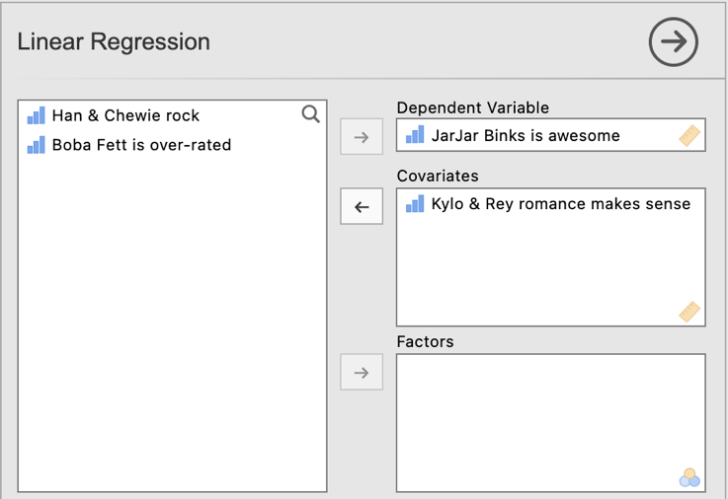

Let’s go through and ask for all the bits and bobs we need then look at the output we get. We need to ask for some extra elements from the Model Coefficients submenu.

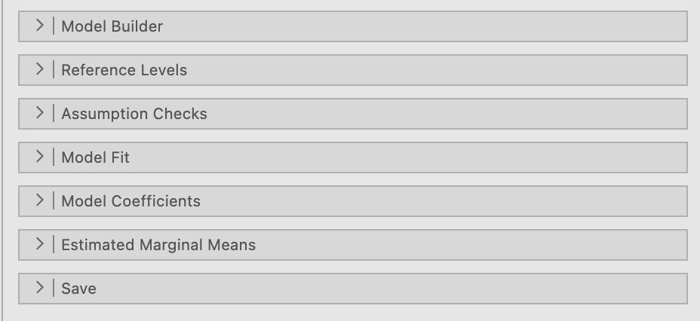

Here you can see reference to “Estimate” and “Standardised Estimate”. “Estimate” refers to the unstandardised regression coefficient, b. “Standardised Estimate” refers to the standardised regression coefficient, $β$. Let’s select standardized estimate so that we get the $β$ in our output. You’ll see we can also ask for confidence intervals for both the regression coefficient forms. We’ll ask for both just for fun. We’ll ask for the ANOVA test as well to look at how our sum of squares are partitioned.

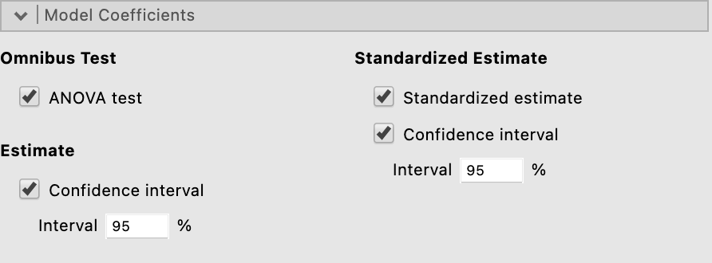

Once we have selected these options our output looks like this.

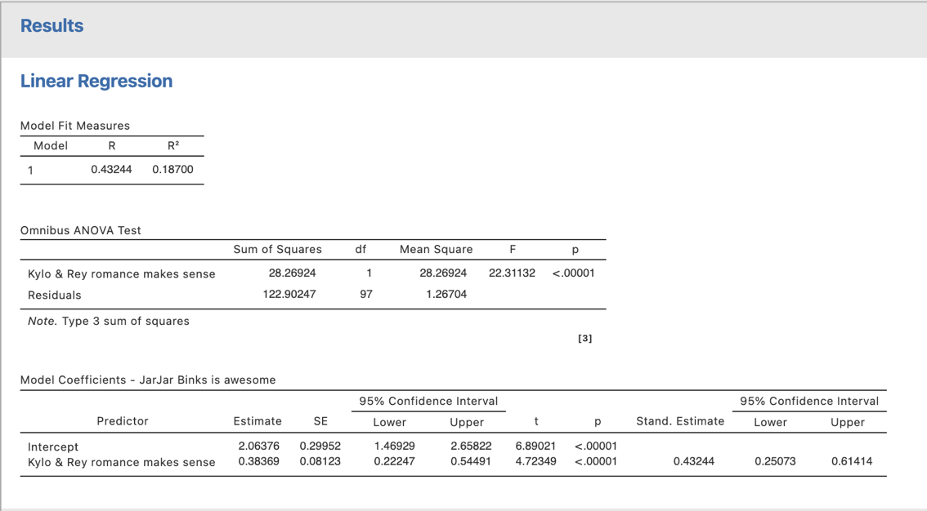
We’ll pull out all the elements we need for constructing the regression equation and reporting on the next page.
Step 4 – Creating the regression equation (for conceptual understanding)

We can construct both the unstandardised and standardised regression equations from the output provided to us by jamovi in the Model Coefficients table.

Let’s tackle the unstandardised regression equation first. The statistics we need come from the “Estimate” column (these are unstandardised regression coefficients).

$$\hat{Y}=a+bX$$

In the output our a, or Y-axis intercept. is labelled “intercept”. In this instance a = 2.06

Our b or slope or unstandardised regression coefficient is listed against our predictor variable which is the Kylo/Rey romance opinion. In this instance b = 0.38

So our unstandardised regression equation is $\hat{Y}=2.06+0.38X$

The standardised regression equation looks like this

$${\hat{Z}}_{Y}=βZ_{X}$$

Our standardised regression coefficient or beta can be found in the stand. estimate column.

$${\hat{Z}}_{Y}=.43Z_{X}$$

Step 5 – Looking at the ANOVA model for regression (for conceptual understanding)

In the Omnibus ANOVA test table we can see how the ANOVA model for our regression has been put together. We have sum of squares residual (error) and sum of squares regression (or the impact of our predictor and hence labelled with our predictor’s name). Each are divided by their associated degrees of freedom to convert to mean square residual and mean square regression. And finally the mean square regression is divided by the mean square residuals to give us our F obtained value.

Step 6 – Finding the components for reporting.

Let’s pull the components out and see where they fit into the write up.
We have four key components here we could report.
- The significance test – the p value for the t test that evaluates the significance of the regression coefficient.
- The degrees of freedom are not specifically reported here though they can be figured out from the N. Degrees of freedom for bivariate regressions are N – 2.
- Regression is full of effect sizes. Regression coefficients, r²s and rs are all forms of effect size.
- 95% confidence intervals around our regression coefficients which give us an indication of the interval within which we expect the population regression coefficient would fall. We can get these for both standardised (beta) and unstandardised (B) regression coefficients.

The Write Up:

A bivariate regression, with a sample of 100 respondents, was conducted to determine the extent to which the opinion that Jar Jar Binks is awesome can be predicted from the opinion that the Kylo Ren and Rey romance makes sense. As level of agreement that the Kylo/Rey romance makes sense increases by one unit, level of agreement that JarJar Binks is awesome increases by 0.38 (95% CI [0.22, 0.54]) of a unit, representing a significant increase, t(98) = 4.72, p <.001. The $β$, at .43 (95% CI [.25, .61]), indicates a moderate to large effect size for this bivariate regression model, with 18.7% of the variance in opinions regarding JarJar Binks associated with the Kylo/Rey romance opinion.

Created by Janine Lurie in consultation with the Statistics Working Group within the School of Psychology, University of Queensland

Based on jamovi v.1.8.4

The Statistics Working Group was formed in November 2020 to review the use of statistical packages in teaching across the core undergraduate statistics units. The working group is led by Winnifred Louis and Philip Grove, with contributions from Timothy Ballard, Stefanie Becker, Jo Brown, Jenny Burt, Nathan Evans, Mark Horswill, David Sewell, Eric Vanman, Bill von Hippel, Courtney von Hippel, Zoe Walter, and Brendan Zietsch.
The jamovi project (2021). jamovi (Version 1.8.4) [Computer Software]. Retrieved from https://www.jamovi.org

