A class of 60 undergraduate law students took part in mock trials in which they were assessed on their ability to defend a fictitious client against a criminal charge. Fellow students acted as jury members for the mock trials and in each case handed down a verdict. Students were assessed on the quality of their presentation and confidence in defending their fake clients, while it was a badge of honour to also receive a not guilty verdict. Students were randomly allocated to use one of two television lawyer mentors to model their approach. Thirty students were instructed to model their style on the character of Annalise Keating from the television series How to Get Away with Murder while the other thirty were told to emulate Harvey Specter from the television series Suits. The Unit Coordinator decided to run some analysis to see if there was an association between the style the students modelled themselves on and the nature of the verdict obtained.

Step 1 – Taking a look at the data.

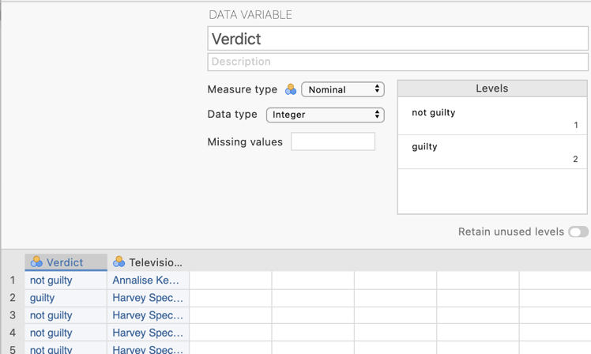
Our dependent variable “Verdict” has been specified as a nominal variable in Measure type and is the first column of data. This variable has two levels: not guilty and guilty.
In the second column of our data spreadsheet we have the variable “Television Lawyer Model” indicating which model the students were instructed to capture. The measure type has been set as nominal. There are two groups: Annalise Keating and Harvey Specter.
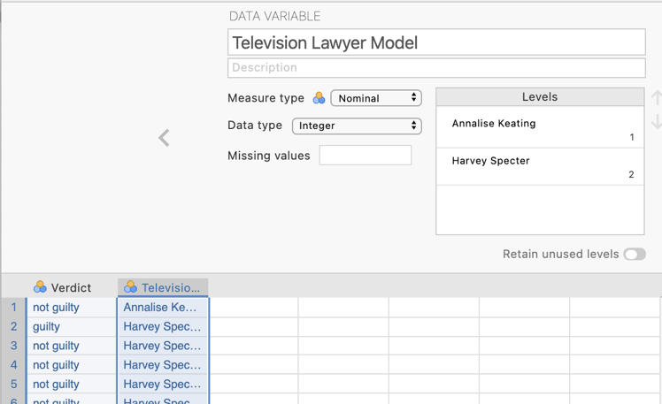

Step 2 – Navigating to the $χ$² analysis menu.

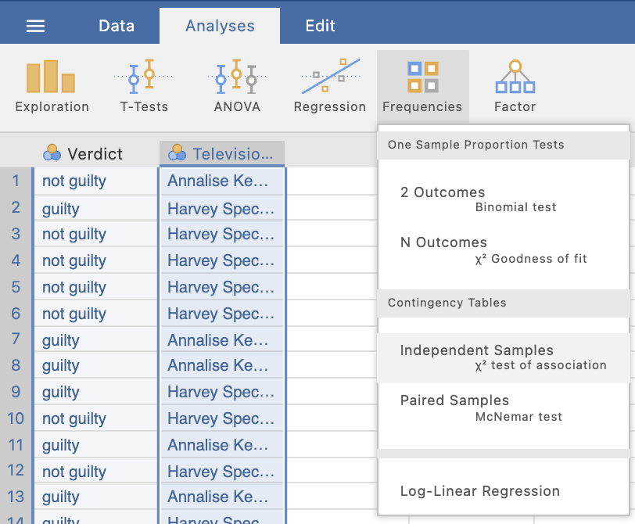
On the Analyses tab select the Frequencies menu. Then under Contingency Tables select Independent Samples, $χ$² test of association.

Step 3 – Selecting analysis options

When we have a variable that we consider our dependent variable we move it to the Rows position and our independent variable we conventionally move to the Columns position.

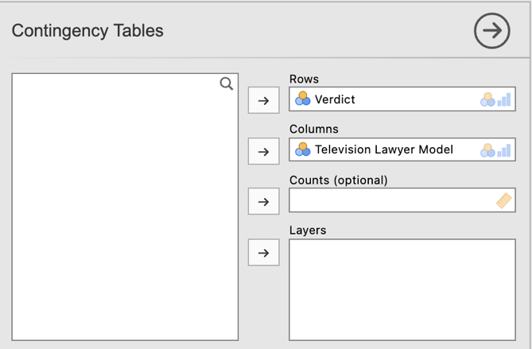
We’ll move Verdict to “Rows” and Television Lawyer Model to “Columns”

Having shifted our two variables into position we are given the following default output.

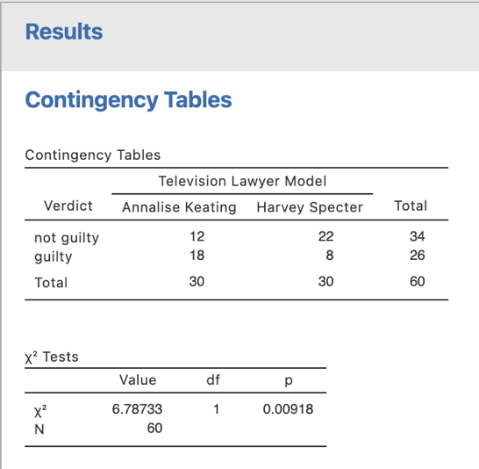
Our p value here is less than .05. This tells us we have a significant association between obtained verdict and which television lawyer the student modelled their court performance on.
We are given a contingency table with frequency counts for our four possible combinations of Verdict and Television Lawyer Model, including row, column and total counts as well.

There are three drop down menus. We’ll be using options from Statistics and Cells.

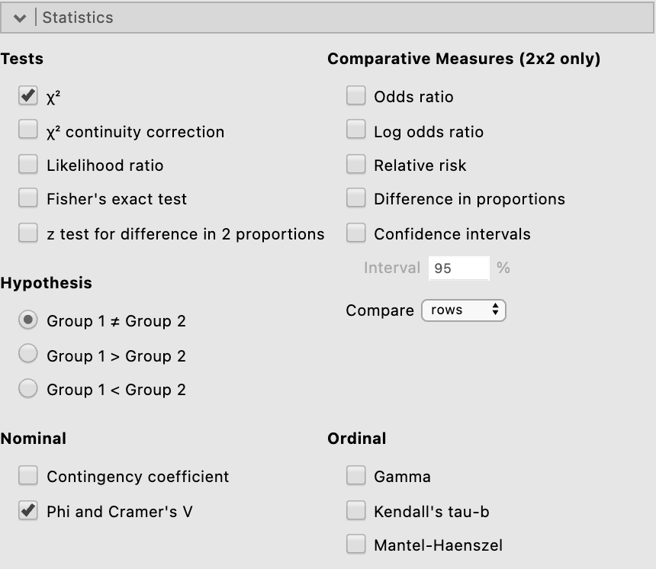
Under the Statistics drop down the key thing we will ask for is Cramer’s V as the most versatile of the effect size options we could select to report with our $χ$² result.

Under the Cells drop down we’ll ask for “Expected Counts” as a comparison point as well as “Column percentages” to aid in our write up.

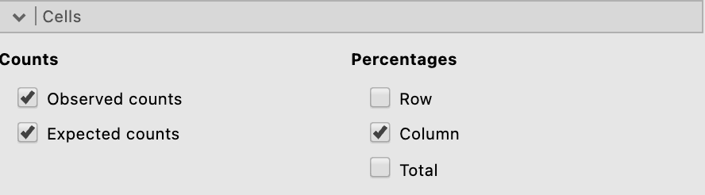

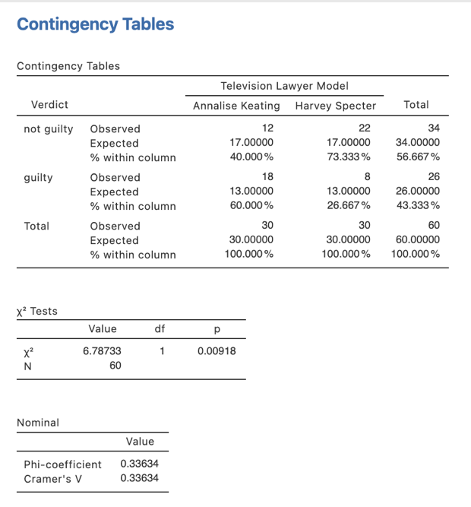
We have all the output we need now. Let’s push on to writing up our results.

N.B., The $χ$² test uses the discrepancy between the observed and expected frequencies in each cell to determine if there is a significant association between the two variables.

Step 4 – Finding the components for reporting the omnibus results

We’ve run all we need to write up our $χ$² analysis.

The components we’ll report are:
- The $χ$² statistic, df and p value – our significance test.
- An effect size in the form of Cramer’s V.
- Column percentages – to help describe the pattern of results.
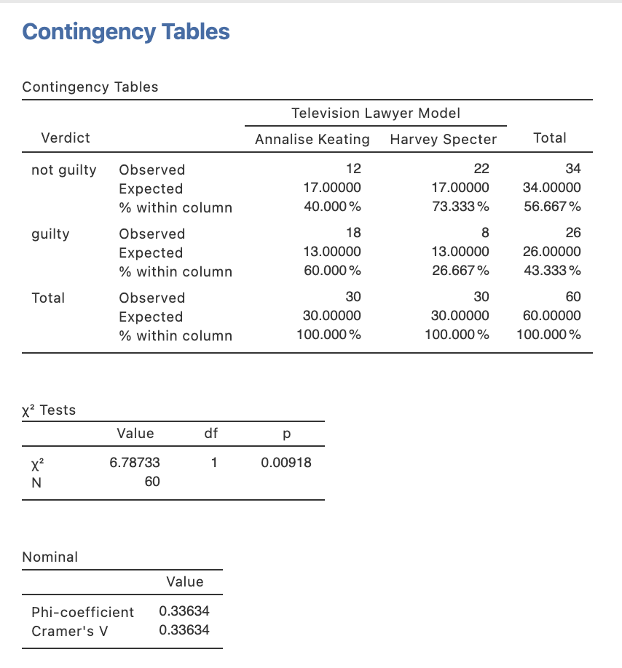

The Write Up:

A $χ$² test for independence was conducted to determine whether the verdict in mock trials conducted by law students was associated with the television lawyer model the defending student lawyer was instructed to emulate. A significant association between verdict and lawyer model was found $χ$² (1) = 6.79, p = .009, V = .34. Examinations of the verdict rates found that 73% of fake clients were found not guilty when represented by student lawyers mimicking the style of Harvey Specter, while only 40% were found not guilty when student lawyers were using a style more in keeping with Annalise Keating.

Created by Janine Lurie in consultation with the Statistics Working Group within the School of Psychology, University of Queensland

Based on jamovi v.1.8.4

Further information about the television series How to Get Away with Murder can be found at https://en.wikipedia.org/wiki/How_to_Get_Away_with_Murder.
Further information about the television series Suits can be found at https://en.wikipedia.org/wiki/Suits_(American_TV_series).
The Statistics Working Group was formed in November 2020 to review the use of statistical packages in teaching across the core undergraduate statistics unit. The working group is led by Winnifred Louis and Philip Grove, with contributions from Timothy Ballard, Stefanie Becker, Jo Brown, Jenny Burt, Nathan Evans, Mark Horswill, David Sewell, Eric Vanman, Bill von Hippel, Courtney von Hippel, Zoe Walter, and Brendan Zietsch.
The jamovi project (2021). jamovi (Version 1.8.4) [Computer Software]. Retrieved from https://www.jamovi.org

