Outlander is an historical/science fiction/time travel television series about a woman who is transported back in time from 1945 to 1743 in Scotland and the lives she leads in both time periods. The television series is based on a book series by author Diana Gabaldon. Of concern to Netflix executives was whether viewers can keep track of the complex underlying plotlines and the interwoven historical details. They commissioned a researcher to conduct a study into how viewing mode influences viewer’s retention of plot details. One of the executives insisted that a measure of 18th century Scottish history knowledge also be included in the study so that this could be controlled for when assessing plotline recall. The researcher recruited 54 people who had not watched Outlander before and randomly allocated them into three separate groups. One group were only allowed to watch one episode per week. The second group watched several episodes in one sitting but ultimately got through the season in multiple sittings. The third and final group watched the entire season in one sitting. All participants were initially gathered for a meeting where the study was explained to them and they were given the 18th century Scottish history test.

Step 1 – Taking a look at the data.
Our dependent variable “Recall of Outlander Plot Details” has been specified as a continuous variable in Measure type. Test scores can range from 0 to 100
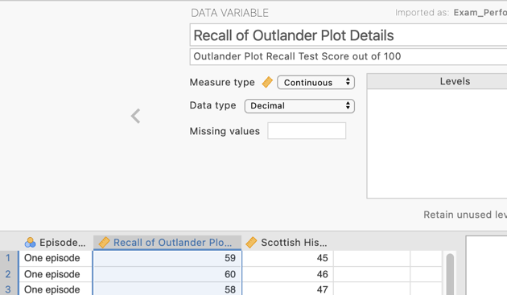
Our independent variable is “Episodes Per Sitting” which tells jamovi which group the participants are in. The measure type has been set as ordinal. There are three groups as created by the researcher. In an ANOVA our independent variable can be ordinal or nominal.
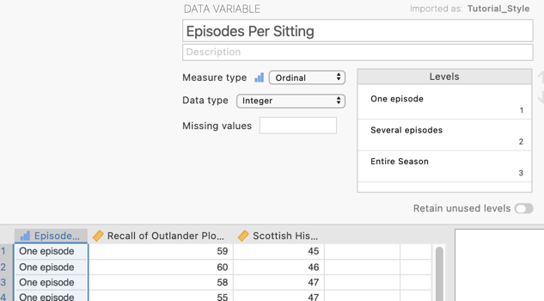

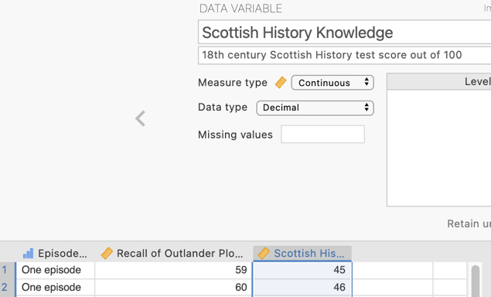
Our covariate is “Scottish History Knowledge” operationalised as a score out of 100 on a test of 18th century Scottish history. This variable has been designated as continuous in the data file.

Step 2 – Navigating to the ANCOVA analysis menu.

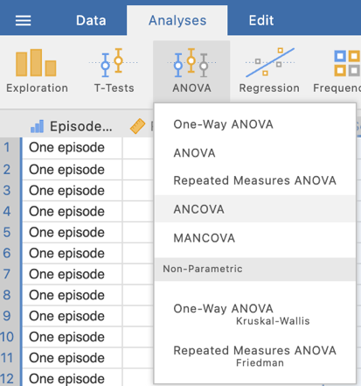
On the Analyses tab select the ANOVA menu, then select ANCOVA.

Step 4 – Selecting analysis options to get the output we need

The first thing we will do is specify our dependent and independent variables.

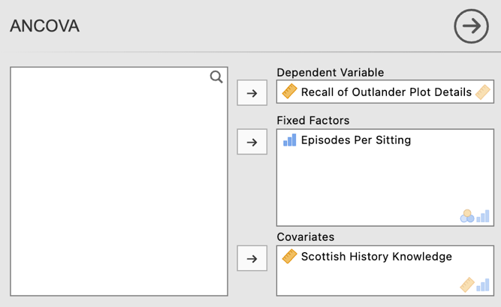
We need to move Recall of Outlander Plot Details to the Dependent Variables box and Episodes Per Sitting to the Fixed Factors box. This tells jamovi we want to compare recall means across the three viewing mode groups.
Finally, add Scottish History Knowledge to the Covariates box in order to convert the analysis from an ANOVA to an ANCOVA with a covariate.
Under the variable specifications we’ll ask for $η$² as our chosen form of effect size for our model.

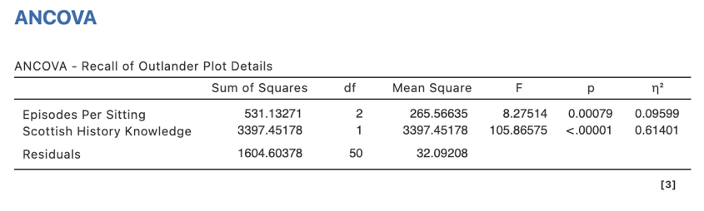
In our ANCOVA table we have test results for both our independent variable of Episodes Per Sitting and the impact of our covariate of Scottish History knowledge with both having F statistics and $η$²

Our p value for our covariate, Scottish History Knowledge is less than .05, in fact less than .001 indicating it accounts for a significant proportion of variance in our dependent variable (vindicating our decision to use it as a covariate). Our independent variable Episodes Per Sitting has a p value less than .05 as well, indicating there are some significant differences in Recall of Outlander Plot Details relating to viewing mode. We’ll have to run some post hoc tests to uncover the specific differences in covariate-adjusted means that are creating this.

We’ll ask for some extra options from the drop down menus to obtain the extra output we need for this analysis.
In our drop down menus we’ll select some options in the Post Hoc Tests and Estimated Marginal Means drop downs.
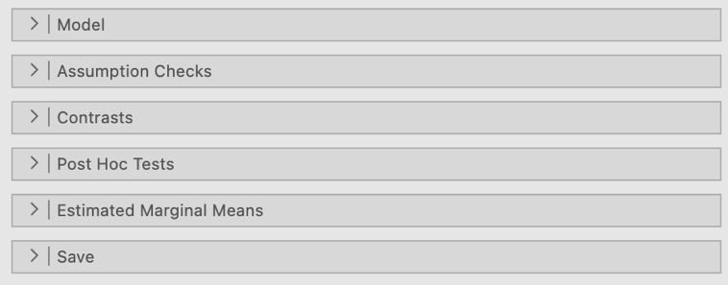
As we have a significant omnibus F test we need to conduct post hoc tests to uncover where the significant differences are.
To do this in the Post Hoc Tests tab we need to move our IV, Episodes Per Sitting from the box on the left to the box on the right. Under corrections we’ll select “No correction.” Finally under Effect Size we’ll ask for Cohen’s d for each of our post hoc pairwise comparisons and associated confidence intervals. The output generated for these can be seen below
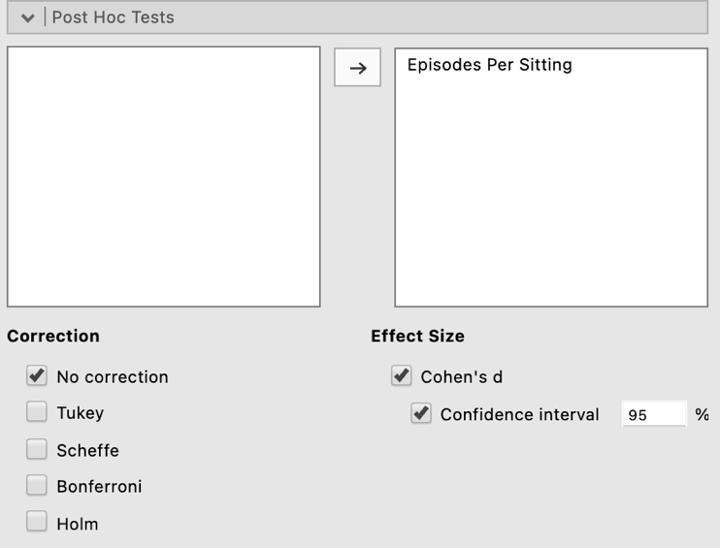

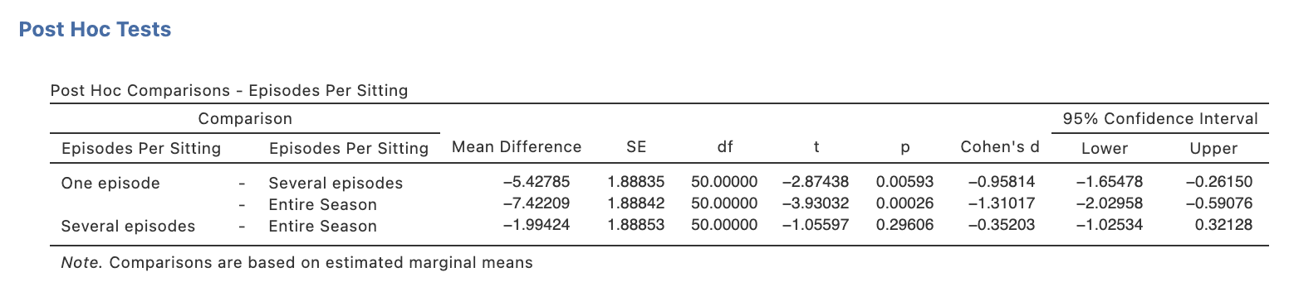

The Estimated Marginal Means tab gives us options to obtain a plot to illustrate our results as well as obtain the adjusted means (our group means when the covariate is held constant at its mean).

Firstly we need to move our IV, Episodes Per Sitting, under the “Term 1” heading in the Marginal Means box on the right hand side like this:

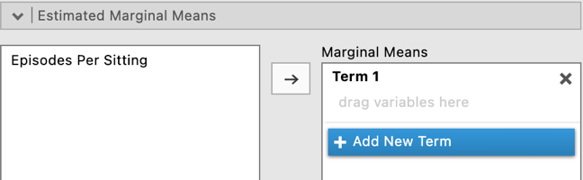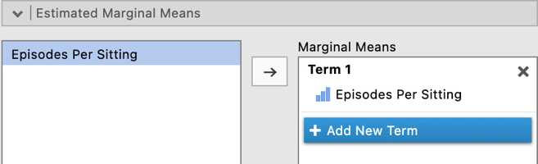

As a default “Marginal means plots” will be selected. We’ll ask for Marginal means table as well. Note that error bars based on 95% confidence intervals will be created on the plot. However you can change these to standard errors or choose to remove them all together in the drop down list.

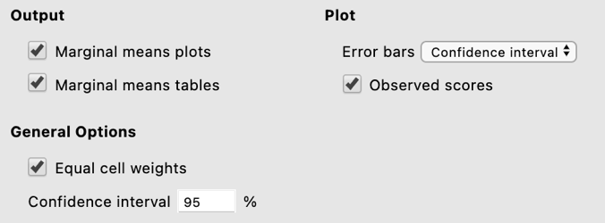

If you tick “Observed scores” your plot will also include all your participants scores so that you can visualise the spread of scores around the group means and error bars.
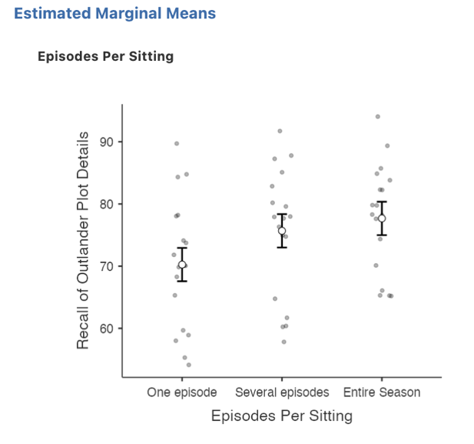
The means in the Estimated Marginal Means table are covariate-adjusted means. These are not the original group means but rather what the group means are when the covariate across the groups is held constant at its mean. These means therefore represent the Recall of Outlander Plot Lines group differences where the variance explainable by Knowledge of Scottish History has been removed/accounted for.

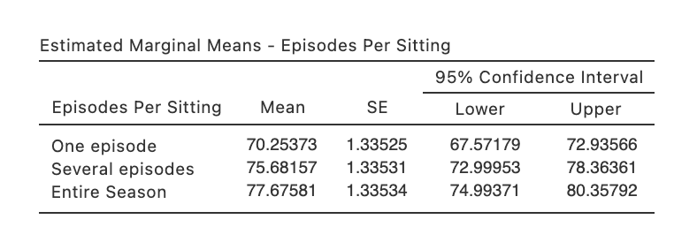

Step 5a – Finding the components for reporting the omnibus results

We’ve now run all the things we need to write up our one-way between groups ANCOVA results, complete with post hoc pairwise comparisons. Let’s pull it all together.

Firstly, let’s report our omnibus results.

The components we obtain here are:
- The F statistic, dfs and p value – the omnibus ANOVA result
- An effect size in the form of$η$²

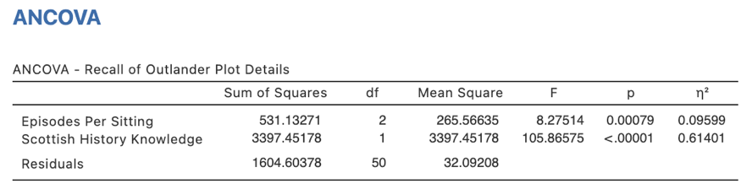

The Write Up (Part 1):

Fifty-four participants were randomly allocated to three groups to watch the first season of the television series Outlander, one episode per week, several episodes over multiple sittings, or all episodes in one sitting. Prior knowledge of 18th century Scottish history was assessed prior to viewing. A one-way between groups ANCOVA found that recall of Outlander plot lines differed significantly across viewing modes, F(2,50) = 8.28, p < .001, $η$² = .10. Scottish history knowledge was found to account for a significant proportion of variance in plot line recall, F(1,50) = 105.87 p < .001, $η$² = .61, therefore its inclusion as a covariate significantly reduced error variance and improved precision of the model.

Step 5b – Finding the components for reporting the post hoc comparisons.

The next stage of the write-up is to present the post hoc comparisons that reveal where the significant differences in covariate-adjusted group means specifically fall. We’ll use the estimated marginal means we obtained as well as the post hoc comparisons table to put this part of our write up together.

The elements needed for the post hoc section of our write up are:

- Post hoc comparison results – to determine which group means are significant from each other. It is sufficient to report the p value for this.
- An effect size for each post hoc comparison in the form of Cohen’s d and associated 95% confidence intervals.
- Means and standard errors – to help describe the pattern of these differences.

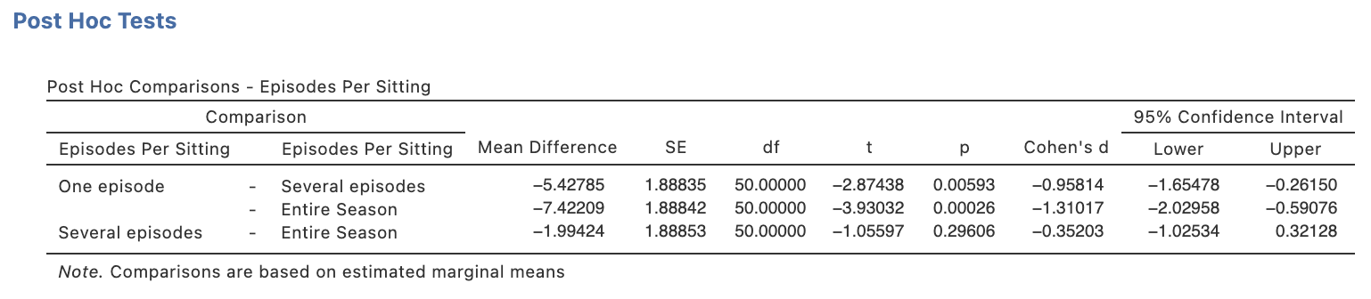

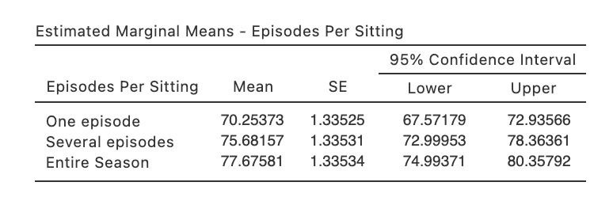

The continuation of the write up could go as follows:

The Write Up (Part 2):

Unadjusted post hoc comparisons between covariate-adjusted means revealed a significantly lower level of recall of plot lines when the season is watched one episode at a time, M_{adj} = 70.25, SE_{adj} = 1.34, than when viewed in several multi-episode sittings, M_{adj}= 75.68, SE_{adj}= 1.34, p = .006, d = 0.96, 95% CI [0.26, 1.65], or when viewed as an entire season, M_{adj} = 77.68, SE_{adj} = 1.34, p = .001, d = 1.31, 95% CI [0.59, 2.03]. There was no significant difference in recall when the season was viewed several episodes per sitting versus the entire season all at once, p = .296, d = 0.35, 95% CI [0.32, 1.03].

Potential addition of plot:

You could also add the plot we obtained to help illustrate the pattern of results. You might add a sentence like the following if you choose to include the plot:

Figure 1 below demonstrates these group differences visually.

Figure 1

Differences in Recall of Outlander Plotlines as a Function of Viewing Mode
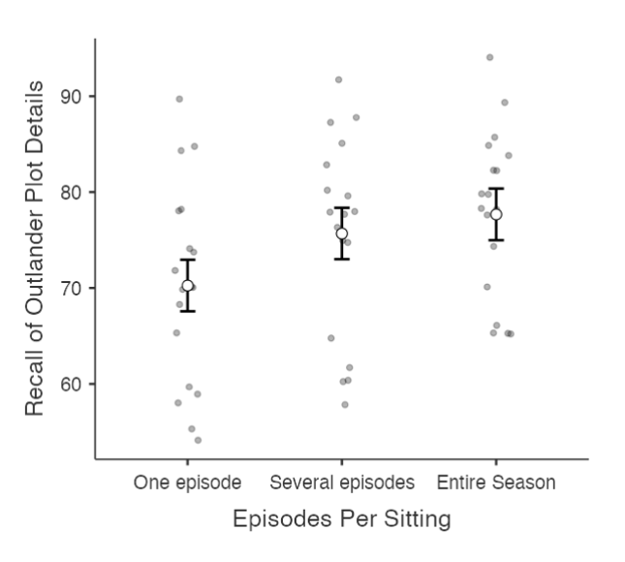
Note. Error bars represent 95% confidence intervals. Means and confidence intervals are adjusted using the covariate Scottish History Knowledge.

Created by Janine Lurie in consultation with the Statistics Working Group within the School of Psychology, University of Queensland

Based on jamovi v.1.8.4

Further information about the Outlander television and book series can be found at https://en.wikipedia.org/wiki/Outlander_(TV_series)#Production.
The Statistics Working Group was formed in November 2020 to review the use of statistical packages in teaching across the core undergraduate statistics unit. The working group is led by Winnifred Louis and Philip Grove, with contributions from Timothy Ballard, Stefanie Becker, Jo Brown, Jenny Burt, Nathan Evans, Mark Horswill, David Sewell, Eric Vanman, Bill von Hippel, Courtney von Hippel, Zoe Walter, and Brendan Zietsch.
The jamovi project (2021). jamovi (Version 1.8.4) [Computer Software]. Retrieved from https://www.jamovi.org

