The work of medical entomologist Bart Knols revealed that a species of mosquito known for its penchant for sucking blood from people’s feet and ankles also quite likes the stinky German cheese, Limberger. Bemused by this discovery upon watching Dr Knols’ TED talk, a researcher decides to try to extend this research by assessing mosquito preferences for a range of stinky cheeses in the hopes of finding the ultimate cheese mosquito magnet. The researcher captures 10 mosquitoes and releases them one by one into four sealed plastic boxes, each containing four different cheese varieties for 30 seconds. Sensors built into the boxes record the amount of time each mosquito spends within a 1cm radius of the cheeses. The researcher is presented with data that reveals how long each mosquito spent hovering over each cheese variety and decides to conduct a one-way repeated measures ANOVA to determine which cheese is most attractive to mosquitoes.

Step 1 – Taking a look at the data.

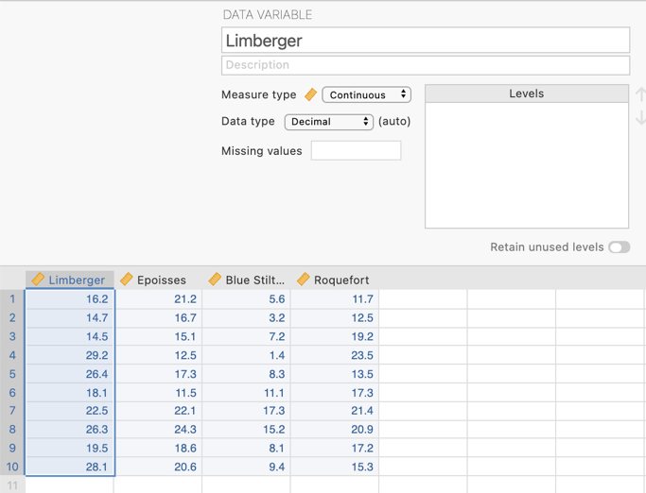
Our data takes the form of four continuous variables that represent the number of seconds spent by each mosquito hovering within 1cm of each of four stinky cheese varieties, namely German Limberger, French Epoisses and Roquefort and British Blue Stilton. The variables are designated continuous.

Step 3 – Navigating to the Repeated Measures ANOVA analysis menu.

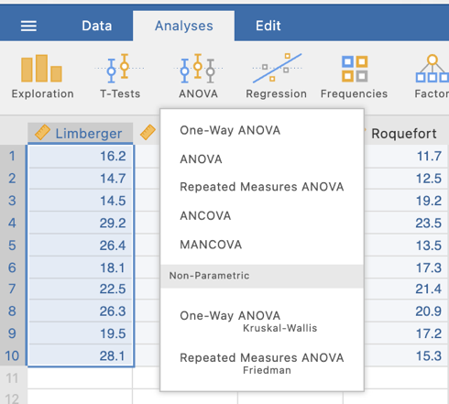
On the Analyses tab select the ANOVA menu, then select Repeated Measures ANOVA.

Step 4a – Selecting analysis options to get the output we need for our omnibus results

The first thing we will do is to let jamovi know that these four variables represent levels of our repeated measures factor. This set up is somewhat more complex than a between groups ANOVA.
Within the Repeated Measures Factors box we need to type in the labels of our factor and its four levels.
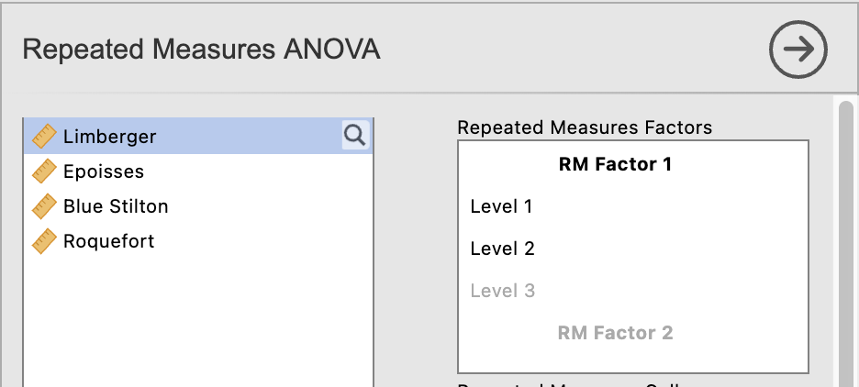

By clicking in each line you can edit and add in the variable name and its levels. Label the RM Factor 1 as Stinky Cheese Variety. Then click in each Level and type the four cheeses in. Note that once you hit the default last level (Level 3), hitting return will create an additional slot to type in our fourth cheese.

You’ll notice that the four cheese varieties now appear down the right hand side of the Repeated Measures Cells box. The next stage is to drag the variables across to these slots.
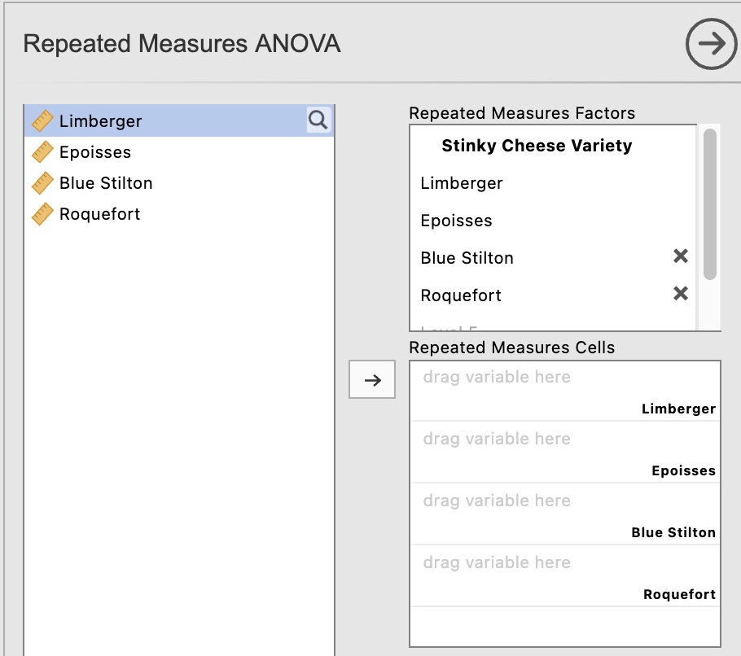

When you have completed the variable set up the Repeated Measures ANOVA variable specification should look like this:

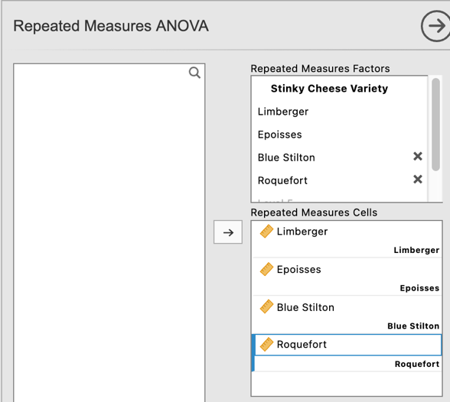

At the bottom of this menu we can also give our Dependent Variable a label to neaten our output, and ask for effect sizes while we are at it.

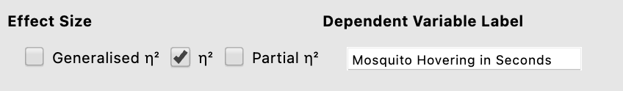

We now have some initial ANOVA output to interpret.
In our ANOVA table we have the components of the calculations that help us arrive at our F statistic (namely the SS_{treat} and SSerror and their associated dfs, which lead us to our MS_{treat} which we divide by the MSerror to get our F statistic.

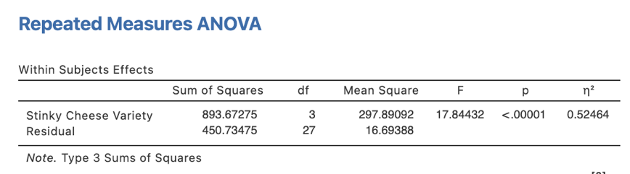

And hidden on the end is our $η$² effect size.
Our p value here is <.00001. This value is less than .05 so we will reject the null hypothesis that there is no difference in the number of seconds mosquitoes hover within 1cm of each stinky cheese variety.

There are a couple of extra things we need to ask for from some of the drop down menus in our one-way repeated ANOVA. These are found under the Assumption Checks menu and the Estimated Marginal Means menu.

NB – We are not going to ask for our post hoc pairwise comparisons here as a pooled error term is used for all comparisons. It is preferable to use error terms that relate only to the two levels being compared. We will get to this soon.

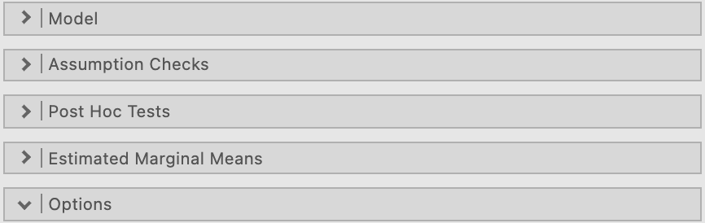
Under Assumption Checks we are going to ask for “Sphericity tests” as well as a “Greenhouse-Geisser correction” under Sphericity corrections. This will enable us to check whether the sphericity assumption has been breached and to report corrected/adjusted results if a breach is present.

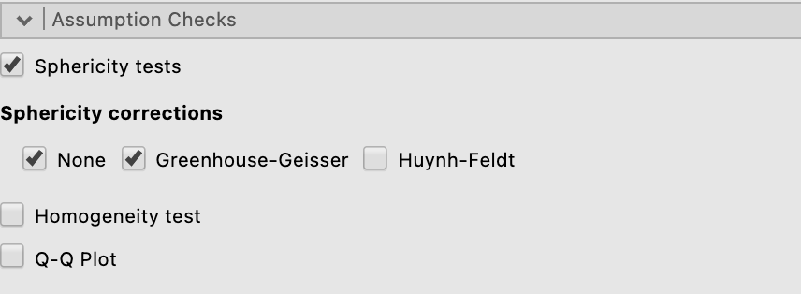

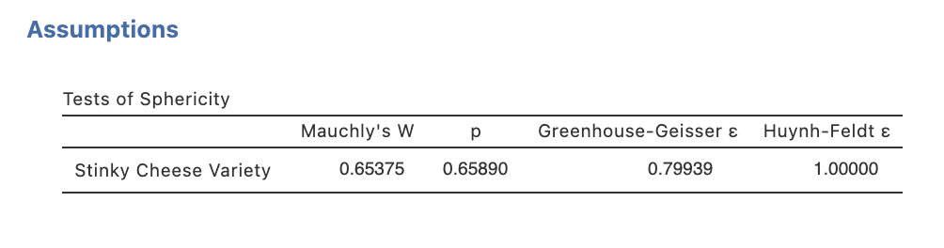
Our output now contains Mauchly’s test of sphericity, and our ANOVA table now includes results with a Greenhouse-Geisser correction if needed
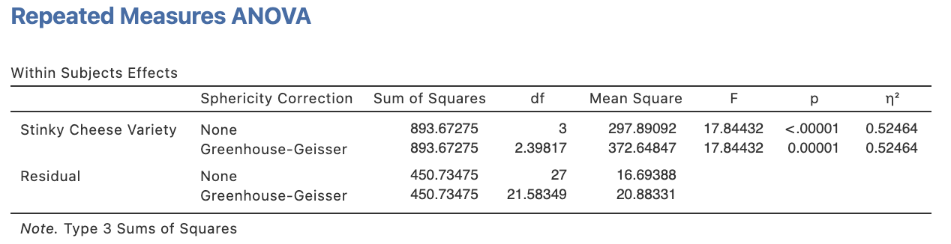
In our case the p value for Mauchly’s test of sphericity is greater than .05 so we can say the sphericity assumption has not been breached. This means we can move forward with uncorrected results.
N.B., Some argue that Greenhouse-Geisser corrected results should always be reported to be on the safe side.

Under the Estimated Marginal Means drop down menu we can ask for our plot to help illustrate our findings.
We need to move our repeated measures factor Stinky Cheese Variety across to the Term 1 slot under the Marginal Means heading.

Marginal means plot with 95% confidence interval error bars is selected as a default.

We’ll also tick observed scores so that we can see where the individual data points fall in relation to the means and error bars.

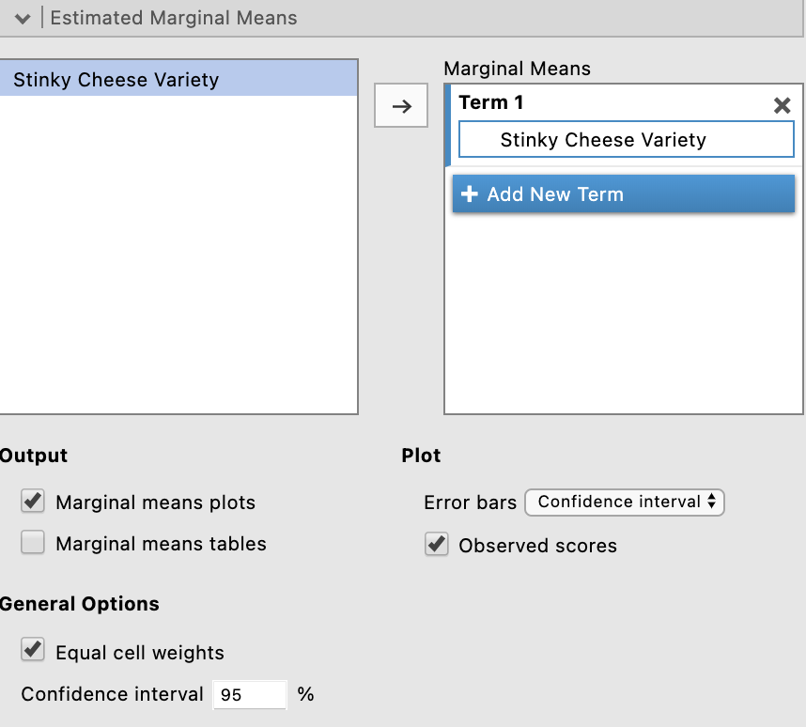

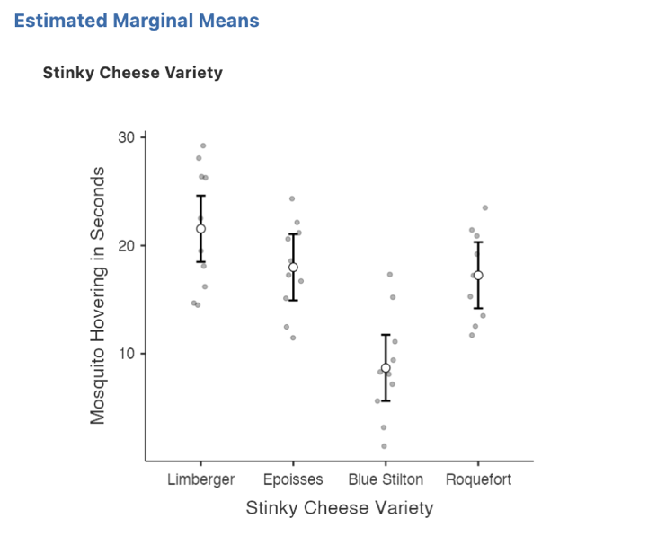
We can see visually here that it seems the mosquitoes most likely are hovering around the Blue Stilton for significantly fewer seconds than the other stinky cheeses. However we need to run our pairwise comparisons to obtain these significance tests.

Step 4a – Selecting analysis options to get the output we need for our post hoc pairwise comparisons following our significant omnibus result

While it is possible to ask for these pairwise comparisons within the Repeated Measures ANOVA menu, the comparisons that are generated use a pooled error term (across all four of our stinky cheese conditions). However, it is preferrable to conduct these pairwise comparisons with error terms that are generated from the two levels being compared. In order to obtain these we will need to run a series of pairwise t-tests.

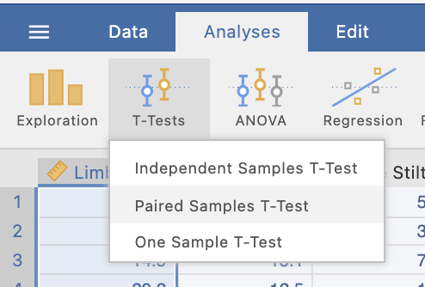
We can specify multiple paired t-tests at once by moving pairs over to the Paired Variables box. We want to create each combination of cheese comparisons to give us the set of comparisons we need.
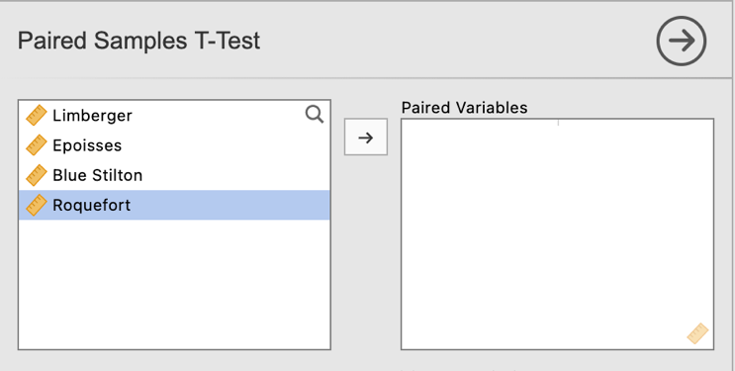
Here we have specified each possible combination of comparisons. Depending on your specific research question or hypothesis you may not need to consider every combination but they have been asked for for completeness here.
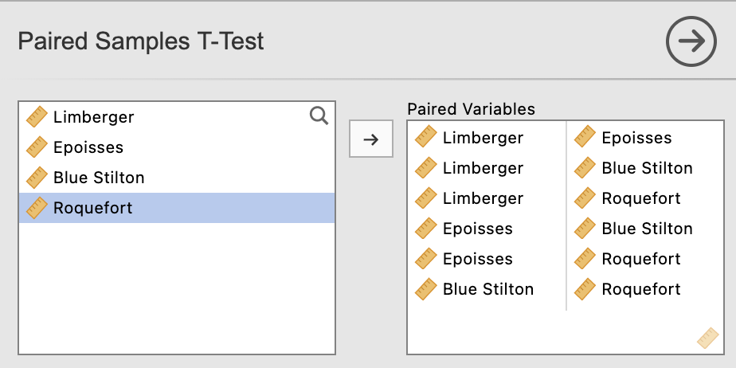

In the analysis options for the paired t-tests output we’ll select Mean difference (to illustrate a learning point only – you don’t need to select this otherwise), effect sizes and associated confidence intervals and descriptives under the “Additional Statistics” heading.

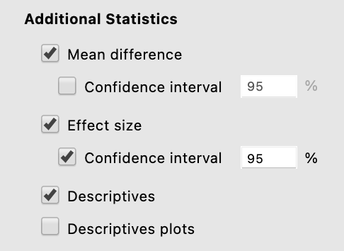

These selections will return the following output:

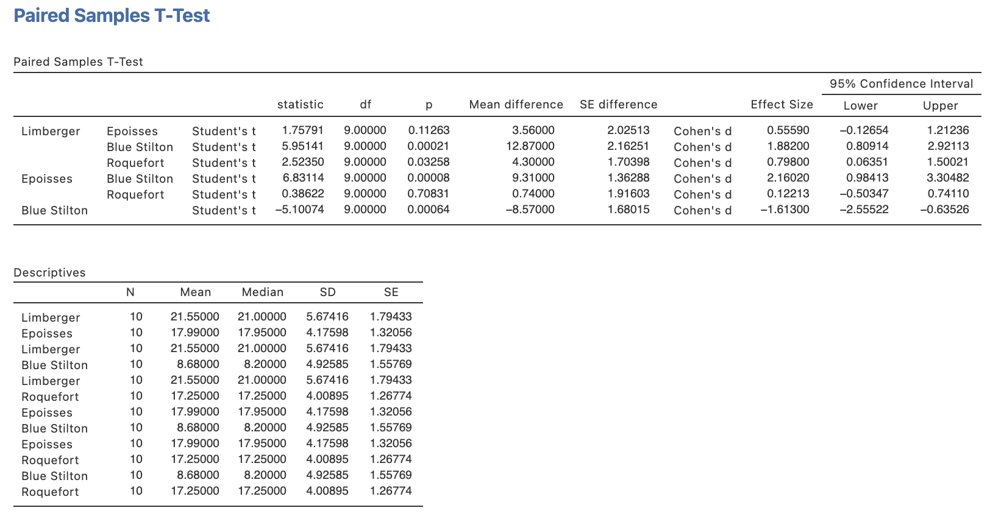
Note that having run these comparisons as separate t-tests the standard errors associated with each comparison are different. They are based on errors derived from each pairing rather than the whole model.

Step 5a – Finding the components for reporting the omnibus results

We’ve now run all the things we need to write up our one-way repeated measures ANOVA results, complete with post hoc pairwise comparisons. Let’s pull it all together.

Firstly, let’s report our omnibus results.

The components we obtain here are:
- The F statistic, dfs and p value – the omnibus ANOVA result
- An effect size in the form of$η$²

The Write Up (Part 1):

Ten mosquitoes were exposed to four types of Stinky Cheese (Limberger, Epoisses, Blue Stilton and Roquefort) for thirty seconds to determine their cheese preference. The number of seconds within each thirty second block that the mosquitoes hovered within one centimetre of the cheese was recorded by sensors. A one-way repeated measures ANOVA revealed that seconds spent hovering differed depending on the variety of cheese contained in the box, F(3,27) = 17.84, p <.001, $η$² = .52.

Tip: In APA format we report our p value to three decimal places. Where our p value would round to .000 we report this as p <.001 and not p = .000 which would imply our p value is equal to zero when it is not.

Step 5b – Finding the components for reporting the post hoc comparisons.

The next stage of the write-up is to present the post hoc comparisons results that reveal which particular differences in cheese hovering are significant. We’ll use the paired t-test results to put this part of our write up together.

The elements needed for the post hoc section of our write up are:

- Post hoc comparison results – to determine which group means are significant from each other. It is sufficient to report the p value for this.
- An effect size for each post hoc comparison in the form of Cohen’s d and its associated confidence interval.
- Means and standard deviations – to help describe the pattern of these differences.

The continuation of the write up could go as follows:

The Write Up (Part 2):

Unadjusted post hoc comparisons revealed that mosquitoes spent significantly fewer seconds hovering over the Blue Stilton (M = 8.68, SD = 4.93) than the Limberger (M = 21.55 SD = 5.67, p < .001, d = 1.88, 95% CI [0.81, 2.92]), Epoisses (M = 17.99, SD = 4.18, p < .001, d = 2.16, 95% CI [0.98, 3.30]) and the Roquefort (M = 17.25, SD = 4.01, p = .001, d = 1.61, 95% CI [0.64, 2.56]). Further, mosquitoes were also seen to hover over the Roquefort cheese for significantly fewer seconds than the Limberger (p = .033, d = 0.80, 95% CI [0.06, 1.50]). No other differences were significant (ps > .113, ds < 0.56).

Potential addition of plot:

You could also add the plot we obtained to help illustrate the pattern of results. You might add a sentence like the following if you choose to include the plot:

Figure 1 below provides a visual demonstration of mosquito preference for Stinky Cheese Varieties.

Figure 1

Mosquito Cheese Hovering as a function of Stinky Cheese Variety
Note. Error bars represent 95% confidence intervals.

Created by Janine Lurie in consultation with the Statistics Working Group within the School of Psychology, University of Queensland

Based on jamovi v.1.8.4

You can view Dr Knols’ TED talk here https://ed.ted.com/lessons/cheese-dogs-and-a-pill-to-kill-mosquitoes-and-end-malaria-bart-knols.
The Statistics Working Group was formed in November 2020 to review the use of statistical packages in teaching across the core undergraduate statistics unit. The working group is led by Winnifred Louis and Philip Grove, with contributions from Timothy Ballard, Stefanie Becker, Jo Brown, Jenny Burt, Nathan Evans, Mark Horswill, David Sewell, Eric Vanman, Bill von Hippel, Courtney von Hippel, Zoe Walter, and Brendan Zietsch.
The jamovi project (2021). jamovi (Version 1.8.4) [Computer Software]. Retrieved from https://www.jamovi.org

