Star Wars is a much beloved franchise. Some characters and plots however are more beloved than others by the fan base. A researcher decided to conduct a quick social media poll on the level of agreement with a number of Star Wars opinions known to have varying levels of acceptance or incredulity to die-hard fans. She was particularly interested in predictors of agreement with the opinion that JarJar Binks is awesome as this opinion seems to be the source of great division in the fandom. A total of 100 survey respondents rated their agreement with four beliefs on a 5-point scale where 1 is strongly disagree and 5 is strongly agree.

The Star Wars opinions rated were:
- JarJar Binks is awesome.
- The Kylo Ren and Rey romance makes sense.
- Han and Chewie rock.
- Boba Fett is over-rated.

Step 1 – Taking a look at the data.
Our four variables have been specified as ordinal variables in Measure type. The anchor points of the likert scale (1 = strongly disagree, 5 = strongly agree) have also been entered

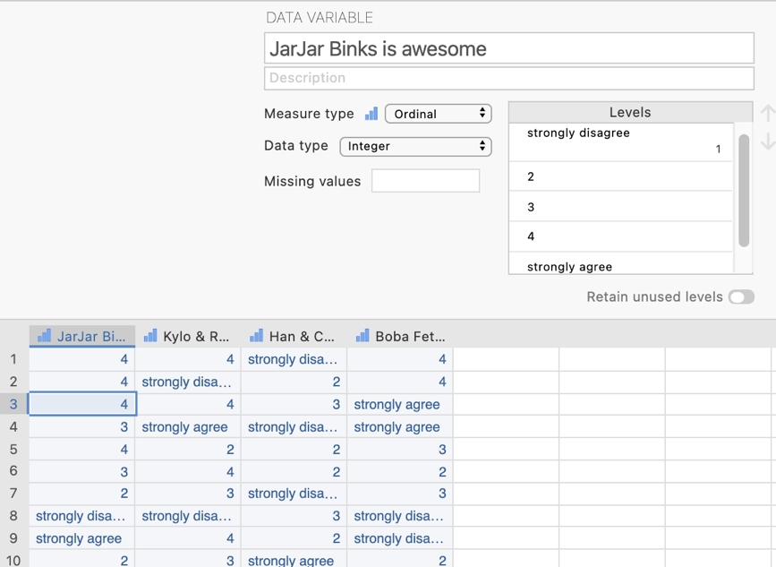
In the data spreadsheet are four columns of data representing the agreement ratings given to each of the four Star Wars opinions. Each row represents a person who has rated each of the four opinions.

Step 2 – Navigating to the Linear Regression menu.

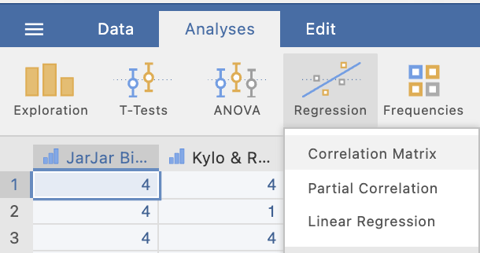
On the Analyses tab select the Regression menu, then select Linear Regression.

Step 3 – Selecting analysis options

The first thing we need to do is tell jamovi what variable is our criterion/dependent variable and which are our predictors. It is important to note that jamovi refers to continuous predictors as covariates and categorical predictors as factors. In our case all our predictors are continuous so we will need to move them across to the covariates box.

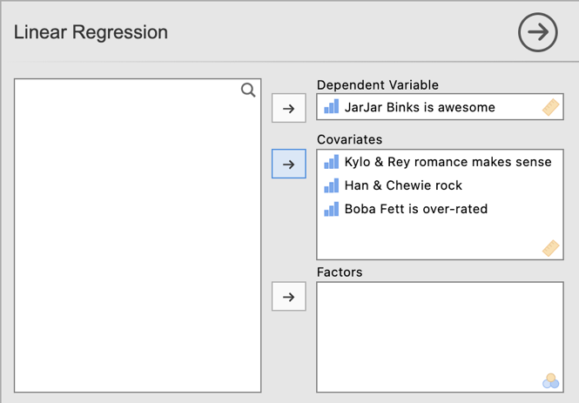

The default output we get from specifying for the variables for the analysis appears below.

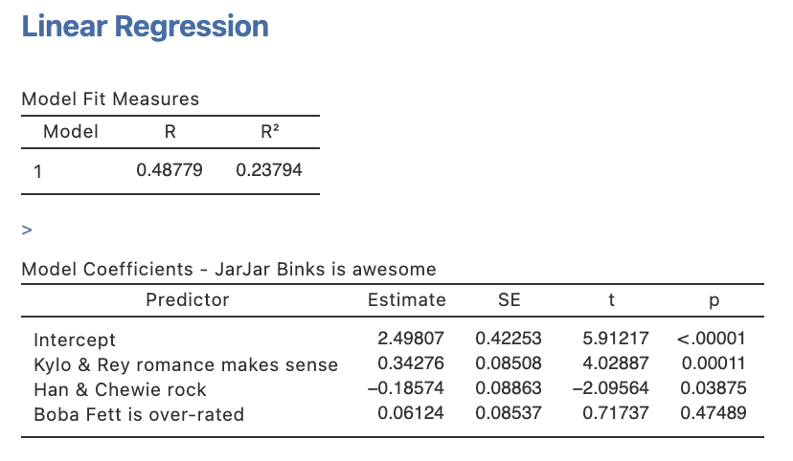
We are given the R and R2 for the whole model as well as unstandardised regression coefficients (labelled Estimate) and associated significance testing.

However, there are a few more elements and tests we require for completeness.

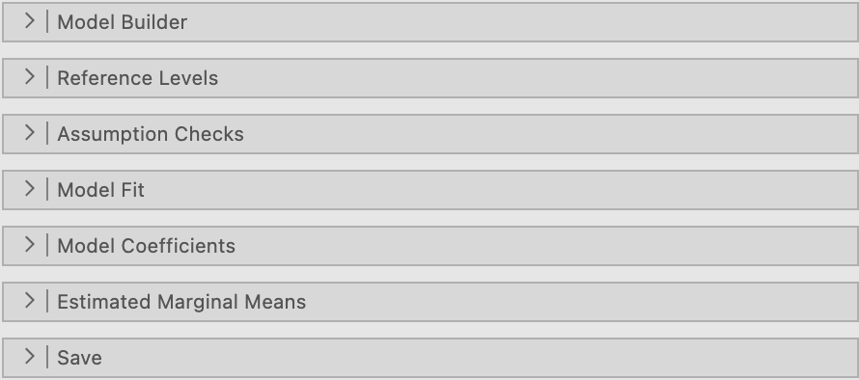
From the drop down lists we’ll ask for options from Model Fit and Model Coefficients.

Under Model Fit, in addition to the R and R2 already set as a default, we’ll ask for adjusted R2 and the Overall Model F test.

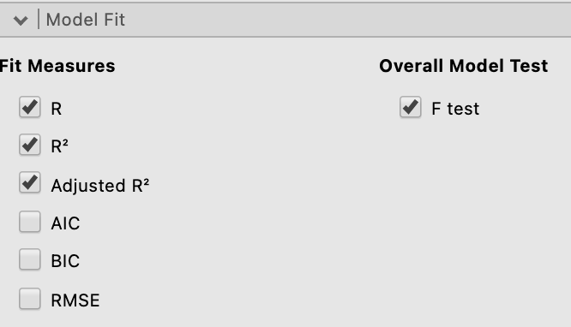
Our Model Fit Measures table now includes the omnibus F test for the full regression model, and the adjusted R2.

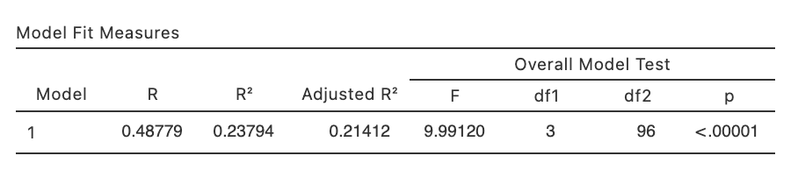

Under the Model Coefficients drop down menu, we’ll ask for confidence intervals for our unstandardised regression coefficients, Bs, (under Estimate) as well as asking for standardised regression coefficients, betas, (under Standardised Estimate) and their confidence intervals as well. You don’t need to report both sets of confidence intervals but have done so here to demonstrate what the output looks like for both.

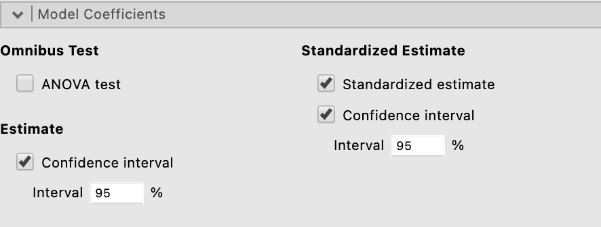

The Model Coefficients table has now substantially expanded to include standardised and unstandardised results.

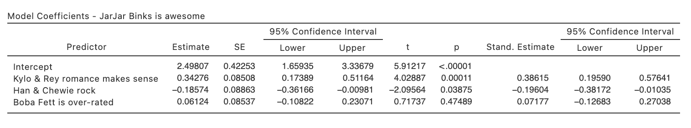
One key statistic that is conventionally reported with standard multiple regression results, namely squared semi-partial correlations, or r²_{a(b,c)}, are not available via the Linear Regression menu (as at jamovi version 1.8.4). To obtain these we need to run some separate analysis.

Head to the Analyses ribbon, select Regression and then Partial Correlation

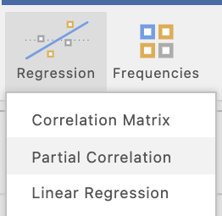

In the current jamovi set up for obtaining partial and semi-partial correlations they need to be specified one at a time. In other words we need to specify a pair of variables to be correlated and which variables to use as control variables, or variables that will be partialled out of the calculations.

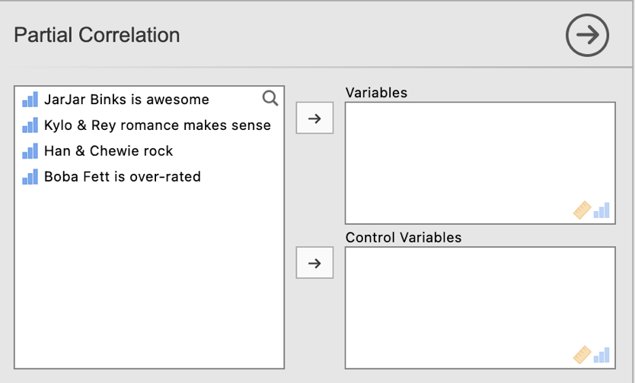

Before we start let’s make sure the options we need have been selected. The most important selection is to change the selection to “Semipartial” under Correlation Type as Partial is the default. Also untick “Report significance” under Additional Options to keep the output minimal and easy to interpret.

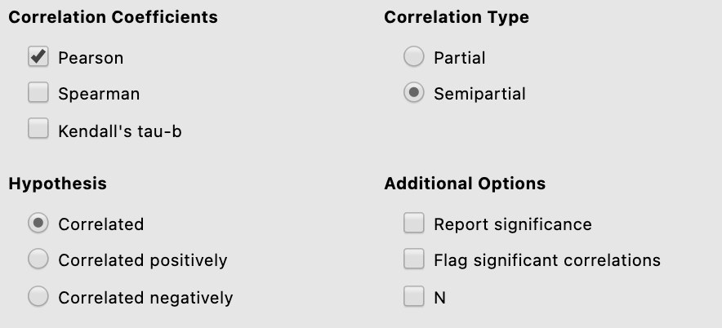

There are three semi-partial correlations we need to request. These are between our criterion/dependent variable JarJar Binks is awesome with each of the three predictor variables/opinions, controlling for the respective remaining two each time. Below is how you will specify each semi-partial correlation that you need for this regression model.

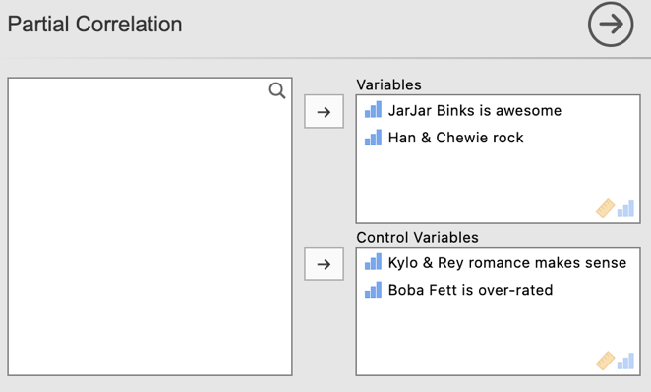.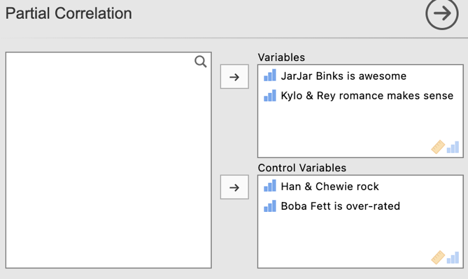
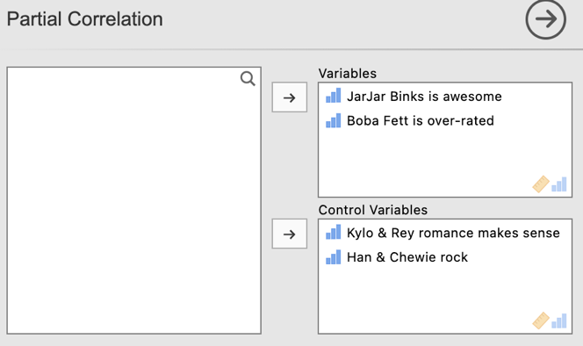

Note that after running each semi-partial correlation you will need to click underneath the output so that jamovi knows to create an additional output, rather than editing the one you just created. Jamovi will edit whichever output is currently highlighted in white. To ensure you get additional output rather than overwritten output ensure you have clicked underneath the output created and it has turned grey as can be seen on the right hand side below.

Below is the first semi-partial correlation.

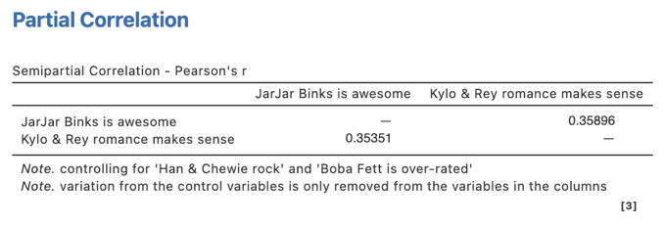 vs 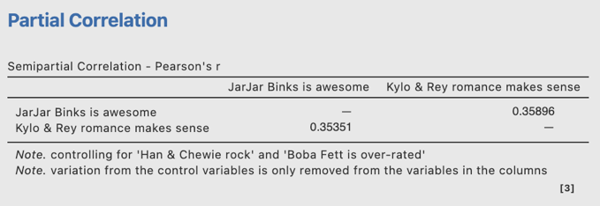

Our three semi-partial correlation runs will provide the following output:

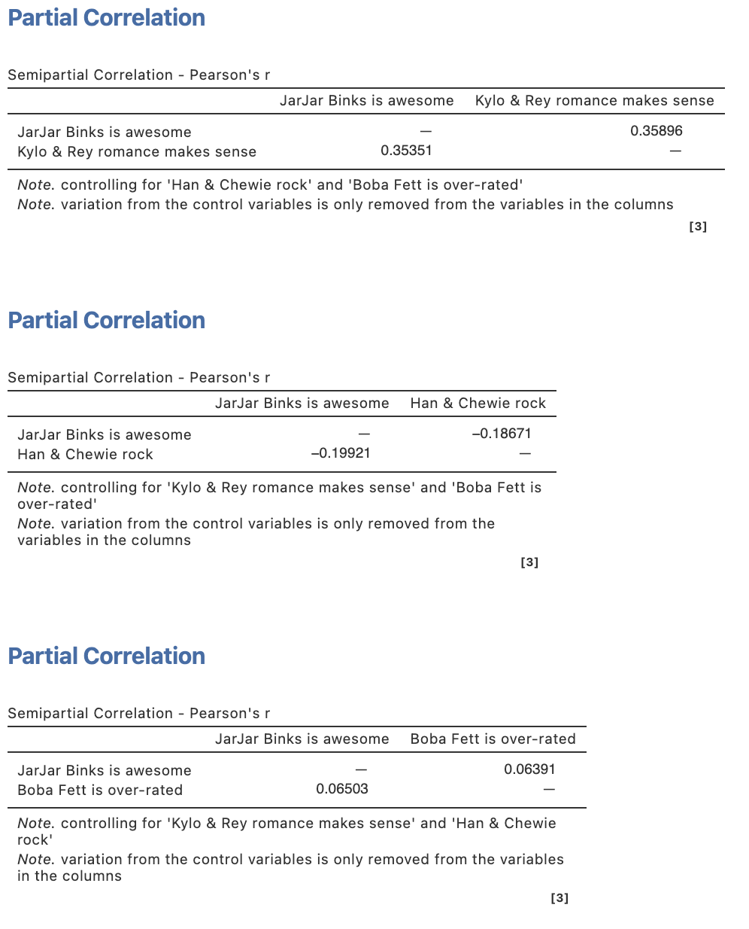
The statistic we need to report in our regression write up is the SQUARED semi-partial correlation. So each of these three semi-partial correlations need to be squared manually.
In each of these semi-partial correlation tables the coefficient we want is listed in the column heading with the predictor name of interest as circled on each.

Step 4 – Finding the components for reporting.

There are two parts to our standard multiple regression write up. The overall model results and then results pertaining to the role of each individual predictor in the model.

The components we need for the overall model results are:
- The F statistic, dfs and p value – the omnibus ANOVA result for the full model
- Effect sizes in the form of R2 and adjusted R2.

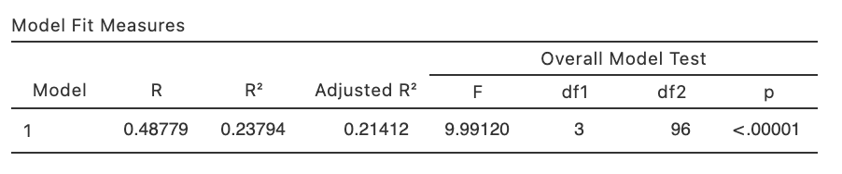

The Write Up (Part 1):

A standard multiple regression was conducted to determine the extent to which three opinions in relation to Star Wars characters and relationships predict level of agreement that JarJar Binks is awesome. The three opinions combined explained 23.8% of the variance in agreement with the JarJar Binks opinion, representing a significant proportion of variance explained, adj. R² = .21, F(3,96) = 9.99, p <.001.

Getting the parts for the Write Up (Part 2):

We’ll create a table to contain the results about the individual predictors. This will require us to consolidate the information from the Model Coefficients table from the regression output as well as the semi-partial correlations we ran separately. We’ll put the regression output elements in the table first.

The elements needed for the regression table are:

- p values for each predictor – to determine the significance of each predictor’s contribution to the model
- Effect sizes in the form of Bs, $β$s and r²_{a(b,c)} (Squared semi-partial correlations).
- Confidence intervals – around the standardised regression coefficients ($β$).

Table 1

Standard Multiple Regression results for the prediction of agreement that JarJar Binks is awesome from three additional opinions of Star Wars characters and plotlines

 | $$β$$ | 95% CI for $β$ |  | B | p | r²_{a(b,c)}
 |  | LL | UL
Kylo and Ren romance makes sense | .39 | .20 | .58 | 0.34 | <.001
Han and Chewie rock | -.20 | -.38 | -.01 | -0.19 | .039
Boba Fett is over-rated | .07 | -.13 | .27 | 0.06 | .475

Getting our r²_{a(b,c)} from our semi-partial correlation output:

Square this value for the r²_{a(b,c)} for the Boba Fett is over-rated predictor.

0.06391² = 0.004
Square this value for the r²_{a(b,c)} for the Han and Chewie rock predictor.

-0.18671² = 0.035
Square this value for the r²_{a(b,c)} for the Kylo & Rey romance makes sense predictor.

0.35896² = 0.129

We can now complete our table below:

Table 1

Standard Multiple Regression results for the prediction of agreement that JarJar Binks is awesome from three additional opinions of Star Wars characters and plotlines

 | $$β$$ | 95% CI for $β$ |  | B | p | r²_{a(b,c)}
 |  | LL | UL
Kylo and Ren romance makes sense | .39 | .20 | .58 | 0.34 | <.001 | .129
Han and Chewie rock | -.20 | -.38 | -.01 | -0.19 | .039 | .035
Boba Fett is over-rated | .07 | -.13 | .27 | 0.06 | .475 | .004

The Write Up (Part 2):

The results for each individual predictor within the regression model are shown in Table 1. Increased agreement with the opinion that the Kylo Ren and Rey romance makes sense was significantly associated with increased agreement that JarJar Binks is awesome, while increased agreement that Han and Chewie rock was significantly associated with decreased agreement regarding JarJar Binks. Opinions regarding Boba Fett did not add a significant unique contribution to the regression model.

Table 1

Standard Multiple Regression results for the prediction of agreement that JarJar Binks is awesome from three additional opinions of Star Wars characters and plotlines

 | $$β$$ | 95% CI for $β$ |  | B | p | r²_{a(b,c)}
 |  | LL | UL
Kylo and Ren romance makes sense | .39 | .20 | .58 | 0.34 | <.001 | .129
Han and Chewie rock | -.20 | -.38 | -.01 | -0.19 | .039 | .035
Boba Fett is over-rated | .07 | -.13 | .27 | 0.06 | .475 | .004

Created by Janine Lurie in consultation with the Statistics Working Group within the School of Psychology, University of Queensland

Based on jamovi v.1.8.4

The Statistics Working Group was formed in November 2020 to review the use of statistical packages in teaching across the core undergraduate statistics unit. The working group is led by Winnifred Louis and Philip Grove, with contributions from Timothy Ballard, Stefanie Becker, Jo Brown, Jenny Burt, Nathan Evans, Mark Horswill, David Sewell, Eric Vanman, Bill von Hippel, Courtney von Hippel, Zoe Walter, and Brendan Zietsch.
The jamovi project (2021). jamovi (Version 1.8.4) [Computer Software]. Retrieved from https://www.jamovi.org

