A class of 60 undergraduate law students took part in mock trials in which they were assessed on their ability to defend a fictitious client against a criminal charge. Fellow students acted as jury members for the mock trials and in each case handed down a verdict. Students were assessed on the quality of their presentation and confidence in defending their fake clients, while it was a badge of honour to also receive a not guilty verdict. Students were randomly allocated to use one of two television lawyer mentors to model their approach. Thirty students were instructed to model their style on the character of Annalise Keating from the television series How to Get Away with Murder while the other thirty were told to emulate Harvey Specter from the television series Suits. The Unit Coordinator decided to run some analysis to see the extent to which a student lawyer’s success in getting a not guilty verdict from the student jury could be predicted from the television lawyer model and their grade in the first year criminal law subject. Knowing that many of her students came from families where at least one parent was also a lawyer she decided to also see if having lawyer parents could also play a predictive role in her model. As the dependent variable or outcome variable here is dichotomous or binary (guilty or not guilty) and the predictors are a mixture of categorical and continuous variables a binary/binomial logistic regression is in order.

Step 1 – Taking a look at the data.

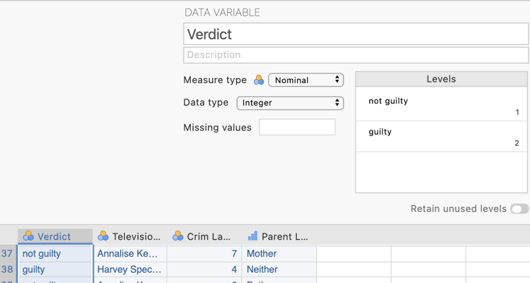
Our dependent variable “Verdict” has been specified as a nominal variable in Measure type and is the first column of data. This variable has two levels: not guilty and guilty.
In the second column of our data spreadsheet we have the variable “Television Lawyer Model” indicating which model the students were instructed to capture. The measure type has been set as nominal. There are two groups: Annalise Keating and Harvey Specter.
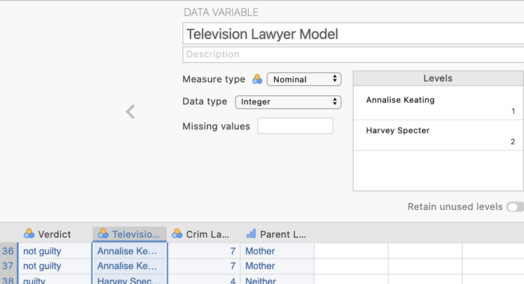

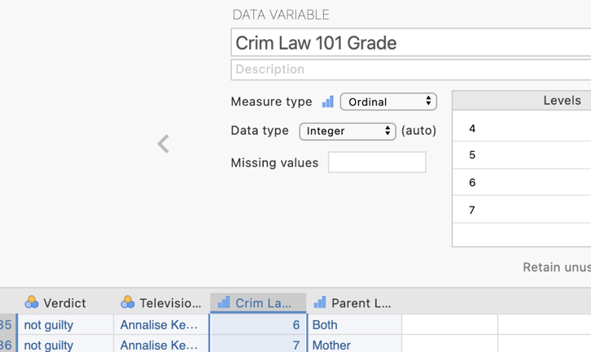
In the third column of our data spreadsheet we have the variable “Crim Law 101 Grade” , which as the name suggests is the grade each student achieved for the first year criminal law subject. The measure type has been set as ordinal as technically grades are not equal interval. However for our analysis we will treat this variable as a continuous predictor.
Our final variable is “Parent Lawyers” specifying how many of each student’s parents are lawyers. There are four levels: neither, mother, father and both. This variable is somewhat ordinal in nature however as we are also denoting which parent is the lawyer when only one is a lawyer this variable is more appropriately labelled as nominal.
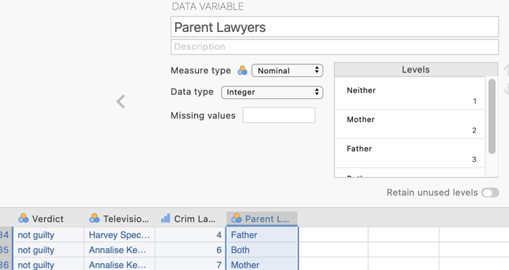

Step 2 – Navigating to the binary/binomial logistic regression menu.

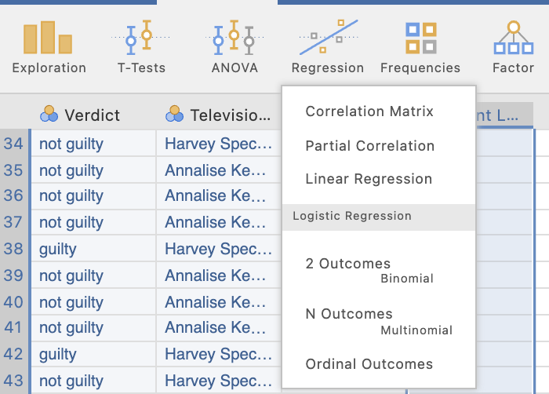
On the Analyses tab select the Regression menu. Then under “Logistic Regression” select 2 Outcomes, Binomial.

Step 3 – Selecting analysis options

First let’s specify out dependent variable and move our predictors to the appropriate spots

Our dependent variable is verdict.
Our predictors need to be organised based on their measurement level.
Continuous predictors are called “Covariates" in jamovi so we’ll move the grade for first year criminal law there.
Our remaining two variables are categorical and jamovi labels categorical predictors as factors.

Before looking at our output we’ll specify all the options we would like from the options drop down menus.
We’ll need to head into four of these drop down lists for our needs and we’ll step through them one at a time.
The Reference Levels tab is very important. It allows us to choose what will be considered our reference category for our dependent variable and any categorical predictors we have. Some will be chosen as a default. We can either leave them as they are or choose to change them.
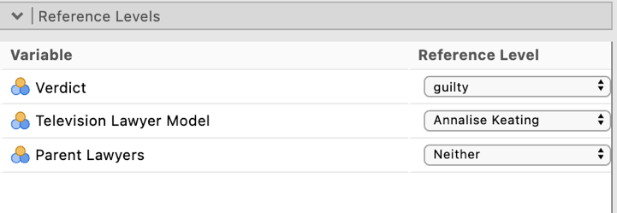

For our dependent variable the desirable or target outcome is to obtain a not guilty verdict. A not guilty verdict reflects greater “lawyering” skill in our mock trial. This means that guilty needs to be our reference category. jamovi will consider which ever category has the lowest code value in as the reference category. As we had coded not guilty as 1 and guilty as 2 in our data file, jamovi defaulted to having not guilty as the reference category. We can (and have in the above screen shot) change this to our desired reference category.
For the Television Lawyer Model it doesn’t make that much difference which we pick as the reference category so we can leave it at what jamovi has picked.
The Parent Lawyers variable also has an intuitive reference category so we’ll leave that as is too.

Having shifted our two variables into position we are given the following default output.

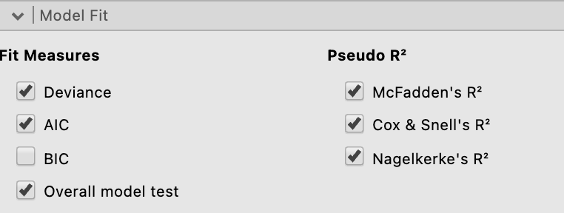
The Model Fit drop down list has a collection of fit and pseudo R²s for us to select from. As a default Deviance (or -2LL) and the AIC will be selected and we’ll also ask for overall model test. Under Pseudo R² the McFadden’s is the default but we’ll also ask for Cox and Snell’s and Nagelkerke as they are more commonly reported.

Under the Model Coefficients drop down list we’ll ask for Odds ratio, also known as Exp(B), and their associated confidence intervals as these are what we use to interpret the impact of our individual predictors.
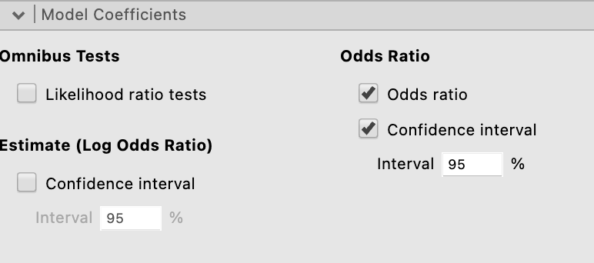
And finally under the Prediction drop down list in the “Predictive Measures” section we’ll ask for accuracy, specificity, and sensitivity and a classification table to help see how these are derived.
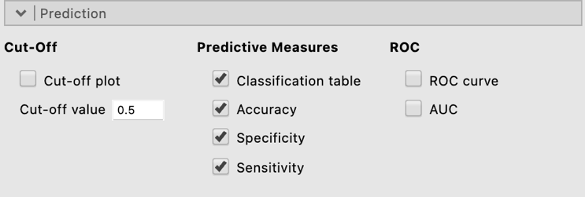

With all our selections made here is our output in all its glory.

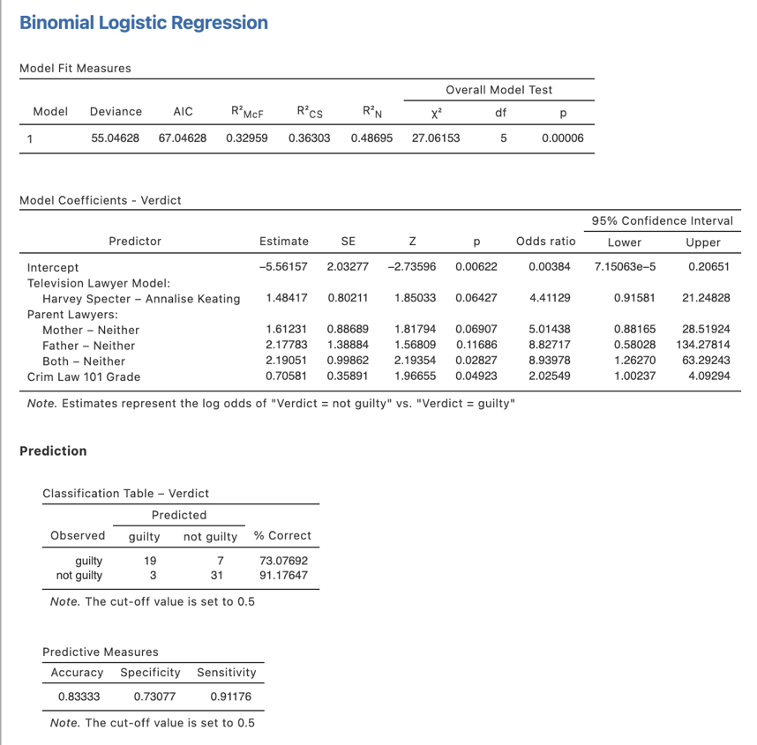
We have all we need to interpret and write up our results now so let’s push on.
Step 4a – Finding the components for reporting the omnibus results / overall model statistics

We’ve run all we need to write up our $χ$² analysis.

The components we’ll report are:
- The $χ$² statistic, df and p value – our significance test for the overall model.
- Effect size in the form of a range from Cox and Snell to Nagelkerke.
- Prediction accuracy – to help describe how well we can predict our outcome.

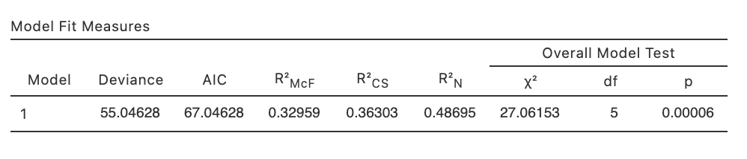
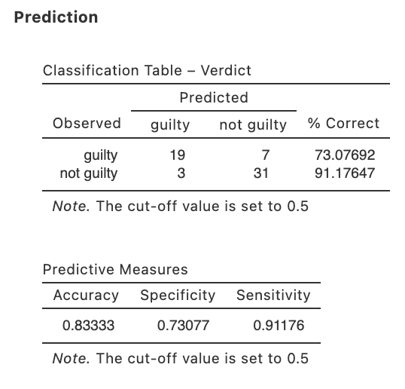
N.B., As the R²s provided in logistic regression are viewed as “pseudo” and less precise than an R² in a standard or ordinary least squares regression, it is common to report several and provide a range. Alternatively the most conservative McFadden estimate could be reported if a more cautionary approach is preferred.

Deviance (also referred to as -2LL) is sometimes reported but mostly not. An AIC is not commonly reported for a binary logistic regression model.

The Write Up (Part 1):

A binary logistic regression was conducted to determine whether a student jury returning a not guilty verdict in student mock trials could be predicted by the television lawyer emulated, prior criminal law subject grade or familial lawyer lineage of the student acting for the defence. The overall model was significant, $χ$² (5) = 27.06, p < .001, with between 36.3% and 48.7% of the variance in the odds of a not guilty verdict explained by the predictor set. Across both outcome categories, 83.3% of cases were accurately classified, with sensitivity somewhat higher than specificity. Guilty verdicts were correctly predicted in 91.2% of cases compared to 73.1% of guilty verdicts.

Step 4b – Finding the components for reporting results for individual predictors

We’ll create a table to contain the results about the individual predictors and then put together some summary text.

The elements needed for the regression table are:

- p values for each predictor – to determine the significance of each predictor’s contribution to the model
- Effect sizes in the form of Bs and Exp(B)s
- Confidence intervals – around the Exp(B)s.

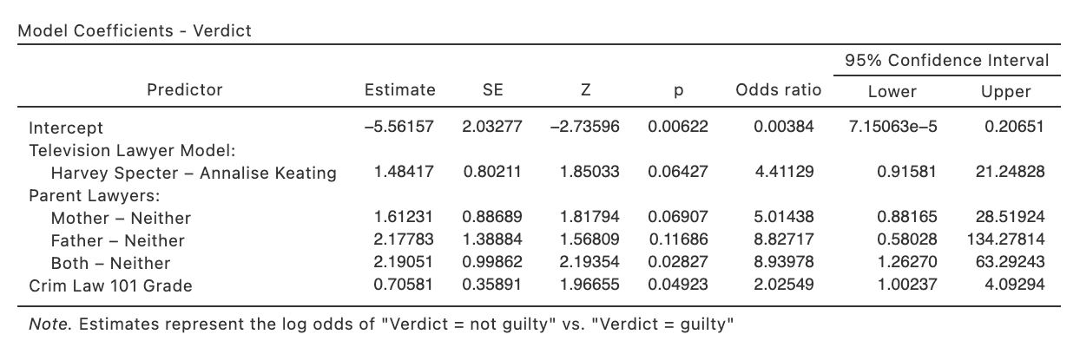

Table 1

Logistic regression results for the prediction of a student jury not guilty verdict from student contested mock trials

 | Exp(B) | 95% CI for Exp(B) |  | B | p
 |  | LL | UL
Television Lawyer Model
Harvey Specter | 4.41 | 0.92 | 21.25 | 1.48 | .064
Parent Lawyers
Mother | 5.01 | 0.88 | 28.52 | 1.61 | .069
Father | 8.83 | 0.58 | 134.28 | 2.18 | .117
Both Parents | 8.94 | 1.26 | 63.29 | 2.19 | .028
Criminal Law 101 Grade | 2.03 | 1.00 | 4.09 | 0.71 | .049
Note. The reference category for Television Lawyer Model was Annalise Keating. The reference category for Parent Lawyers was neither.

Write Up (Part 2):

A student acting for the defence having both two parent lawyers significantly increased the odds of not guilty verdict by 783% compared to having neither parent being a lawyer. The odds of a not guilty verdict were also significantly increased by 103% with each unit increase in Criminal Law 101 grade. No other predictors significantly related to the odds of a not guilty verdict.

Created by Janine Lurie in consultation with the Statistics Working Group within the School of Psychology, University of Queensland

Based on jamovi v.1.8.4

Further information about the television series How to Get Away with Murder can be found at https://en.wikipedia.org/wiki/How_to_Get_Away_with_Murder.
Further information about the television series Suits can be found at https://en.wikipedia.org/wiki/Suits_(American_TV_series).
The Statistics Working Group was formed in November 2020 to review the use of statistical packages in teaching across the core undergraduate statistics units. The working group is led by Winnifred Louis and Philip Grove, with contributions from Timothy Ballard, Stefanie Becker, Jo Brown, Jenny Burt, Nathan Evans, Mark Horswill, David Sewell, Eric Vanman, Bill von Hippel, Courtney von Hippel, Zoe Walter, and Brendan Zietsch.
The jamovi project (2021). jamovi (Version 1.8.4) [Computer Software]. Retrieved from https://www.jamovi.org

