Star Wars is a much beloved franchise. Some characters and plots however are more beloved than others by the fan base. One particularly divisive character is JarJar Binks, who first appeared in the first of the three prequels to the original trilogy, The Phantom Menace in 1999. A researcher decided to explore what factors predict a love for this character and so conducted a survey to explore this. To participate in the survey participants had to have seen JarJar Binks in at least one form. This could either be in the live action movies The Phantom Menace, Attack of the Clones or Revenge of the Sith (also known as Episodes 1, 2 and 3 respectively) or in the animated series The Clone Wars. The survey included questions such as “How old were you when you first saw JarJar Binks?” and “How would you rate the extent of your Star Wars fandom” which the researcher assumed would strongly relate to attitudes towards JarJar. However, she was particularly interested in whether, once first accounting for variance in JarJar Binks attitudes from these factors, additional variance could be accounted for via a shared agreement with other somewhat maligned beliefs about Star Wars characters and plotlines. To this end, the survey also asked participants to rate their level of agreement that the Kylo Ren and Rey romance makes sense, and that Boba Fett is over-rated. Responses from 100 participants were obtained.

Step 1 – Taking a look at the data.
Our three Star Wars opinion variables (JarJar Binks is awesome, The Kylo Ren and Rey romance makes sense, and Boba Fett is over-rated) have been specified as ordinal variables in Measure type. The anchor points of the Likert scale (1 = strongly disagree, 5 = strongly agree) have also been entered

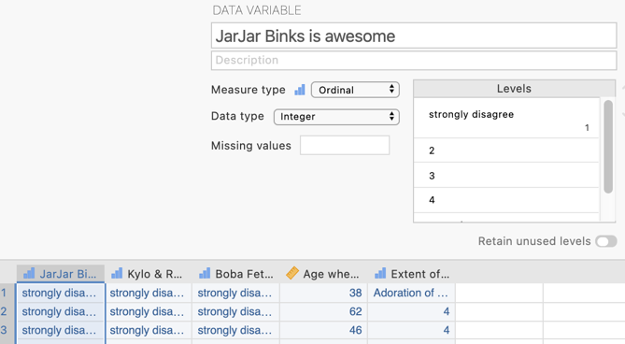

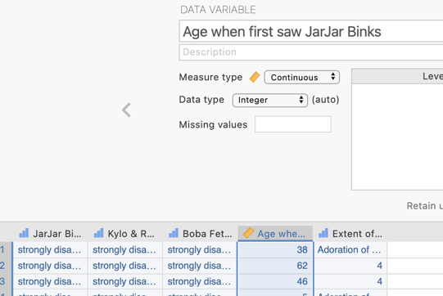
The age a participant was when they first saw JarJar Binks in a Star Wars movie or The Clone Wars is specified as a continuous variable

And finally, the rating of the extent of Star Wars fandom is specified as an ordinal variable with the anchor points of the Likert scale (1 = Could not care less about the Star Wars, 5 = Adoration of the franchise) also entered

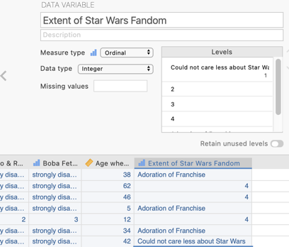

Step 2 – Navigating to the Linear Regression menu.

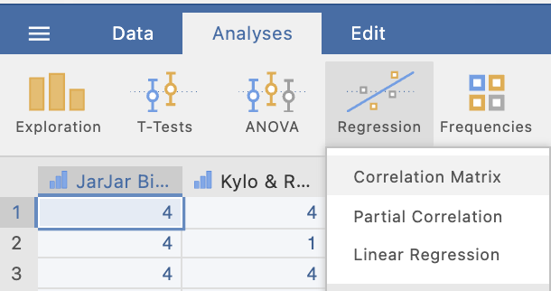
On the Analyses tab select the Regression menu, then select Linear Regression.

Step 3 – Selecting analysis options

The first thing we need to do is tell jamovi what variable is our criterion/dependent variable and which are our predictors. It is important to note that jamovi refers to continuous predictors as covariates and categorical predictors as factors. In our case all our predictors are continuous so we will need to move them across to the covariates box.

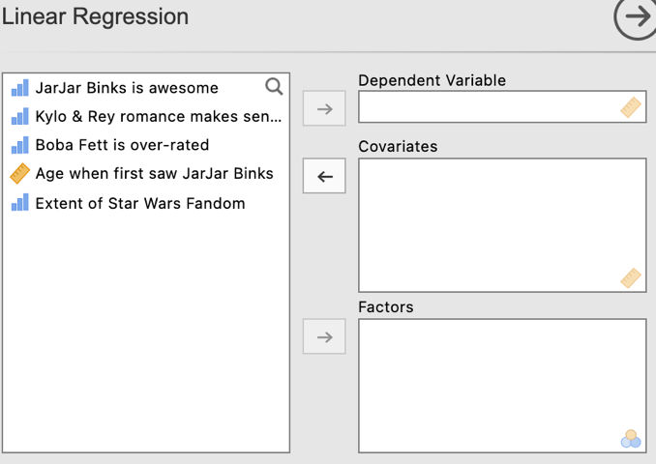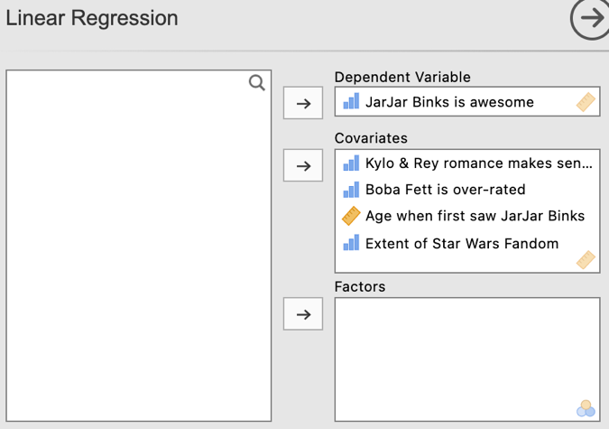

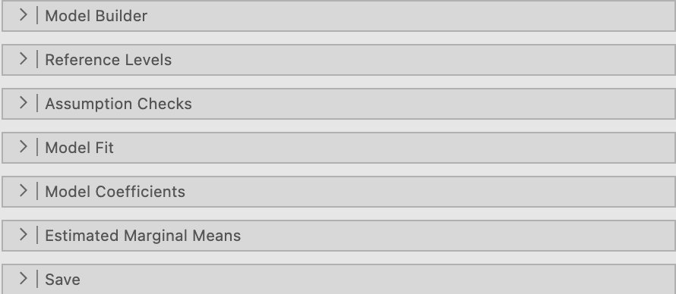
From the drop down lists we’ll ask for options from Model Builder, Model Fit and Model Coefficients.

Under Model Builder we will be setting up our multiple regression as a hierarchical model by telling jamovi how many Blocks or steps we want in our model, as well as which of our predictors to put in which of those Blocks.

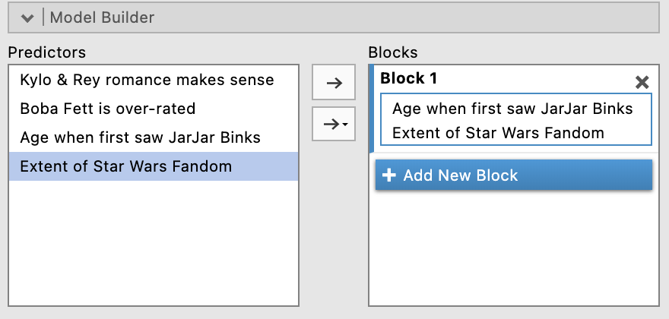
Initially you will see under the heading Blocks on the right hand side a heading for Block 1 and a space to move variables to. Here we want to drag the variables we want in our first Block which are the age when first saw JarJar and Star Wars fandom rating.
To create additional Blocks we click on “Add New Block”. Doing this gives us Block 2, which we can now add the two Star Wars opinion ratings about Kylo and Rey and Boba Fett. We’ll stop here as we only need two Blocks but you can see you could continue adding additional Blocks if you wanted to.
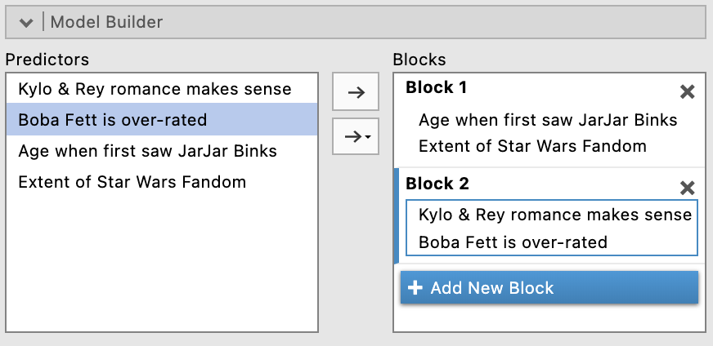

Under Model Fit, in addition to the R and R² already set as a default, we’ll ask for adjusted R² and the Overall Model F test. This will give us three F tests, one for the Block 1 model, one for the Block 2 model (which includes both Block 1 and 2 predictors), and an F_{change} test that assesses whether the predictors in Block 2 explain a significant amount of additional variance in our dependent variable over and above that explained by the Block 1 variables.

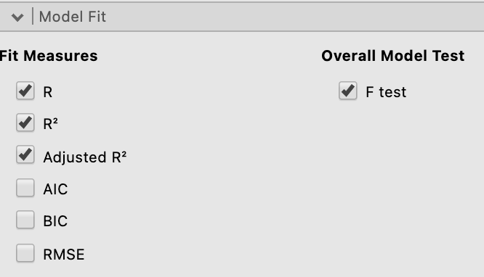

Under the Model Coefficients drop down menu, we’ll ask for confidence intervals for our unstandardised regression coefficients, Bs, (under Estimate) as well as asking for standardised regression coefficients, betas, (under Standardised Estimate) and their confidence intervals as well. You don’t need to include both sets of confidence intervals in your write up but we have done so here to demonstrate what the output looks like for both.

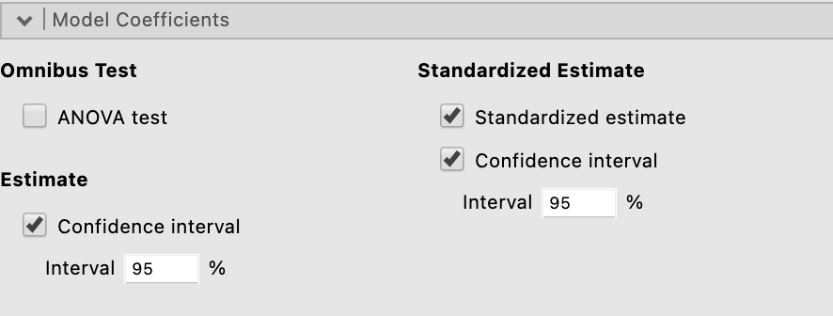

Our output so far looks like this:

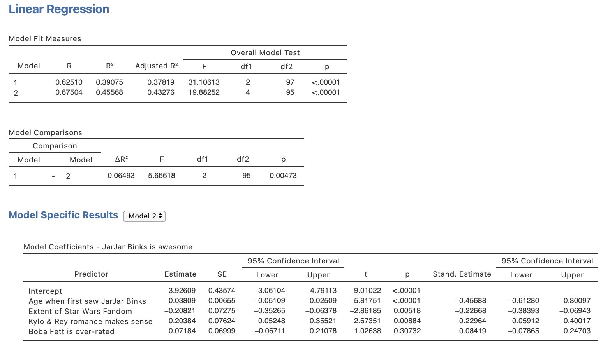
One thing to be aware of is that currently (as at jamovi version 1.8.4), the Model Specific Results or Coefficients table does not display the results for both Model 1 (which is just Block 1 prior to the addition of Block 2) as well as Model 2 (which is all predictors from both Blocks). However you can see there is a drop down list that allows you to toggle between the Model 1 and Model 2 results. So both are obtainable, just not viewable simultaneously.
Make sure you toggle between the Model 1 and Model 2 views to obtain the full set of results.

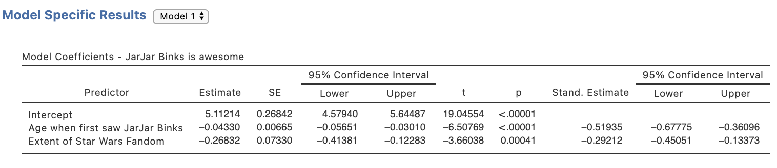
One key statistic that is conventionally reported with hierarchical multiple regression results, namely squared semi-partial correlations, or r²_{a(b,c)}, are not available via the Linear Regression menu. To obtain these we need to run some separate analysis.

Head to the Analyses ribbon, select Regression and then Partial Correlation

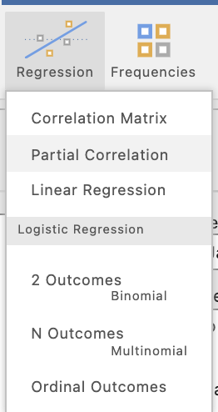
In the current jamovi set up for obtaining partial and semi-partial correlations they need to be specified one at a time. In other words we need to specify a pair of variables to be correlated and which variables to use as control variables, or variables that will be partialled out of the calculations.

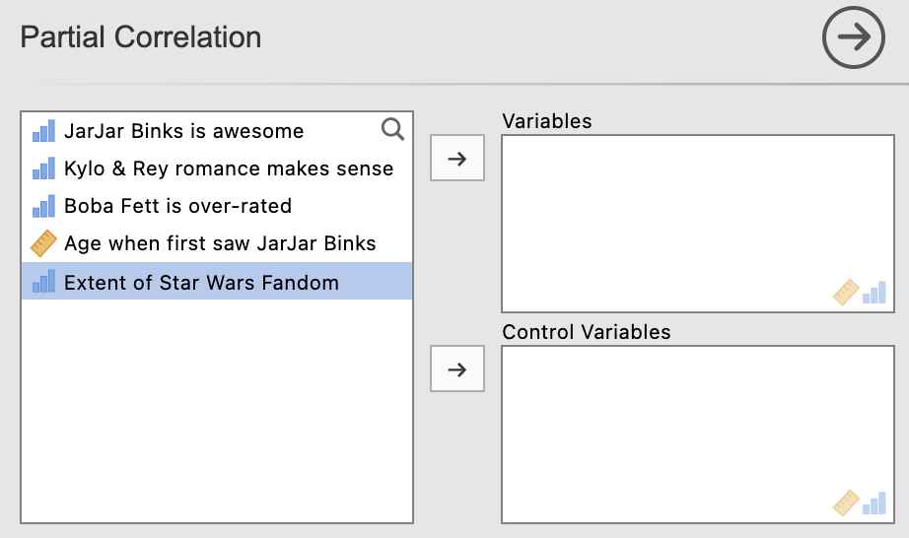

Before we start let’s make sure the options we need have been selected. The most important selection is to change the selection to “Semipartial” under Correlation Type as Partial is the default. Also untick “Report significance” under Additional Options to keep the output minimal and easy to interpret.

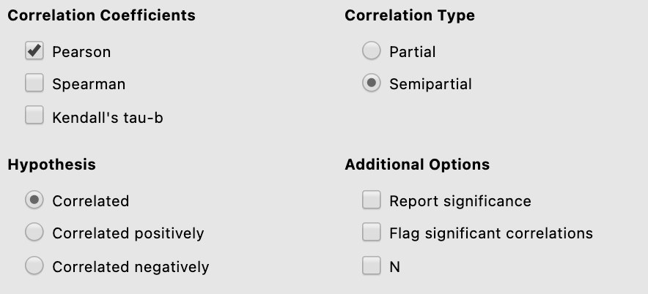
There are six semi-partial correlations we need to request. These are between our criterion/dependent variable JarJar Binks is awesome with each of the two predictors in the first Block, controlling for the other that appears in Block 1. Then, secondly with each of all four predictors controlling for other three that appear in Block 2. It’s a little fiddly but keep your wits about you and you’ll be fine. Below is how you will specify each semi-partial correlation that you need for this regression model.

The two semi-partial correlations we need to get for Block 1 are:

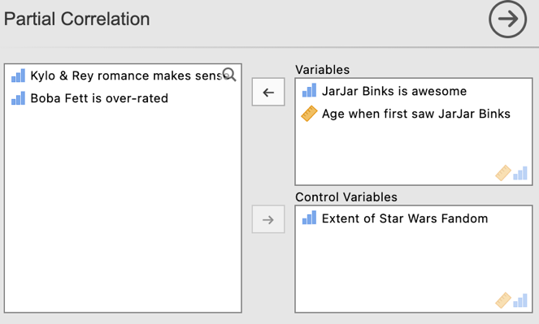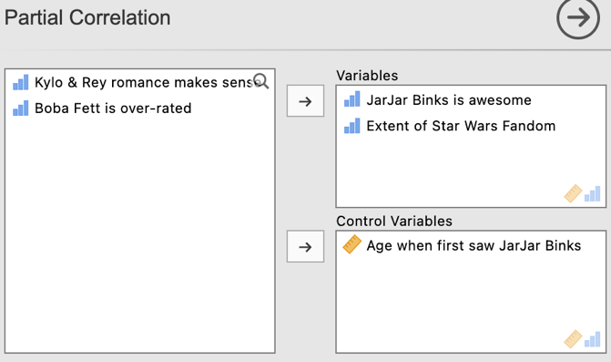

And for Block 2 we need to run the following four semi-partial correlations:

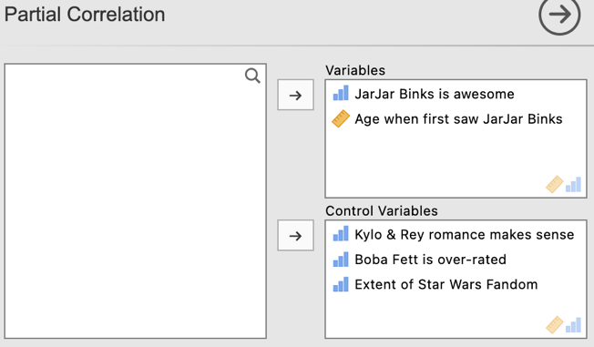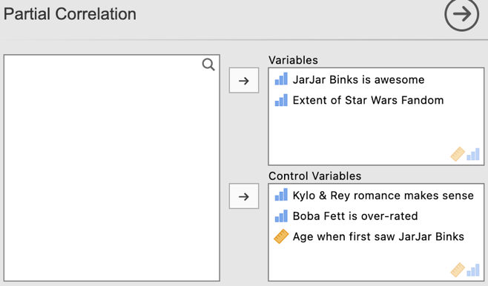

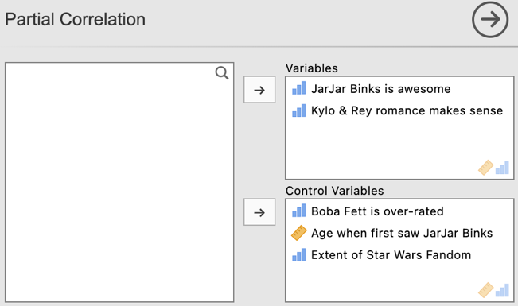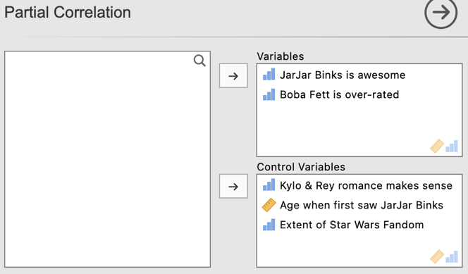

Note that after running each semi-partial correlation you will need to click underneath the output so that jamovi knows to create an additional output, rather than editing the one you just created. Jamovi will edit whichever output is currently highlighted in white. To ensure you get additional output rather than overwritten output ensure you have clicked underneath the output created and it has turned grey.

Our two semi-partial correlations for our first Block look like this:
In each of these semi-partial correlation tables the coefficient we want is listed in the column heading with the predictor name of interest as circled on each.
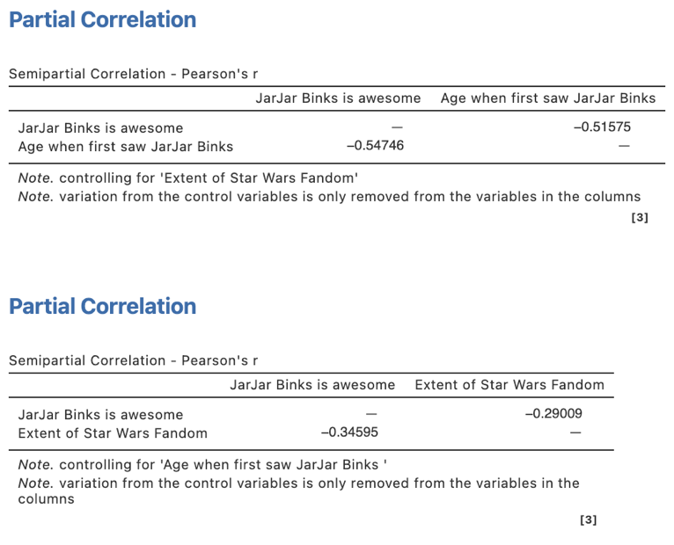

For Block 2 the four semi-partial correlations look like this:

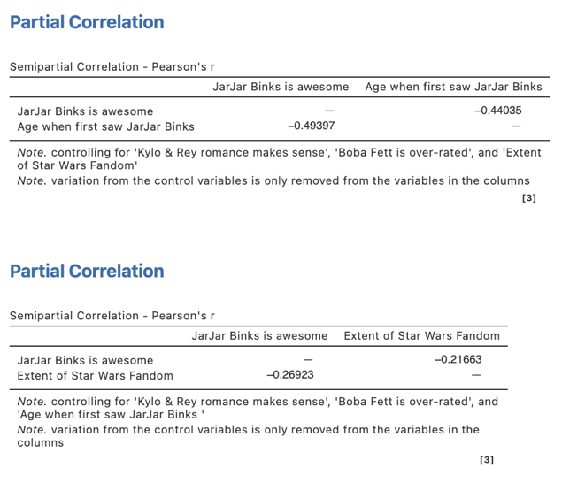
The statistic we need to report in our regression write up is the SQUARED semi-partial correlation. So each of these three semi-partial correlations need to be squared manually.
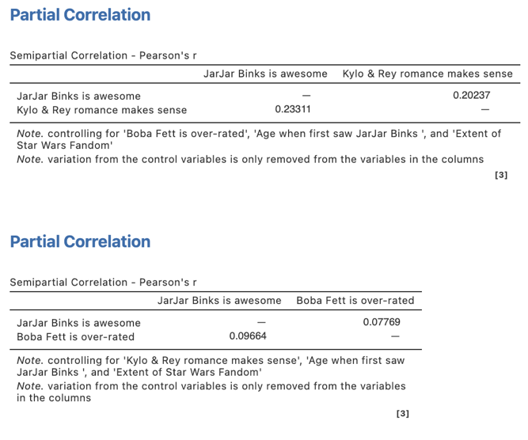
The statistic we need to report in our regression write up is the SQUARED semi-partial correlation. So each of these three semi-partial correlations need to be squared manually.
In each of these semi-partial correlation tables the coefficient we want is listed in the column heading with the predictor name of interest as circled on each.

Step 4 – Finding the components for reporting.

There are two parts to our hierarchical multiple regression write up. The overall model results and then results pertaining to the role of each individual predictor in the model.

The components we need for the overall model results are:
- The F statistics, dfs and p values – these tell us the significance of the proportion of our dependent variable variance explained by predictors in Block 1 (Model 1), by the full set of predictors in Blocks 1 and 2 combined (Model 2), and the significance of the proportion of variance added by Block 2.
- Effect sizes in the form of R² and R²_{change} and adjusted R².

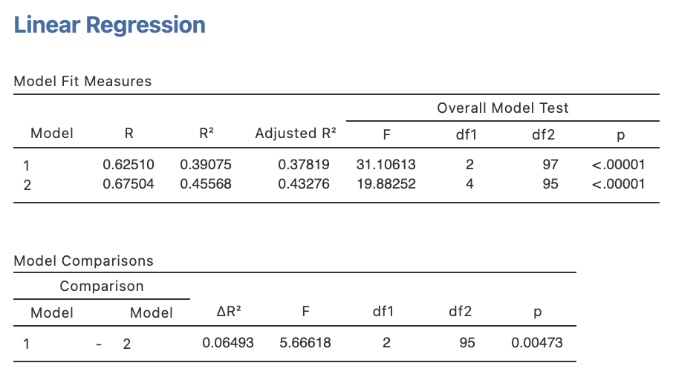

The Write Up (Part 1):

A hierarchical multiple regression was conducted to determine the extent to which the belief that JarJar Binks is awesome can be explained by other controversial Star Wars opinions, after accounting for age of exposure to JarJar Binks and extent of Star Wars fandom. Age of JarJar Binks exposure and extent of Star Wars fandom were found to jointly explain 39.1% of the variance in JarJar Binks awesomeness belief, R² = .39, F(2, 97) = 31.11, p <.001. Agreement ratings with the two controversial Star Wars opinions regarding Kylo Ren, Rey and Boba Fett jointly contributed a significant increment of 6.5% variance explained when added to the model, R²_{change} = .06, F_{change}(2, 95) = 5.67, p = .005. All four predictors accounted for 45.6% of variance in agreement levels that JarJar Binks is awesome, adj. R² = .43, F(4,95) = 19.88, p <.001.

Getting the parts for the Write Up (Part 2):

We’ll create a table to contain the results about the individual predictors. This will require us to consolidate the information from the Model Coefficients table from the regression output as well as the semi-partial correlations we ran separately. We’ll put the regression output elements in the table first. We’ll need the coefficients information for Model 1 (Block 1 only) and Model 2 (All predictors in model).

The elements needed for the regression table are:

- p values for each predictor – to determine the significance of each predictor’s contribution to the model
- Effect sizes in the form of Bs, $β$s and r²_{a(b,c)} (Squared semi-partial correlations).
- Confidence intervals – around the standardised regression coefficients ($β$).

Table 1

Hierarchical Multiple Regression results for the prediction of agreement that JarJar Binks is awesome

 | $$β$$ | 95% CI for $β$ |  | B | p | r²_{a(b,c)}
 |  | LL | UL
Step 1
Age first saw JarJar Binks | -.52 | -.68 | -.36 | -0.04 | <.001
Intensity of Star Wars fandom | -.29 | -.45 | -.13 | -0.27 | <.001
Step 2
Age first saw JarJar Binks | -.46 | -.61 | -.30 | -0.04 | <.001
Intensity of Star Wars fandom | -.23 | -.38 | -.07 | -0.21 | .005
Kylo/Rey romance makes sense | .23 | .06 | .40 | 0.20 | .009
Boba Fett is over-rated | .08 | -.08 | .25 | 0.07 | .307

Getting our r²_{a(b,c)} from our semi-partial correlation output:

For Step/Block 1 of our model we need:
Square this value for the r²_{a(b,c)} for age when first saw JarJar Binks for Step/Block 1.

-0.51575² = 0.266
Square this value for the r²_{a(b,c)} for intensity of Star Wars Fandom for Step/Block 1.

-0.29009² = 0.084

 | $$β$$ | 95% CI for $β$ |  | B | p | r²_{a(b,c)}
 |  | LL | UL
Step 1
Age first saw JarJar Binks | -.52 | -.68 | -.36 | -0.04 | <.001 | .266
Intensity of Star Wars fandom | -.29 | -.45 | -.13 | -0.27 | <.001 | .084

For Step/Block 2 of our model we need:
Square this value for the r²_{a(b,c)} for age when first saw JarJar Binks for Step/Block 2.

-0.44035² = 0.194

Square this value for the r²_{a(b,c)} for Kylo/Rey romance makes sense for Step/Block 2.

0.20237² = 0.041
Square this value for the r²_{a(b,c)} for intensity of Star Wars Fandom for Step/Block 2.

-0.21663² = 0.047
Square this value for the r²_{a(b,c)} for Boba Fett is over-rated for Step/Block 2.

0.07769² = 0.006

 | $$β$$ | 95% CI for $β$ |  | B | p | r²_{a(b,c)}
 |  | LL | UL
Step 2
Age first saw JarJar Binks | -.46 | -.61 | -.30 | -0.04 | <.001 | .194
Intensity of Star Wars fandom | -.23 | -.38 | -.07 | -0.21 | .005 | .047
Kylo/Rey romance makes sense | .23 | .06 | .40 | 0.20 | .009 | .041
Boba Fett is over-rated | .08 | -.08 | .25 | 0.07 | .307 | .006

The statistic we need to report in our regression write up is the SQUARED semi-partial correlation. So each of these three semi-partial correlations need to be squared manually.

Square this value for the r²_{a(b,c)} for the Boba Fett is over-rated predictor.

0.06362² = 0.004

The Write Up (Part 2):

The results for each individual predictor within the regression model are shown in Table 1. The age participants first saw JarJar Binks and the intensity of their Star Wars fandom were both significantly and negatively related to the belief that JarJar Binks is awesome in step one and remained so in step two. Of the two controversial Star Wars opinions added in step two of the model, only the belief that the Kylo Ren/Rey romance makes sense made a significant unique contribution to the model with the level of agreement with this and JarJar Binks awesomeness positively related to each other.

Table 1

Hierarchical Multiple Regression results for the prediction of agreement that JarJar Binks is awesome

 | $$β$$ | 95% CI for $β$ |  | B | p | r²_{a(b,c)}
 |  | LL | UL
Step 1
Age first saw JarJar Binks | -.52 | -.68 | -.36 | -0.04 | <.001 | .266
Intensity of Star Wars fandom | -.29 | -.45 | -.13 | -0.27 | <.001 | .084
Step 2
Age first saw JarJar Binks | -.46 | -.61 | -.30 | -0.04 | <.001 | .194
Intensity of Star Wars fandom | -.23 | -.38 | -.07 | -0.21 | .005 | .047
Kylo/Rey romance makes sense | .23 | .06 | .40 | 0.20 | .009 | .041
Boba Fett is over-rated | .08 | -.08 | .25 | 0.07 | .307 | .006

Created by Janine Lurie in consultation with the Statistics Working Group within the School of Psychology, University of Queensland

Based on jamovi v.1.8.4

Whether to repeat information for predictors in each Block or just provide the full coefficients for the last and full Block/model is a matter of preference. It is however particularly necessary to include the information from each Block where there is interest in how the coefficients differ for a predictor when additional predictors are added to the model. If the regression model has quite a lot of predictors repeating these details can make the table very large and cumbersome.
The Statistics Working Group was formed in November 2020 to review the use of statistical packages in teaching across the core undergraduate statistics units. The working group is led by Winnifred Louis and Philip Grove, with contributions from Timothy Ballard, Stefanie Becker, Jo Brown, Jenny Burt, Nathan Evans, Mark Horswill, David Sewell, Eric Vanman, Bill von Hippel, Courtney von Hippel, Zoe Walter, and Brendan Zietsch.
The jamovi project (2021). jamovi (Version 1.8.4) [Computer Software]. Retrieved from https://www.jamovi.org

