A statistics tutor surveyed her class of 15 students about the time they spend on Instagram. Her students wrote the estimated minutes per day they spend on Instagram. When the data was collected it was revealed that the students spent an average of 80.67 minutes a day on Instagram. This tutor was also a postgraduate student and had asked her fellow postgrads to also give an estimate of their daily “Insta-minutes” as a comparison point. The tutor asked her class, “Who do you think would use Instagram more? You first year students? Or postgrad students?” There was much conjecture and the statistics class set about testing whether there was a significant difference in Insta-minutes between them and the postgraduate students.

Step 1 – Taking a look at the data.

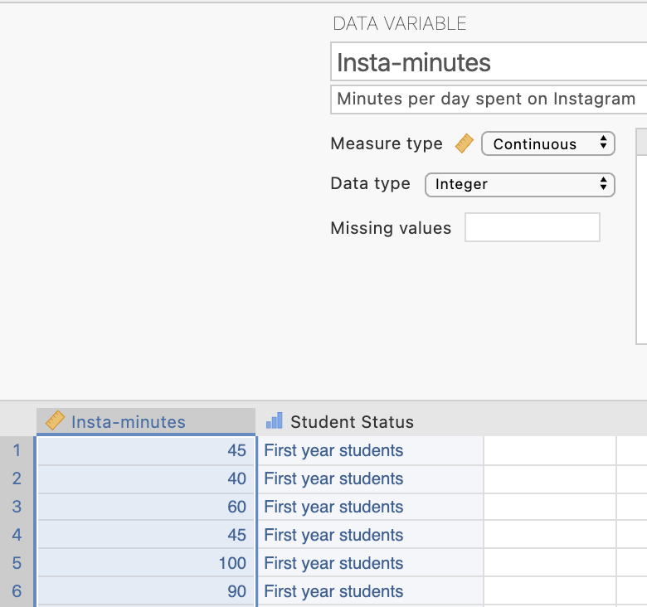
Our dependent variable “Insta-minutes” has been specified as a continuous variable in Measure type and is the first column of data
In the second column of our data spreadsheet we have a variable “Student Status” which tells jamovi which group the students are in. You can see the measure type has been set as ordinal. There are two levels to this variable. First year students who have been given a code of 1 and postgraduate students with a code of 2. The first 15 rows in the data set are first year students and then the second 15 rows are the postgrads. Our independent variable or grouping variable can be ordinal or nominal for an independent means t-test.
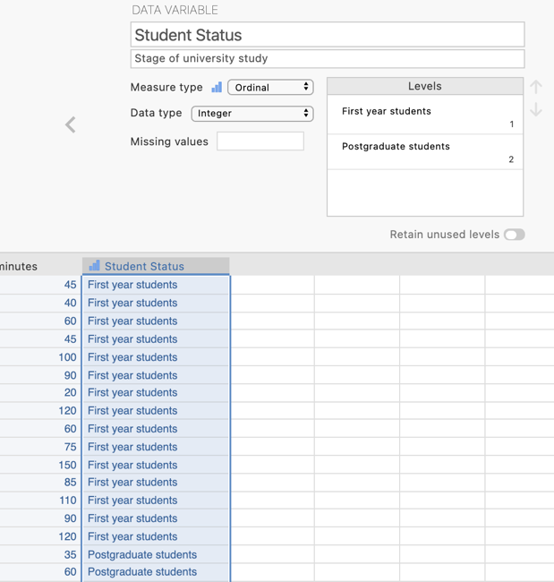

Step 2 – Navigating to the Independent Samples t-test analysis menu.
On the Analyses tab select the T-tests menu, then select Independent Samples T-Test. This is an alternate name for the Independent means t-test.
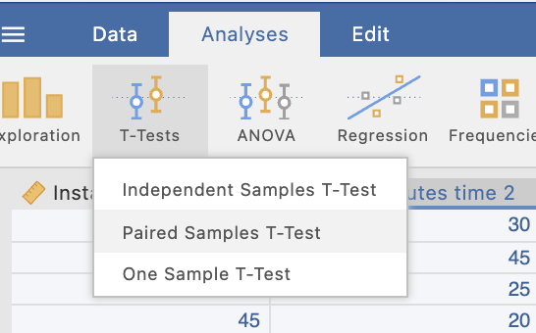

Step 3 – Selecting analysis options

When you first select the Independent Samples T-Test the following screen will appear. The analysis options appear on the left and the empty results appears on the right, ready to update as you select the analysis options.

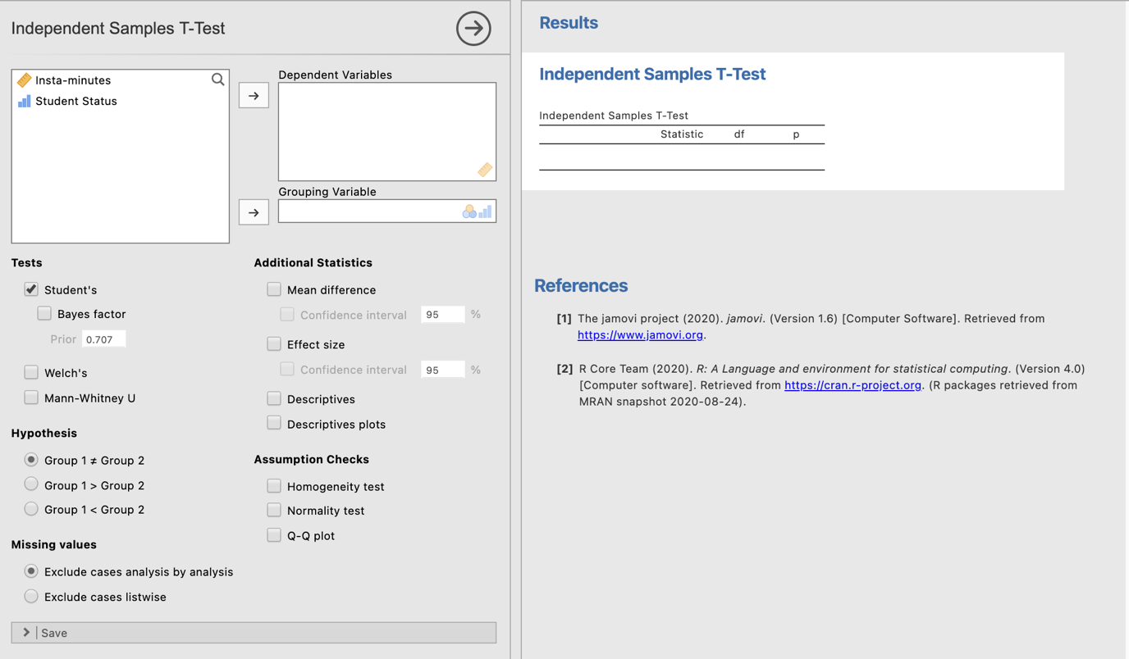

The first thing we need to do is specify our dependent and independent variables.
We need to move Insta-minutes to the dependent variables box and student status to the grouping variable box. This tells jamovi we want to compare Insta-minutes means across the groups or levels of student status.

Moving our IV and DV into place gives us our initial t-test result.
The “Statistic” value is the t score we would calculate if we calculated it by hand. We are also given the degrees of freedom (28, given that we have two groups of 15 and df = (n – 1) + (n – 1).
Our p value here is .00027. This value is less than .05 so we will reject the null hypothesis that there is no difference in minutes spent on Instagram by first year students and postgraduate students.

We need to ask for some additional statistics to aid our interpretation and write up of the results.

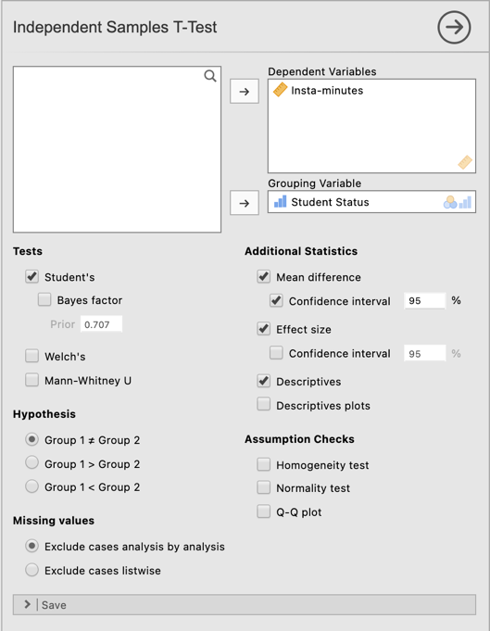
Additional statistics that are helpful to ask for are descriptives and the mean difference to help you describe the pattern of results. The effect size helps you describe the magnitude of the result you have obtained. You can also ask for confidence intervals around the effect size or the mean difference. We’ll ask for these for our mean difference in this instance.

Step 4 – Finding the components for reporting.

Here we have all the information to write up a detailed results paragraph. Let’s pull the components out and see where they fit into the write up.

The four key components here are:
- The t score, df and p value – the t-test result
- An effect size in the form of Cohen’s d.
- The mean difference and associated confidence interval – the difference between our two group means.
- Descriptives for our data – mean and standard deviation are of most use here.

The Write Up:

First year statistics students and postgraduate students estimated their daily number of minutes spent on Instagram. First year students were found to spend significantly more time on Instagram (M = 80.67 minutes, SD = 35.95) than postgraduate students (M = 35.33 minutes, SD = 21.91), t (28) = 4.17, p <.001, M_{diff} = 45.33, 95% CI [23.07, 67.60]. With a Cohen’s d effect size of 1.52 this effect was large.
Tip: In APA format we report our p value to three decimal places. Where our p value would round to .000 we report this as p <.001 and not p = .000 which would imply our p value is equal to zero when it is not.

Created by Janine Lurie in consultation with the Statistics Working Group within the School of Psychology, University of Queensland

Based on jamovi v.1.8.4

The Statistics Working Group was formed in November 2020 to review the use of statistical packages in teaching across the core undergraduate statistics unit. The working group is led by Winnifred Louis and Philip Grove, with contributions from Timothy Ballard, Stefanie Becker, Jo Brown, Jenny Burt, Nathan Evans, Mark Horswill, David Sewell, Eric Vanman, Bill von Hippel, Courtney von Hippel, Zoe Walter, and Brendan Zietsch.
The jamovi project (2021). jamovi (Version 1.8.4) [Computer Software]. Retrieved from https://www.jamovi.org

