The work of medical entomologist Bart Knols revealed that a species of mosquito known for its penchant for sucking blood from people’s feet and ankles also quite likes the stinky German cheese, Limberger. Bemused by this discovery upon watching Dr Knols’ TED talk, a researcher decides to try to extend this research by assessing mosquito preferences for a range of stinky cheeses. Some species of mosquitoes are known transmitters, or vectors, for a range of diseases. The researcher decides to explore the potential viability of stinky cheeses as a form of mosquito repellent/distraction with two vector mosquito species: the aedes aegypti mosquito, a vector for several tropical fevers including dengue fever and yellow fever, and anopheles gambiae, a vector for malaria. The researcher obtains 10 individual mosquitoes from the two species and releases them one by one into four sealed plastic boxes (in random order), each containing one of the four cheeses for 30 seconds. Sensors built into the boxes record the amount of time each mosquito spends within a 1cm radius of the cheeses. The researcher is presented with data that reveals how long each mosquito spent hovering over each cheese variety. A mixed-design ANOVA is required to assess mosquito cheese preferences and how that may differ by mosquito species.

Step 1 – Taking a look at the data.

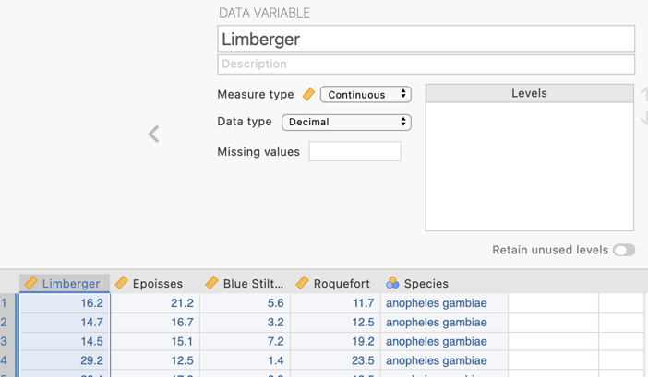
We have four continuous variables that represent the number of seconds spent by each mosquito hovering within 1cm of each of four stinky cheese varieties, namely German Limberger, French Epoisses and Roquefort and British Blue Stilton. The variables are designated continuous.

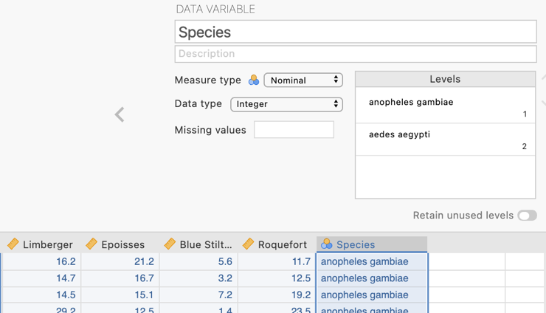
In addition our between-groups or between-mosquitoes variable Species is designated nominal and has two levels/groups which are the two species of mosquito used in the study, anopheles gambiae and aedes aegypti.

Step 3 – Navigating to the Repeated Measures ANOVA analysis menu.

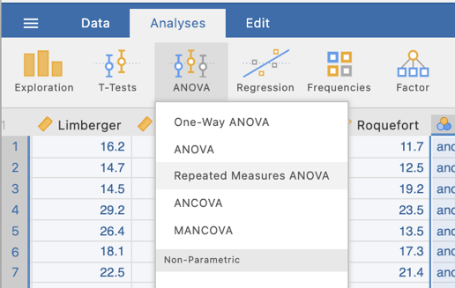
On the Analyses tab select the ANOVA menu, then select Repeated Measures ANOVA.

Step 4a – Selecting analysis options to get the output we need for our omnibus results

The first thing we will do is to let jamovi know that these four cheese variables represent levels of our repeated measures factor. This set up is somewhat more complex than a between groups ANOVA.
Within the Repeated Measures Factors box we need to type in the labels of our factor and its four levels.
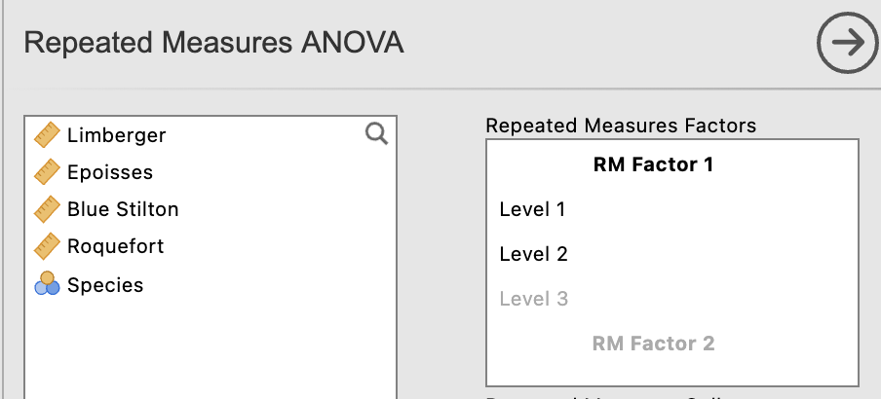

By clicking in each line you can edit and add in the variable name and its levels. Label the RM Factor 1 as Stinky Cheese Variety. Then click in each Level and type the four cheeses in. Note that once you hit the default last level (Level 3), hitting return will create an additional slot to type in our fourth cheese.

You’ll notice that the four cheese varieties now appear down the right hand side of the Repeated Measures Cells box. The next stage is to drag the variables across to these slots.
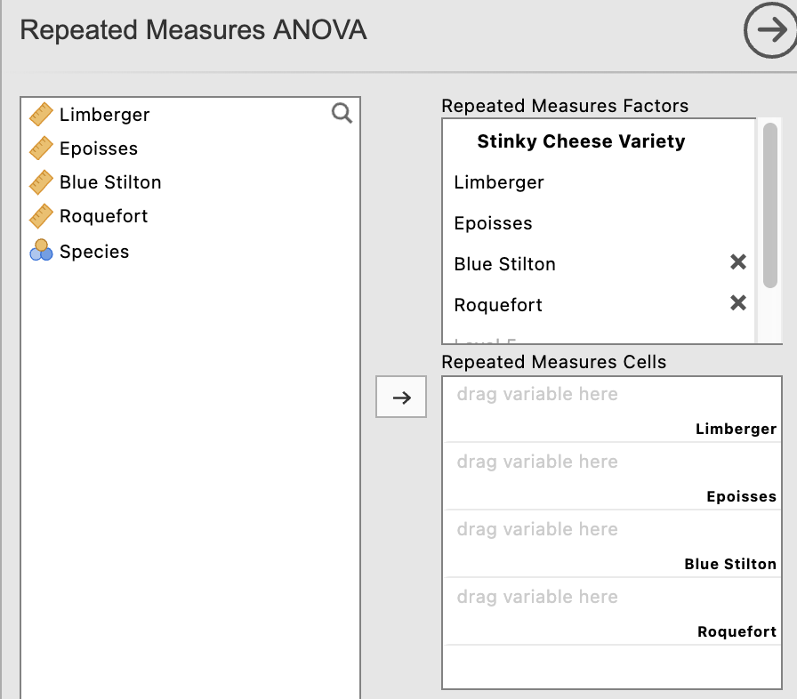

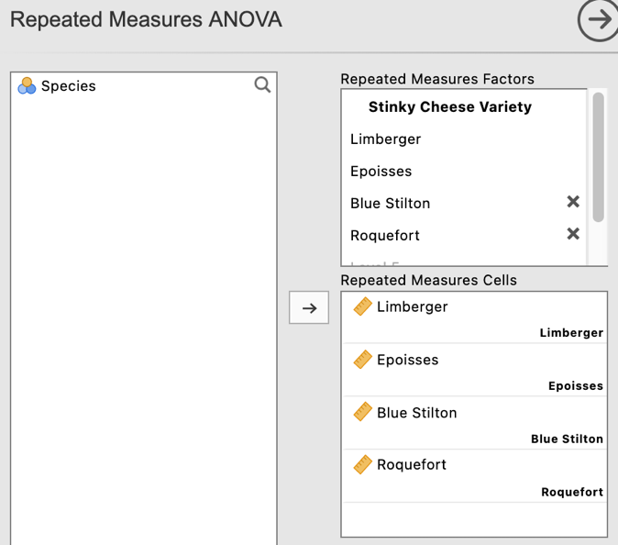
The final set up for your Repeated Measures Factors and Repeated Measures Cells should now look like this.

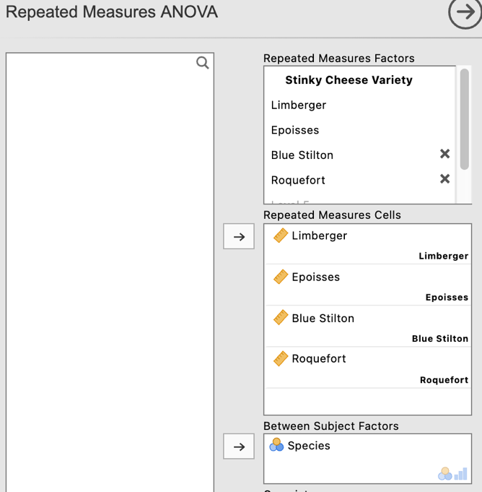
Underneath the Repeated Measures set up you will see a box for Between Subject Factors. Moving our Species variable across to this box now makes our analysis a mixed design ANOVA.

At the bottom of this menu we can also give our Dependent Variable a label to neaten our output, and ask for effect sizes while we are at it.

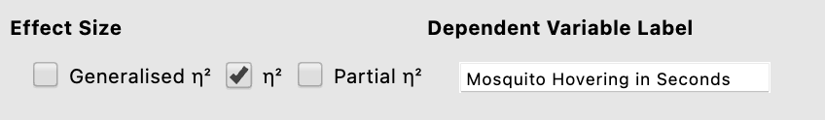
The output provided by our set up so far gives us the omnibus test results for the repeated measures main effect for Stinky Cheese Variety and the interaction test in the Within Subjects Effects table. The Between Subjects Effects table has given us the main effect for Mosquito Species. All three p values are significant suggesting both main effects are significant but are qualified by a significant interaction.
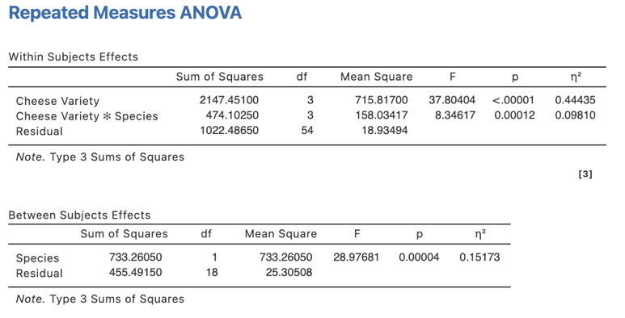
There are a couple of extra things we need to ask for from some of the drop down menus in our one-way repeated ANOVA. These are found under the Assumption Checks menu and the Estimated Marginal Means menu.

NB – We are not going to ask for our post hoc pairwise comparisons here as a pooled error term is used for all comparisons. It is preferable to use error terms that relate only to the two levels being compared for repeated measures comparisons. We will get to this soon.

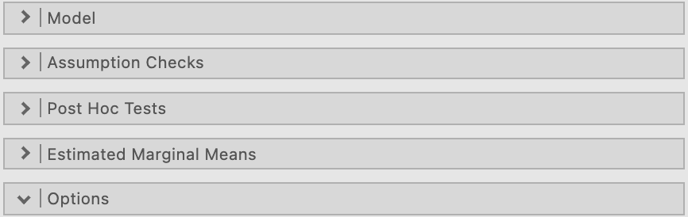
Under Assumption Checks we are going to ask for “Sphericity tests” as well as a “Greenhouse-Geisser correction” under Sphericity corrections. This will enable us to check whether the sphericity assumption has been breached and to report corrected/adjusted results if a breach is present.

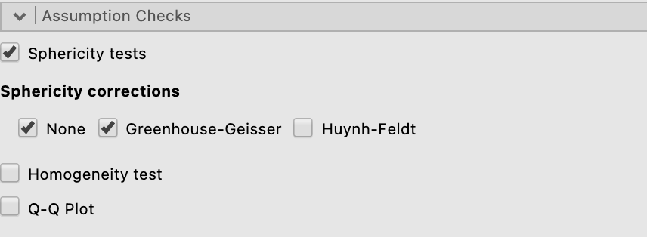

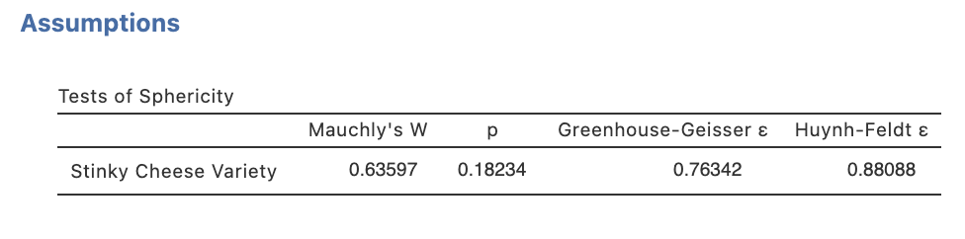
Our output now contains Mauchly’s test of sphericity, and our ANOVA table now includes results with a Greenhouse-Geisser correction if needed
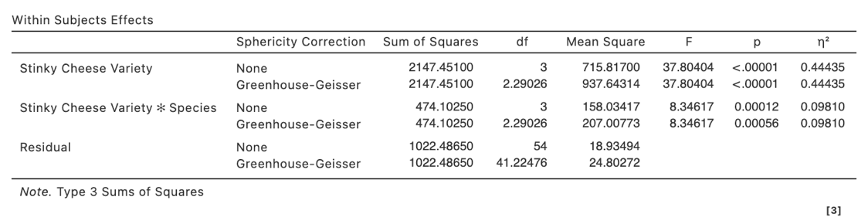
In our case the p value for Mauchly’s test of sphericity is greater than .05 so we can say the sphericity assumption has not been breached. This means we can move forward with uncorrected results.
N.B., Some argue that Greenhouse-Geisser corrected results should always be reported to be on the safe side.

Under the Estimated Marginal Means drop down menu we can ask for plots to help illustrate our findings. Since we know we have a significant interaction, and our main factor of interest is Stinky Cheese Variety and our proposed moderator is Mosquito Species we want to get a plot that illustrates the simple effect of Stinky Cheese Variety for each species.
We need to move both of our factors across to the Term 1 box on the right hand side. We’ll put Stinky Cheese Varieties at the top as this will mean that jamovi creates a plot of the simple effects of this factor with separate lines for the two mosquito species.

Tick “Marginal means plot”. The 95% confidence interval error bars is selected as a default to appear on the plot but you can change this if you like to standard error.

We’ll also tick observed scores so that we can see where the individual data points fall in relation to the means and error bars.

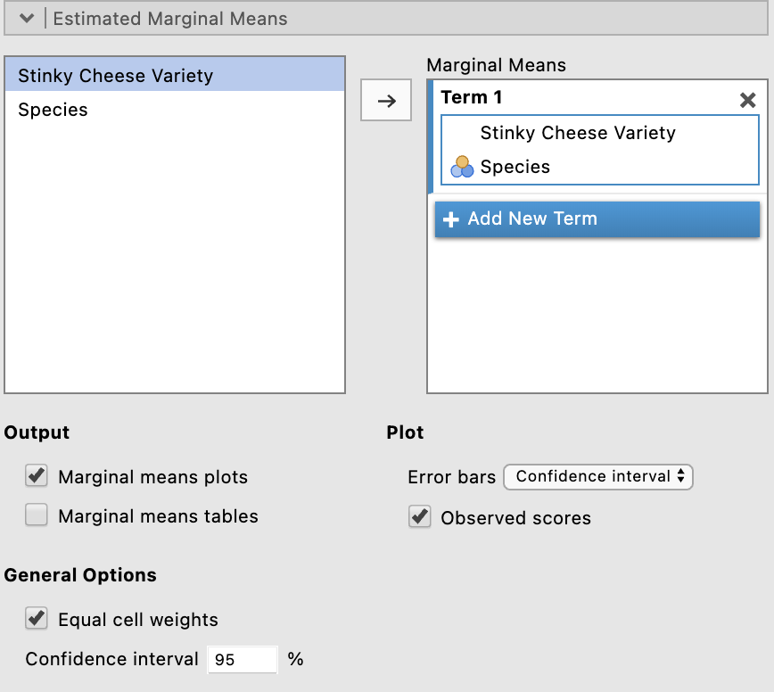

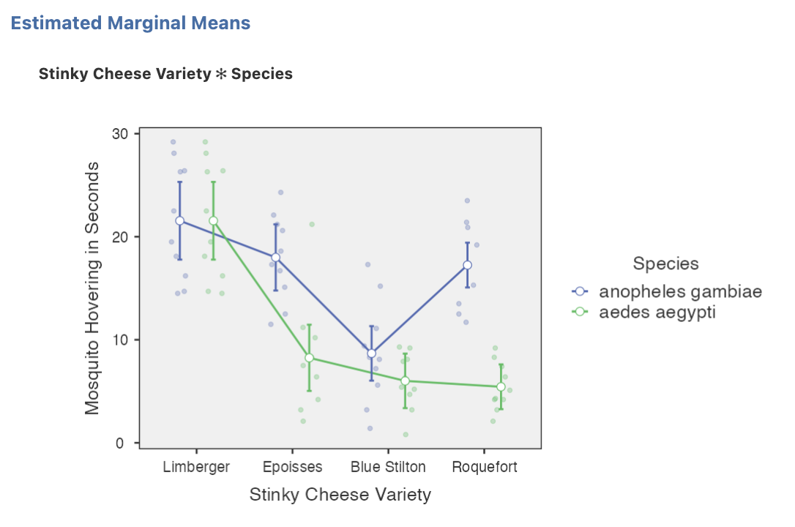
We can see visually here why there is a significant interaction. It’s clear that the mosquitoes attraction to the cheeses differs depending on their species. However we need to do some further post hoc analysis to find out where the significant differences are.

Step 4b – Following up significant between-subjects main effects with main effect comparisons in a two-way mixed design ANOVA

We only have two mosquito species so technically we don’t need to run any follow-up main effect comparisons here in order to report our main effect. However we do have one irritating little snag that would apply also if we had more than two groups so let’s go through the motions here. While jamovi can supply us with both marginal and cell means for us to report with our main effects and simple effects, it only provides standard errors and not standard deviations to accompany these. Conventionally we report standard deviations. However, we don’t have a variable in our data set at this point that will give us the standard deviations we need. For the main effect of Mosquito Species we need marginal means and standard deviations that are collapsed across or averaged across each of the four Stinky Cheese Varieties. So we need a variable in our data set that is each mosquito’s average hovering seconds across the four cheeses.

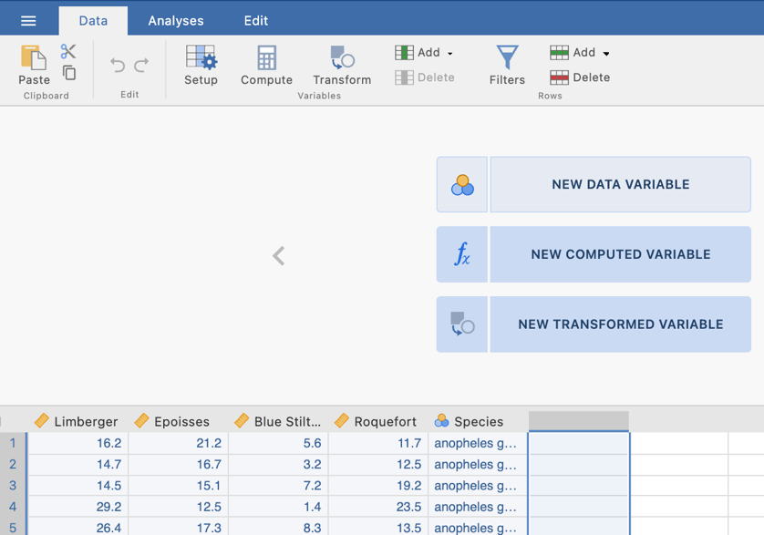
- Go to the Data Tab along the top ribbon
- Click on Setup to get into the data view in full.
- Click in the first column that does not contain any data.
- Click on New Computed Variable

3
4
2
1

In the formula cell create the formula that will average the scores for the four cheese variables. Note you can use the functions to create the MEAN formula shown or create the formula (Cheeses added)/4. Note variables with spaces in their names need to have single quotation marks around their names. Give the variable an appropriate name like Average Cheese Hovering.

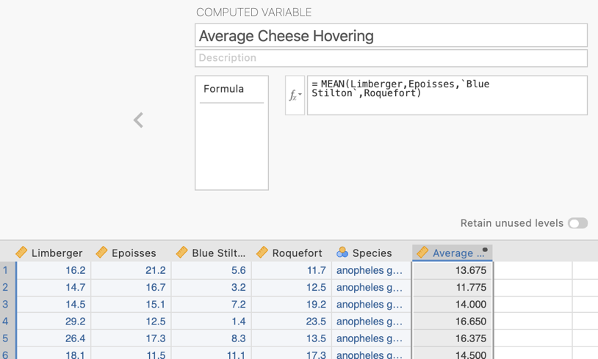

We’ll now be able to run descriptives on this variable and obtain the standard deviations we’d need to report if we were going to this main effect further.

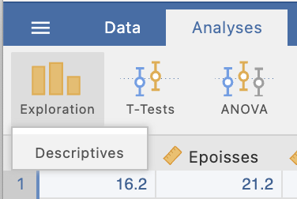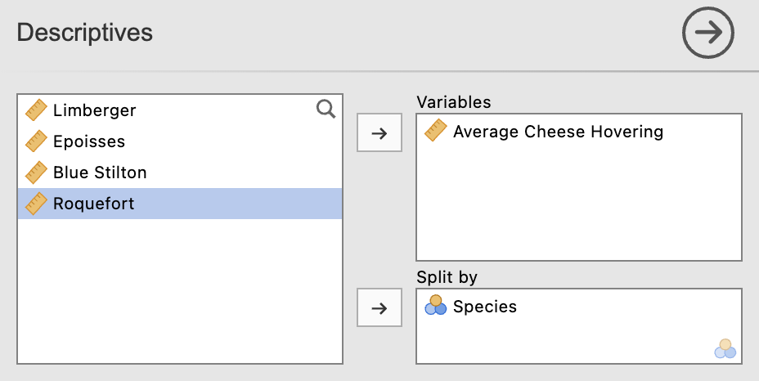

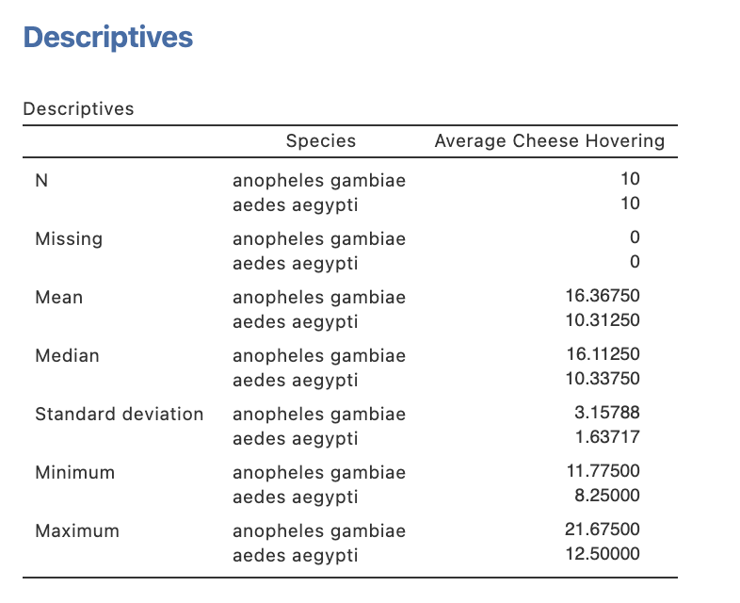

If we had three or more mosquito species in our study we would go on to conduct a one-way between-groups ANOVA with follow-up pairwise comparisons on this average cheese hovering variable to explore the main effect comparisons of species type if we needed to. In our case we don’t need to do this. Our attention can turn to how we would examine the main effect of our repeated measures/within-subjects factor of stinky cheese variety.

NB. We are exploring how to dig deeper into main effects here for teaching purposes. Given that we have a significant interaction the key focus would be on exploring the simple effects and follow-up simple comparisons for this. However you now know how to obtain the variable you would need to run main effect comparisons if you needed them.

Step 4c – Following up significant repeated measures/within-subjects main effects with main effect comparisons in a two-way mixed design ANOVA

While it is possible to ask for these pairwise comparisons within the Repeated Measures ANOVA menu, the comparisons that are generated use a pooled error term (across all four of our stinky cheese conditions). However, it is preferrable to conduct these pairwise comparisons with error terms that are generated from the two levels being compared. In order to obtain these we will need to run a series of pairwise t-tests.

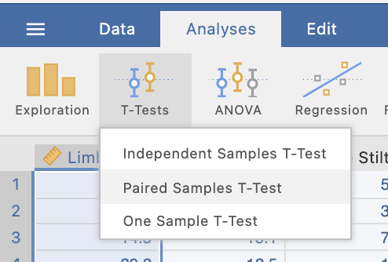
We can specify multiple paired t-tests at once by moving pairs over to the Paired Variables box. We want to create each combination of cheese comparisons to give us the set of comparisons we need.
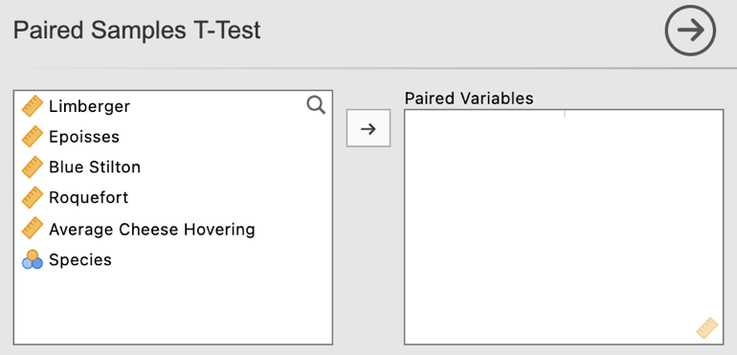
Here we have specified each possible combination of comparisons. Depending on your specific research question or hypothesis you may not need to consider every combination but they have been asked for for completeness here.
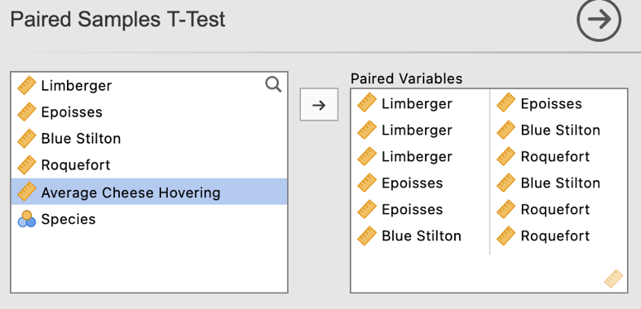

In the analysis options for the paired t-tests output we’ll select Mean difference (to illustrate a learning point only – you don’t need to select this otherwise), effect sizes and associated confidence intervals and descriptives under the “Additional Statistics” heading.

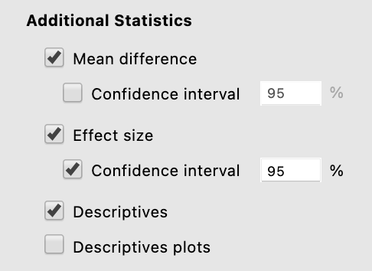

These selections will return the following output:

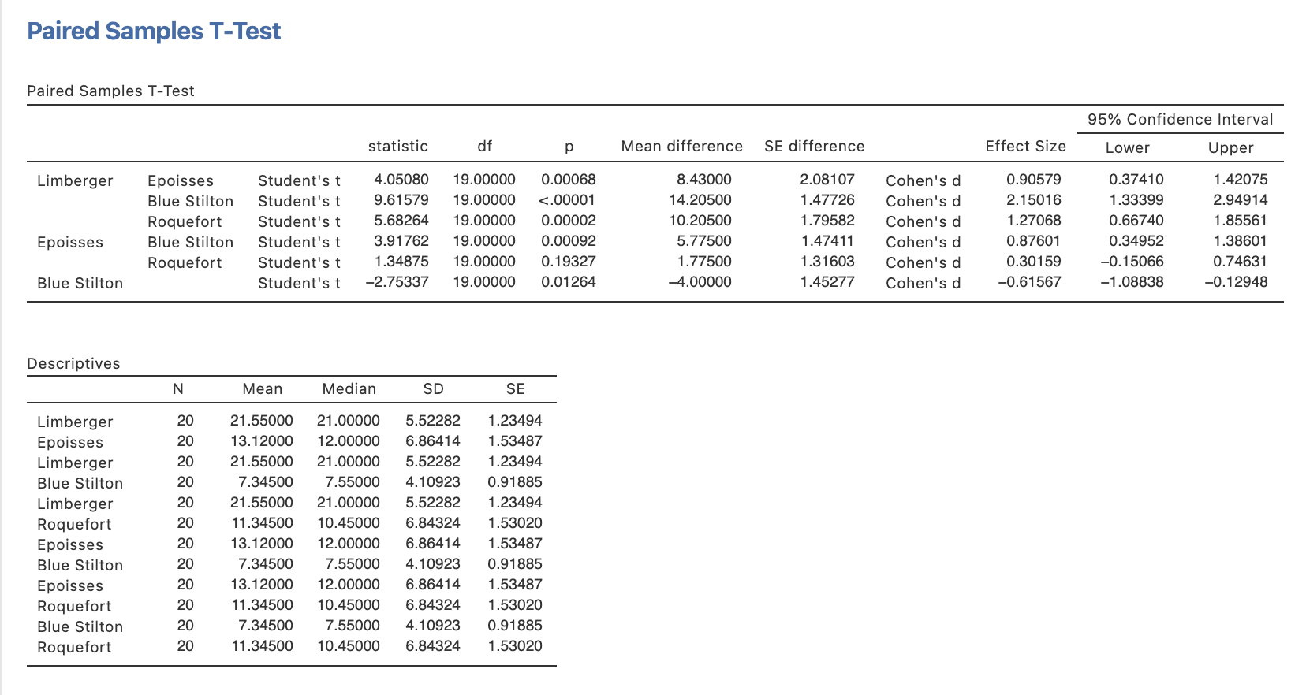
Note that having run these comparisons as separate t-tests the standard errors associated with each comparison are different. They are based on errors derived from each pairing rather than the whole model.

Step 4d – Following up significant interactions with simple effects

When we obtain a significant interaction our next step is to consider simple effects. In this instance we are going to examine the simple effects of Stinky Cheese Variety for each mosquito species separately. To do this we will run two separate one-way repeated measures ANOVAs, using a filter to split our file by mosquito species.

To apply a filter in order to run our repeated measures ANOVAs for one mosquito species at a time go to the Data ribbon and select filters.

A new column will appear in the far left of your data file called Filter 1. We want to create a filter that will filter out each of our mosquito species one at a time. To do this we specify Species as the variable to use to filter. We can then specify to filter out either species by specifying the code of the species/group we want to use. On the left side below we have chosen species code 1, and you can see ticks appear against all mosquitos in that species and crosses against the other group. If we change that value to a 2 in the filter you can see the ticks and crosses have switched over. Cases with a tick against them will be used in the analysis and cases with a cross against them will be filtered out of that analysis.

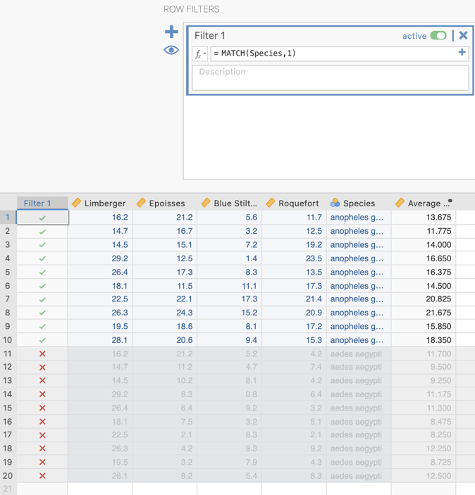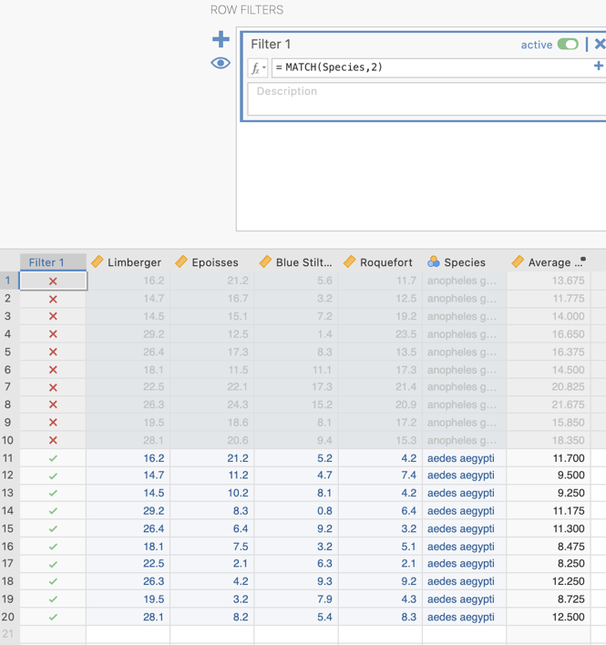

We can turn our filter on and off by sliding across the active versus inactive button in the Filter specification box.
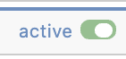 or
One-way repeated measures ANOVA 1 – The simple effect of Stinky Cheese Variety for anopheles gambiae mosquitoes.

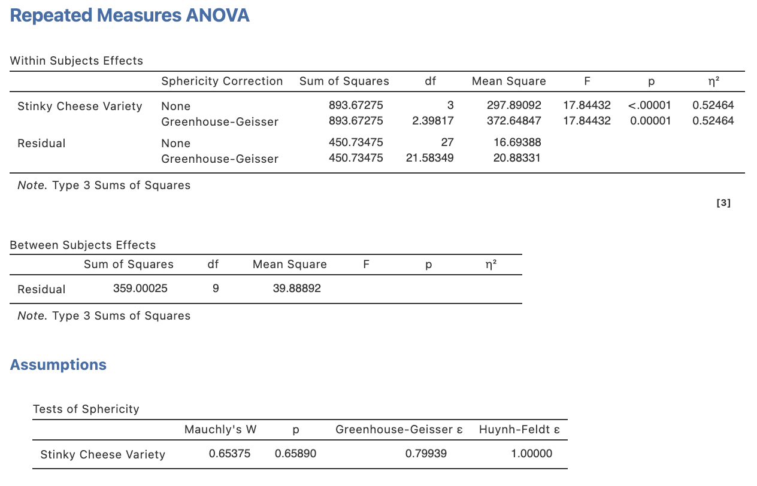

We’ll follow this up with pairwise t-tests for the simple comparisons (with the filter still on).

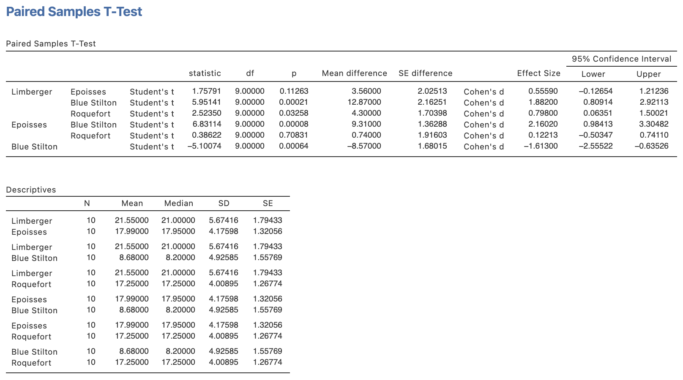

One-way repeated measures ANOVA 2 – The simple effect of Stinky Cheese Variety for aedes aegypti mosquitoes (switch the filter over to use the other group).

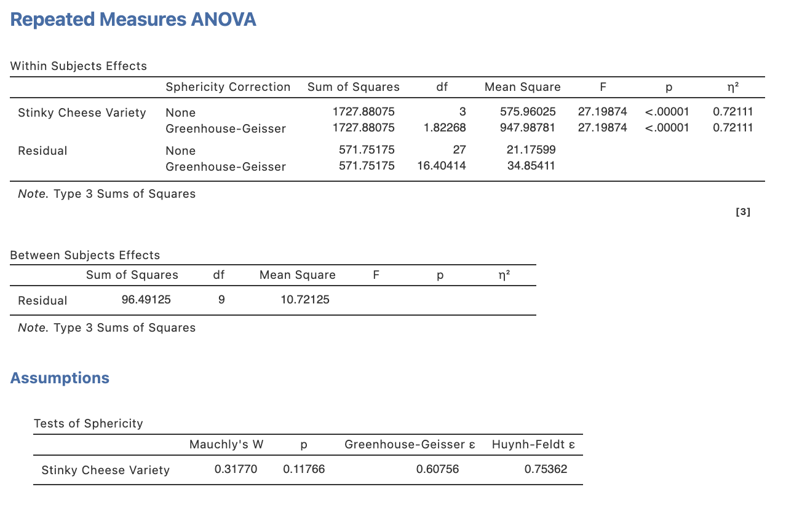
And again follow this up with pairwise t-tests for the simple comparisons (with the filter still on).

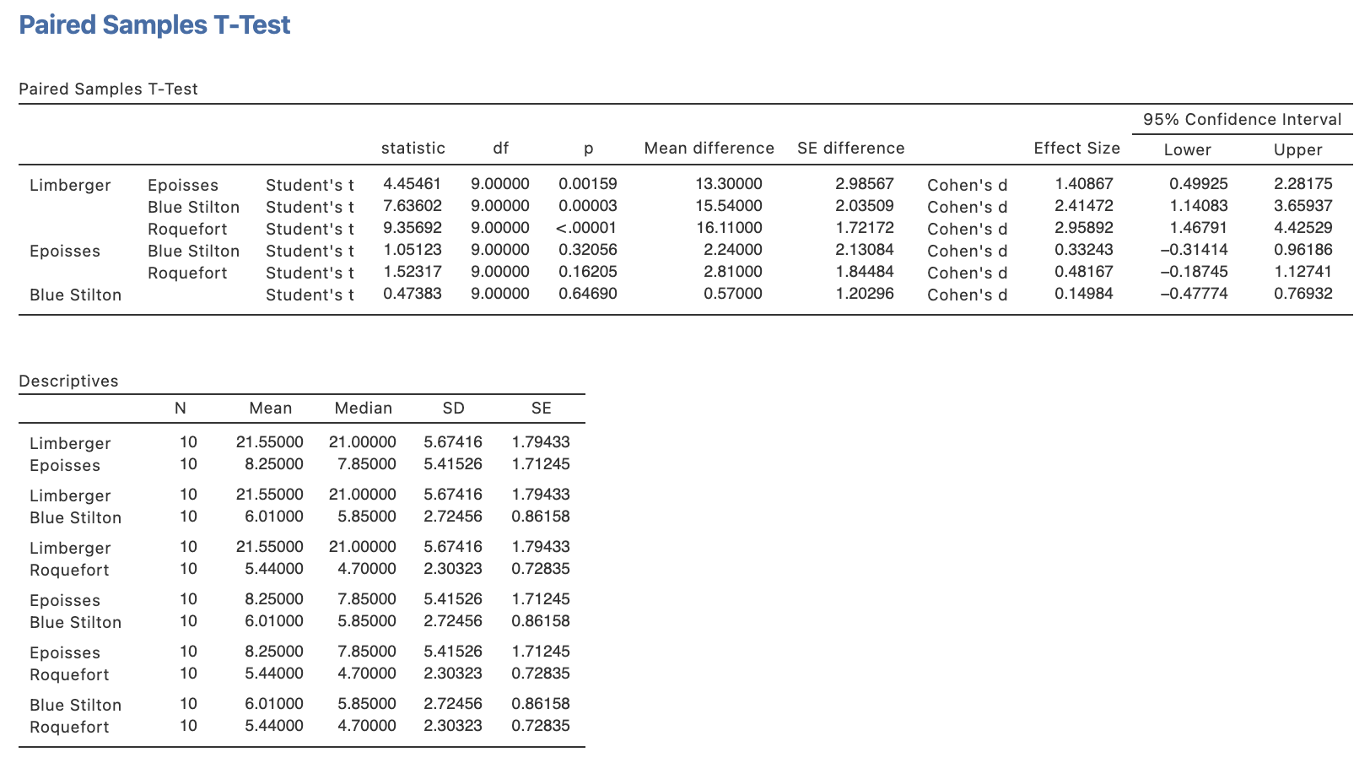

Phew! We’ve got all we need to start reporting now so let’s go through that one step at a time.
Step 5a – Finding the components for reporting the omnibus results

Firstly, let’s report our omnibus results.

The components we obtain here are:
- The F statistics, dfs, p values and Greenhouse-Geisser $ε$ (when reporting corrected results for sphericity breaches) – the omnibus ANOVA results for the main effects and interaction.
- Effect sizes in the form of$η$²

The Write Up (Part 1):

Ten anopheles gambiae and ten aedes aegypti mosquitoes were exposed to randomly ordered combinations of four types of Stinky Cheese (Limberger, Epoisses, Blue Stilton and Roquefort) for thirty seconds to determine their cheese preferences and the impact of species on those preferences. The number of seconds within each thirty second block that the mosquitoes hovered within one centimetre of the cheese was recorded by sensors. A two-way mixed design ANOVA was conducted to analyse the results. No sphericity breach was noted from an examination of Mauchly’s test (p = .182) for the repeated measures factor. Both a significant main effect of Stinky Cheese Variety, F(3,54) = 37.80, p < .001, $η$² = .44, and a significant main effect of Species, F(1,18) = 28.98, p < .001, $η$² = .15, were revealed, but were qualified by a significant Stinky Cheese Variety x Species interaction, F(3,54) = 8.35, p < .001, $η$² = .10.

Step 5b – Finding the components for reporting the simple effects to follow a significant interaction

These come from the two one-way repeated measures ANOVAs we ran for the simple effects of Stinky Cheese Variety separately for the two mosquito species.

The components we obtain here are:
- The F statistics, dfs, p values and Greenhouse-Geisser $ε$ (when reporting corrected results for sphericity breaches) – the omnibus ANOVA results for the simple effects.
- Effect sizes in the form of$η$²

One-way repeated measures ANOVA 1 – The simple effect of Stinky Cheese Variety for anopheles gambiae mosquitoes.

One-way repeated measures ANOVA 2 – The simple effect of Stinky Cheese Variety for aedes aegypti mosquitoes.

The Write Up (Part 2):

The simple effects of Stinky Cheese Varieties were explored in light of the significant Stinky Cheese Varieties x Mosquito Species interaction. Mauchly’s test of sphericity indicated no sphericity breach for either simple effect (ps > .12). The Stinky Cheese Varieties simple effect for anopheles gambiae mosquitoes, F(3,27) = 17.84, p < .001, $η$² = .52, and aedes aegypti mosquitoes, F(3,27) = 27.20, p < .001, $η$² = .72, were both significant necessitating examination of each respective set of simple comparisons.

Step 5c – Finding the components for reporting the simple comparisons to follow significant simple effects.

The end of the road write-up wise is drilling down into these simple comparisons within each simple effect.

These results come from our two sets of paired t-test results which provided us with pairwise comparisons between the four cheese varieties within the simple effect of Stinky Cheese Variety for each mosquito species.

The elements needed for the post hoc section of our write up are:

- Simple comparison results – to determine which cell means within each simple effect are significant from each other. It is sufficient to report the p value for this.
- An effect size for each post hoc comparison in the form of Cohen’s d and its associated confidence interval.
- Means and standard deviations – to help describe the pattern of these differences.

Paired samples t-tests set 1 – Simple comparisons for the simple effect of Stinky Cheese Varieties for anopheles gambiae mosquitoes.

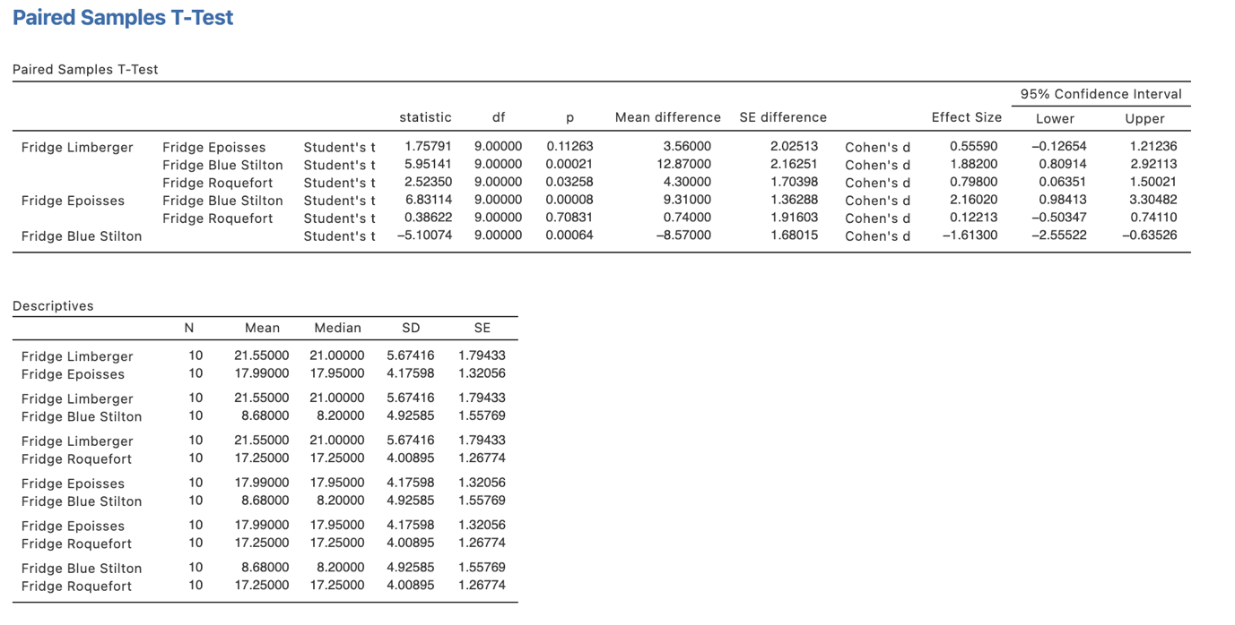
Paired samples t-tests set 2 – Simple comparisons for the simple effect of Stinky Cheese Varieties for aedes aegypti mosquitoes.

The Write Up (Part 3):

Unadjusted post hoc simple comparisons revealed that anopheles gambiae spent significantly fewer seconds hovering over the Blue Stilton, M = 8.68, SD = 4.93, than the Limberger, M = 21.55, SD = 5.67, p = .002, d = 1.88, 95% CI [0.81, 2.92], Epoisses, M = 17.99, SD = 4.18, p < .001, d = 2.16, 95% CI [0.98, 3.30] and Roquefort cheese, M = 17.25, SD = 4.01, p = .001, d = 1.61, 95% CI [0.64, 2.56]. Additionally the Limberger cheese was favoured with significantly more hovering by the anopheles gambiae mosquitoes than the Roquefort cheese, p = .033, d = 0.80, 95% CI [0.06, 1.50].

The aedes aegypti mosquitoes, however, showed a distinct preference for the Limberger cheese, M = 21.55, SD = 5.67, over Roquefort, M = 5.44, SD = 2.30, Blue Stilton, M = 6.01, SD = 2.72, and Epoisses cheeses, M = 8.25, SD = 5.42, ps < .002, ds > 1.41. No other differences were significant, ps > .162, ds < 0.48.

Potential addition of plot:

You could also add the plot we obtained to help illustrate the pattern of results. You might add a sentence like the following if you choose to include the plot:

Figure 1 below provides a visual demonstration of mosquito preference for Stinky Cheese Varieties as moderated mosquito species.

Figure 1

Mosquito Cheese Hovering as a function of Stinky Cheese Variety and Mosquito Species
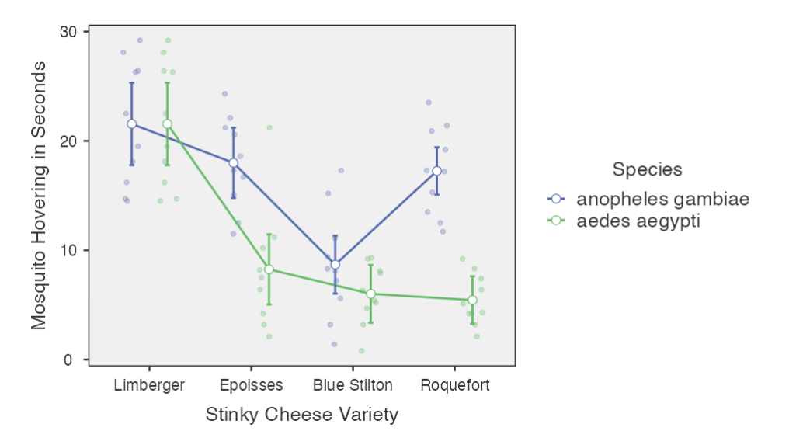
Note. Error bars represent 95% confidence intervals.

Created by Janine Lurie in consultation with the Statistics Working Group within the School of Psychology, University of Queensland

Based on jamovi v.1.8.4

You can view Dr Knols’ TED talk here https://ed.ted.com/lessons/cheese-dogs-and-a-pill-to-kill-mosquitoes-and-end-malaria-bart-knols.
The Statistics Working Group was formed in November 2020 to review the use of statistical packages in teaching across the core undergraduate statistics unit. The working group is led by Winnifred Louis and Philip Grove, with contributions from Timothy Ballard, Stefanie Becker, Jo Brown, Jenny Burt, Nathan Evans, Mark Horswill, David Sewell, Eric Vanman, Bill von Hippel, Courtney von Hippel, Zoe Walter, and Brendan Zietsch.
The jamovi project (2021). jamovi (Version 1.8.4) [Computer Software]. Retrieved from https://www.jamovi.org

