Tantrums are a common event in a child’s toddler years, prior to development of emotion regulation. Often the triggers for these tantrums are seemingly quite absurd. As a consequence, parents can be left trying to suppress their laughter while attempting to care for their child during a tantrum. Anecdotal evidence suggests that an amused reaction from a parent can serve to further intensify a child’s tantrum. Bemused by a recent tantrum in which her son had thrown a tantrum because he wanted to eat a chocolate yoghurt before going to the shop in order to buy said chocolate yoghurt, a young mother, and coincidentally also young researcher, decided to explore this phenomenon in a study. She recruited 80 parents with children aged between two and three years of age. The parents were asked to consider their child’s most recent tantrum event and to rate their impression of the absurdity of its trigger, the extent to which the visibly were supressing laugher in response and finally the intensity of the tantrum. The researcher predicts that the suppression of laughter will mediate the relationship between absurdity of trigger and intensity of tantrum. In other words she is interested in testing the following model:

Obvious Laughter Suppression

Absurdity of Tantrum Trigger
Intensity of tantrum

Step 1 – Taking a look at the data.
Our dependent variable is Intensity of Tantrums set up as an ordinal scale variable. Scores range from 1 to 10 with 10 being the highest intensity.

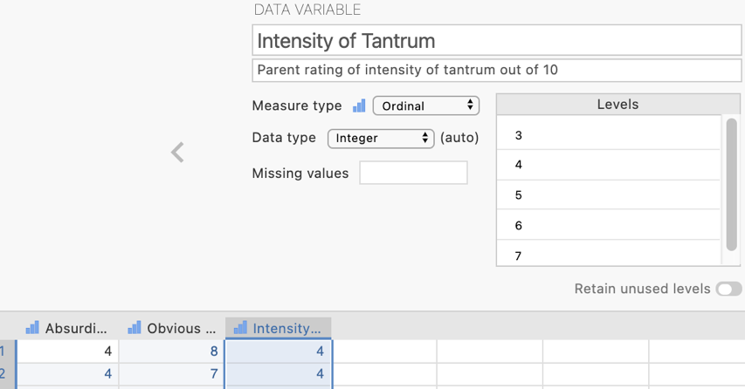

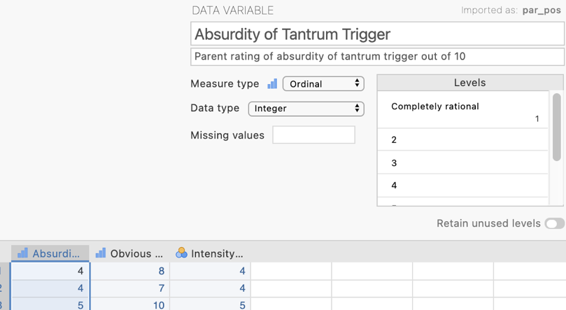
Our independent variable is Absurdity of Tantrum Trigger set up as an ordinal scale variable. Scores range from 1 , completely rational, to 10, completely absurd.

Our proposed mediator is Obvious Laughter Suppression set up as an ordinal scale variable. Scores range from 1 to 10 with 10 indicating extreme laughter suppression.

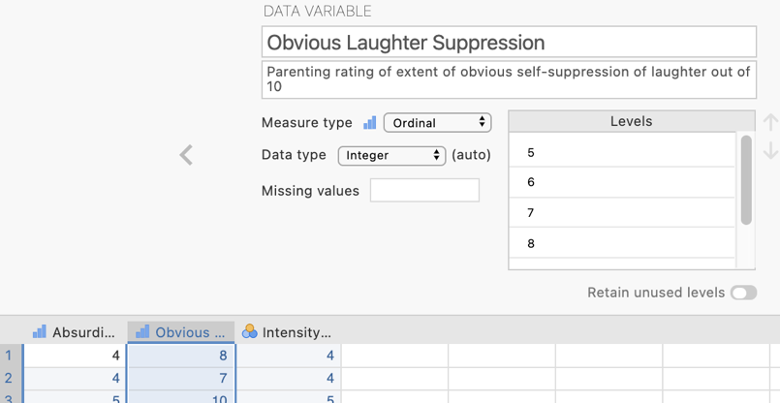

Step 2 – Installing the jamm – Advanced Mediation Models module

Base jamovi does not have the ability to run a mediation model so we will have to install one of the add-on modules from the jamovi library.
Click on the Modules icon in the right hand corner of the navigation window then click on jamovi library

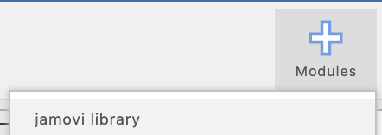
Go to the “Available” tab and scroll to the find the jamm module and click install
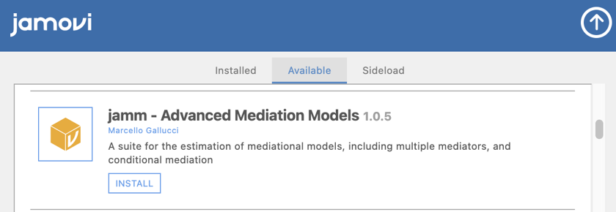
The Analyses ribbon should now have an extra module called “medmod” with a mediation diagram icon.
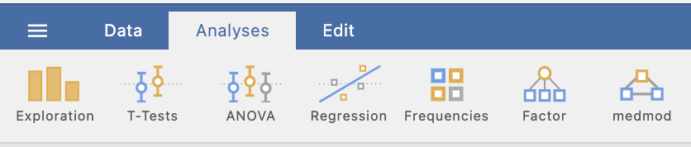

Step 3 – Navigating to the GLM Mediation Model menu
On the Analyses tab select the medmod menu, then select GLM Mediation Model

Step 4 – Selecting analysis options for the GLM Mediation Model

The first thing we need to do is specify the roles each of our variables are hypothesised to play in the mediation model. It is important to note that jamovi refers to continuous predictors as covariates and categorical predictors as factors so our independent variable (Absurdity of Tantrum Trigger) needs to go in the covariates slot. Intensity of Tantrum is our dependent variable and Obvious Laughter Suppression goes into the Mediators box.

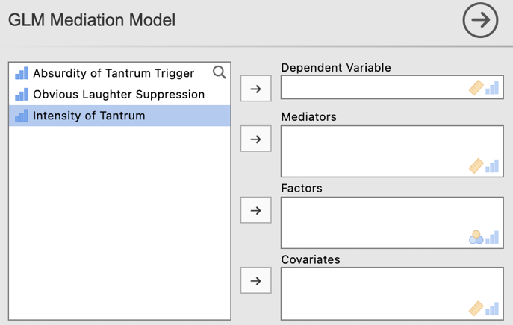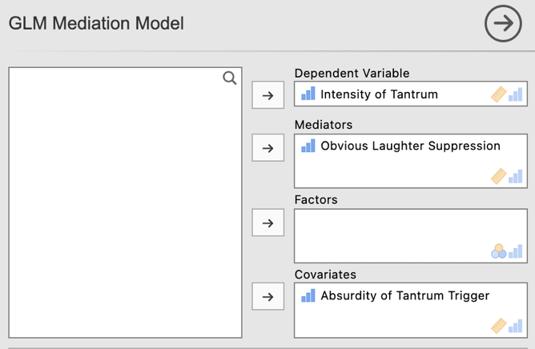

We only need to select options from one of the drop down menus, Mediation options.

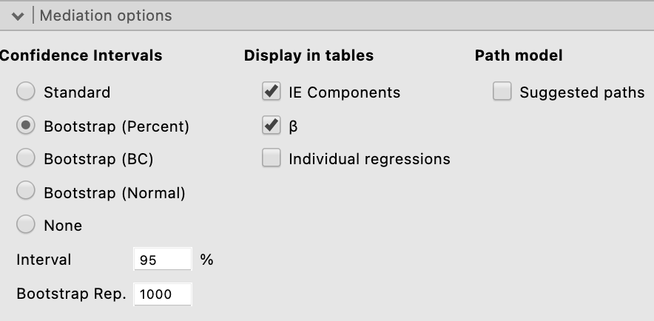
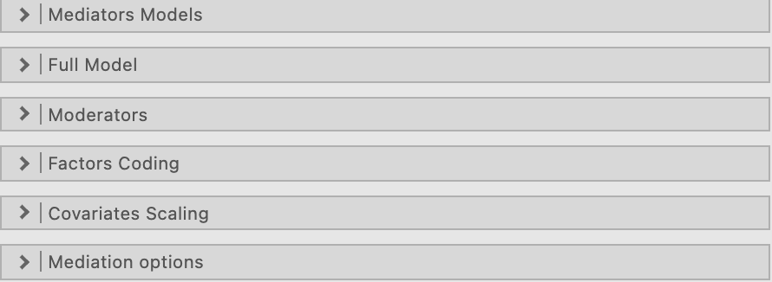

As the test of the indirect effect in a mediation model should be bootstrapped we will ask for Bootstrap (Percent) for our Confidence Intervals (note 1000 samples is the default here which we could change if desired). The remaining options we require will be selected as defaults. These are the IE (indirect effect) components (which will give us “a” and “b” path details) as well as $β$.

We get some orienting information about our model in the output and it is a good idea to check it over to ensure we have specified our model, and variable roles, correctly.

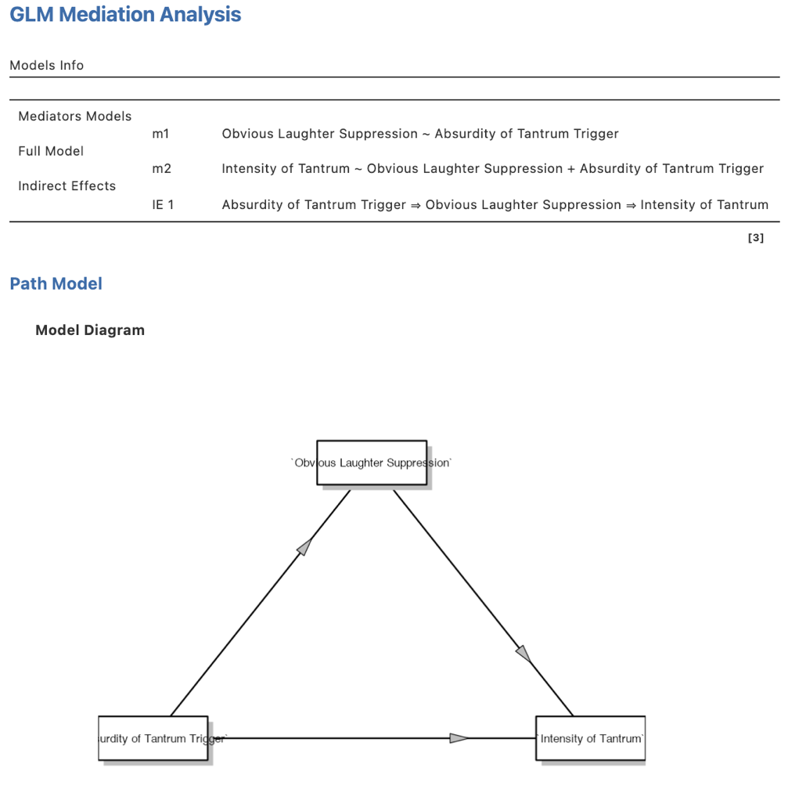
Models Info lays out the models required to assess the paths of our model.
The Model Diagram provided lays out our model in a traditional mediation diagram.

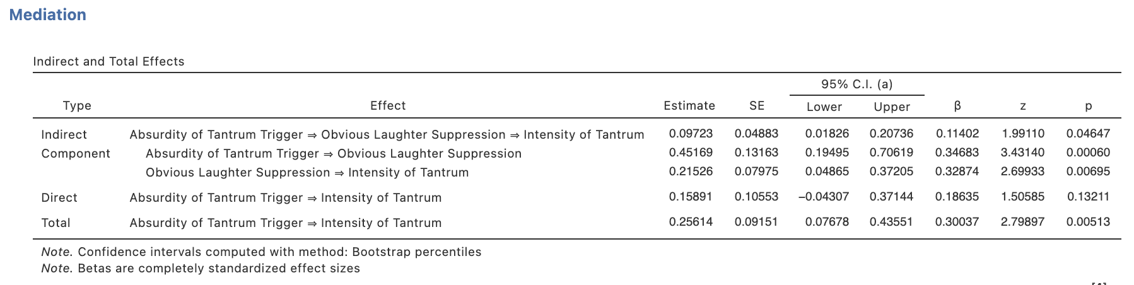
We can do some initial interpretation of results here.

C path (Total effect of IV on DV) is significant (p = .005)
A*B path (Indirect effect of IV on DV via M) is significant (p = .046) suggesting mediation is present.
C’ path (Direct effect of IV on DV) is not significant (p = .132) suggesting mediation is full rather than partial. Though this full vs partial delineation is no longer considered appropriate to report.
A path (IV to M) is significant (p = .001)
B path (M to DV) is significant (p =.007)

Step 5a – Obtaining some extra output required for our write up, Part 1

While we have some key elements to make a conclusion about whether there is support for the mediation hypothesis, there are a number of elements that are needed for reporting that are not provided in this output. We’ll need to run some regressions and semi-partial correlations for completeness of reporting.

Step 5b – Navigating to the Linear Regression menu.

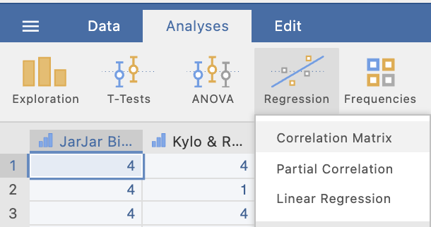
On the Analyses tab select the Regression menu, then select Linear Regression.

Step 5c – Selecting Linear Regression analysis options

There are two linear regression models we want to run to obtain key information for the full model as well as for the a, b, c and c’ pathways.

Model 1 – Path a from the Independent Variable to the Mediator

The first model will obtain pathway a information and has the independent variable as the predictor (in the covariates box) and the mediator in the dependent variable position. The default output we get from this is all we require.

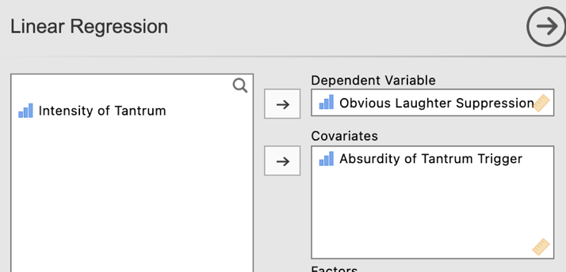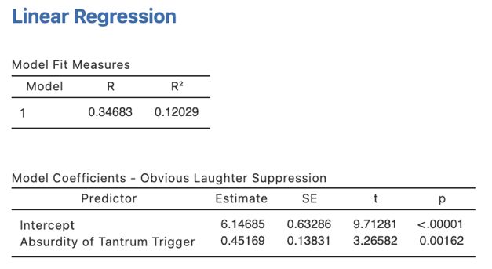

Model 2 – The Full Model predicting the Dependent Variable with the Independent Variable and the Mediator.

The second model we need to run will be the full model to obtain b, c, and c’ pathway information. This model has our dependent variable in the dependent variable position and the independent variable and mediator both in the covariates box.

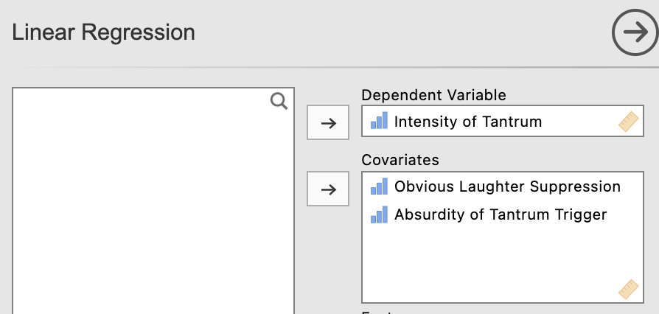

In order to obtain information about the c path we will need to make this model a hierarchical regression. We need the independent variable in the first block to obtain the c path information and then the mediator added into the second block which will then provide us our b and c’ path information.

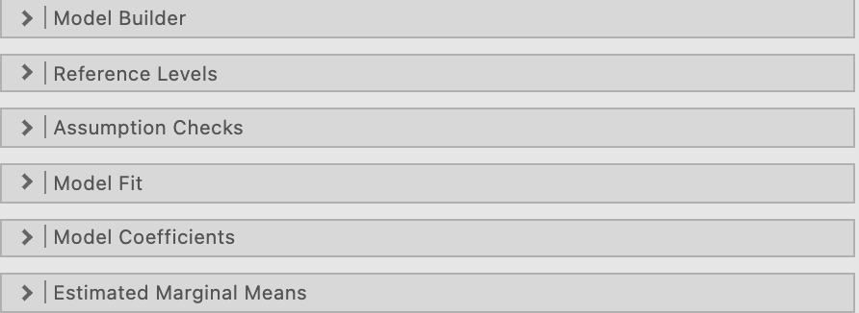
From the drop down lists we need to head into Model Builder and Model Fit.
You’ll see the model has been built as a standard one block multiple regression as a default. Click on “Add New Block.”
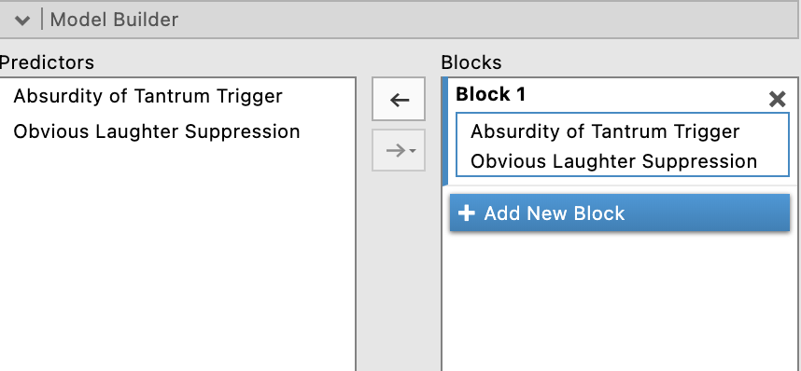

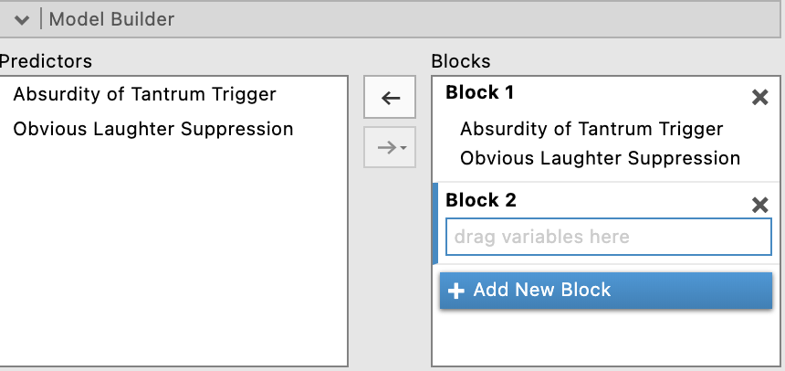
You’ll see we now have a “Block 2”. Drag our mediator, Obvious Laughter Suppression from Block 1 to Block 2.
You should now have Block 1 with our independent variable Absurdity of Tantrum Trigger and Block 2 as our mediator of Obvious Laughter Suppression.
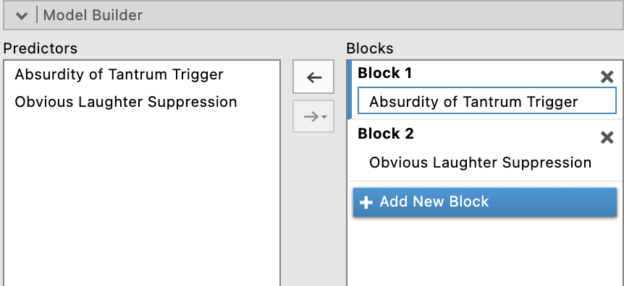

Under Model Fit, in addition to the R and R² already set as a default, we’ll ask for adjusted R² and the Overall Model F test.

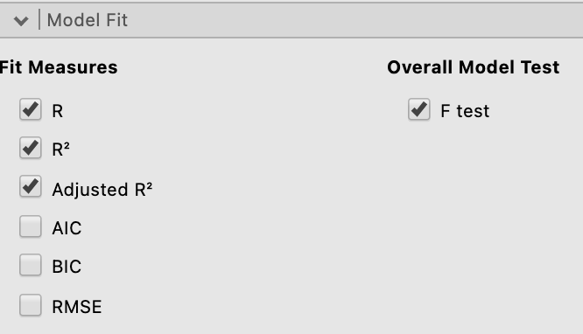

We now have all we need from this model for our reporting purposes.

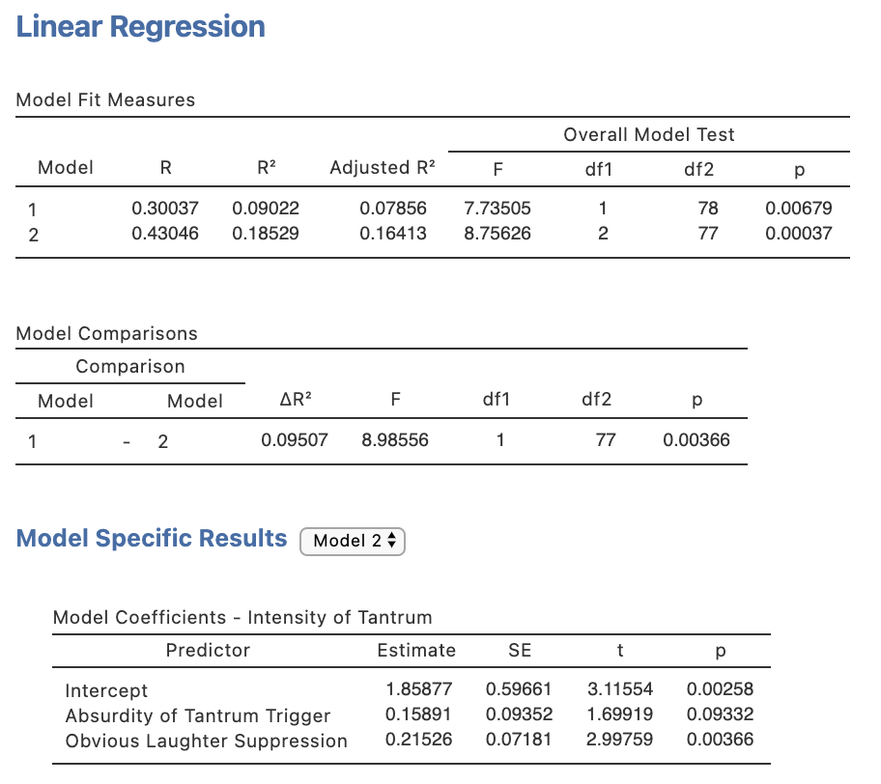
Step 6a – Obtaining some extra output required for our write up, Part 2

One key statistic that is conventionally reported with standard multiple regression results, namely squared semi-partial correlations, or r²_{a(b,c)}, are not available via the Linear Regression menu. To obtain these we need to run some further separate analysis.

Head to the Analyses ribbon, select Regression and then Partial Correlation

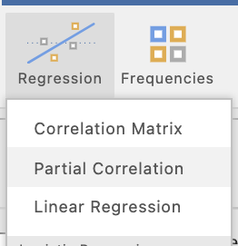
In the current jamovi set up for obtaining partial and semi-partial correlations (as at version 1.8.4) they need to be specified one at a time. In other words we need to specify a pair of variables to be correlated and which variables to use as control variables, or variables that will be partialled out of the calculations.

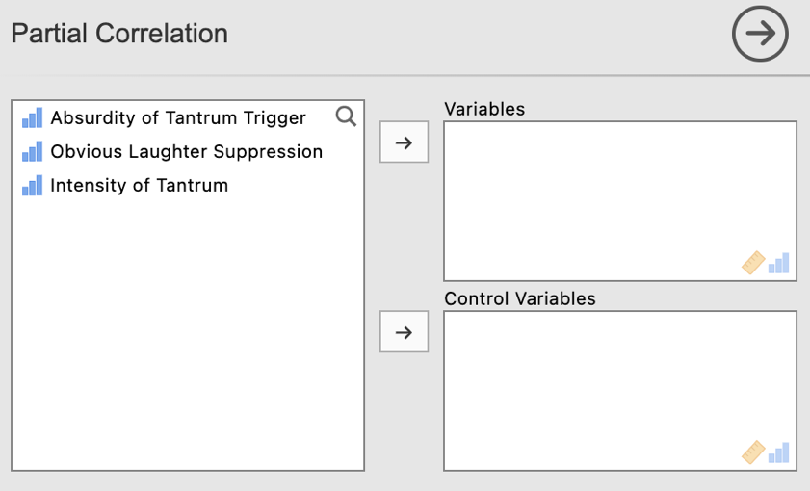

Before we start let’s make sure the options we need have been selected. The most important selection is to change the selection to “Semipartial” under Correlation Type as Partial is the default. Also untick “Report significance” under Additional Options to keep the output minimal and easy to interpret.

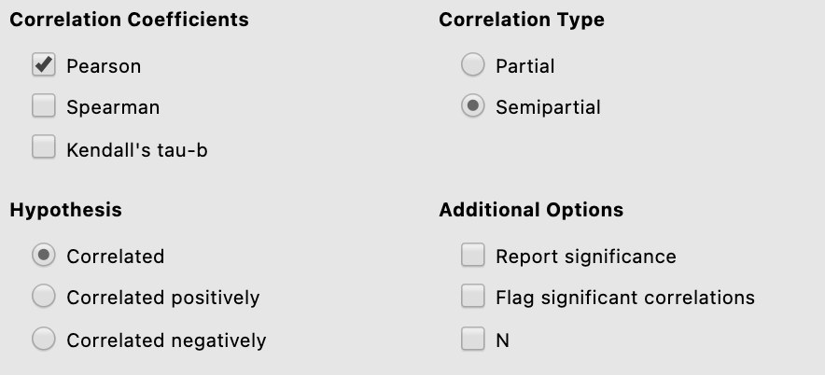

There are two semi-partial correlations we need to request. These are between our dependent variable Intensity of Tantrum and our independent and mediator variables, each time controlling for the other.

.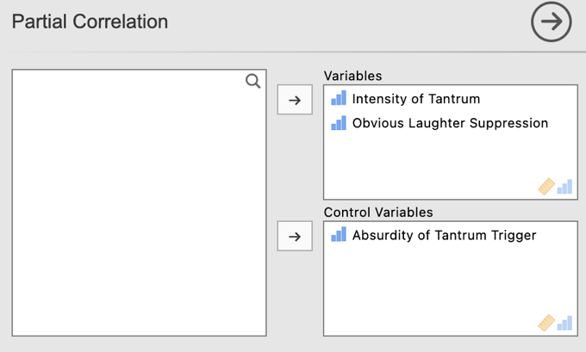 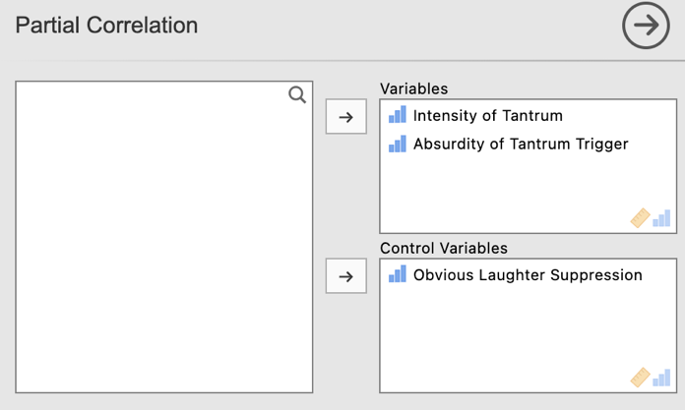

Note that after running each semi-partial correlation you will need to click underneath the output so that jamovi knows to create an additional output, rather than editing the one you just created. Jamovi will edit whichever output is currently highlighted in white. To ensure you get additional output rather than overwritten output ensure you have clicked underneath the output created and it has turned grey.

Our semi-partial correlation outputs obtained are below.

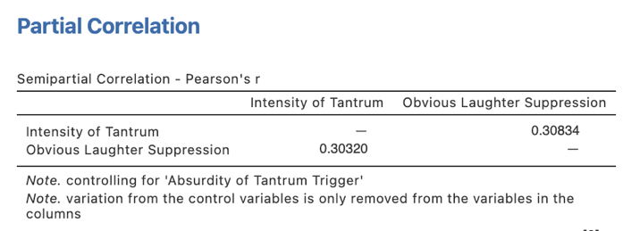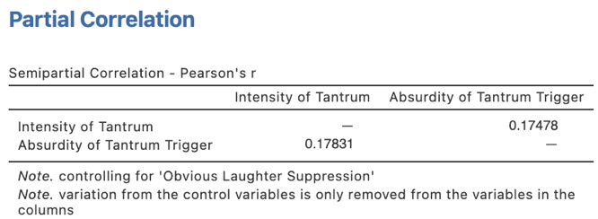

In each of these semi-partial correlation tables the coefficient we want is listed in the column heading with the predictor name of interest as circled on each.

For reporting we need to square these values.

Our r²_{a(b,c)} for Obvious Laughter Suppression will be .30834² = .095
Our r²_{a(b,c)} for Absurdity of Tantrum Trigger will be .17478² = .031

The statistic we need to report in our regression write up is the SQUARED semi-partial correlation. So each of these three semi-partial correlations need to be squared manually.

We finally have all the elements we need to write the full results for our mediation analysis.

Let’s get reporting.

Step 7 – Finding the components for reporting.

There are several key parts to a mediation analysis write up. These are a summary of the full model, an indication of support for mediation via discussion of the indirect effect, and a presentation of the pathways (often in a diagram). We’ll walk through these steps one at a time.

The Full Model:

We use Model 2 (explained in Step 5c) for this.

The components we need for the full model results are:
- The F statistic, dfs and p value – the omnibus ANOVA result for the full model
- Effect sizes in the form of R² and adjusted R².

The Write Up (Part 1):

Data from 80 parents were analysed to explore whether there was statistical support for the hypothesis that the relationship between the absurdity of tantrum trigger and intensity of tantrum in children aged two to three years is mediated by the degree of obvious suppressed laughter on the part of the parent. Within the full regression model 18.5%, R² = .19. Adj. R² = .16, of the variance ratings of tantrum intensity was explained by the combination of tantrum trigger absurdity and obvious parental laughter suppression. This represents a significant amount of variance explained, F (2, 77) = 8.76, p < .001.

Getting the parts for the Write Up (Part 2):

The next part is to address whether we have support for mediation in our model. For this we turn to the mediation results obtained via the jamm add-on module. Note we are going to include the statistical elements in a diagram so here we will simply describe the results and direct the readers’ attention to the Figure for more information.

The elements needed for this part of the write up are:

- Effect sizes in the form of Bs, and $β$s.
- Bootstrapped Confidence interval – around the unstandardised regression coefficients (B).

The Write Up (Part 2):

Using 1000 bootstrapped samples, the indirect effect was significant providing statistical support for the argument that mediation is present, B = 0.10, 95% BCp CI [0.02, 0.21], β = .11. Given that the direct effect of absurdity of tantrum trigger on intensity of tantrum is not significant the mediation present is partial and not full.

It is traditional in mediation write ups to provide a mediation model path diagram and incorporate the path statistics.

The elements needed for the unstandardised Figure are:

- Effect sizes in the form of Bs,
- Bootstrapped Confidence interval – around the unstandardised regression coefficients (B).

The Write Up (Part 3) – The Mediation Model Diagram:

Figures 1 below provides a visual representation of the various pathways of the mediation model.

Figure 1
Unstandardised Regression Coefficients for the Relationship Between Absurdity of Tantrum Trigger and Tantrum Intensity as Mediated by Obvious Suppression of Parental Laughter

Obvious Laughter Suppression

Path b: B = 0.22, 95% BSp CI [0.05, 0.37]
Path a: B = 0.45, 95% BSp CI [0.19, 71]

Total Path c: B = 0.26, 95% BSp CI [0.08, 0.44]
Intensity of tantrum
Absurdity of Tantrum Trigger
Direct Path c’: B = 0.16, 95% BSp CI [-0.04, 0.37]

Indirect Path a*b: B = 0.10, 95% BSp CI [0.02, 0.21]

Note. CI = Confidence interval, BSp = Bootstrapped percentile method

Bonus Option – You could also or alternatively use standardised coefficients for the mediation diagram. The r²s and r²_{a(b,c)} have been obtained from the regression outputs on pages 5 to 9.

Figure 2

Standardised Regression Coefficients and Squared Correlation Effect Sizes for the Relationship Between Absurdity of Tantrum Trigger and Tantrum Intensity as Mediated by Obvious Suppression of Parental Laughter

Obvious Laughter Suppression

Path b: $β$ = .33**, r²_{a(b,c)} = .095
Path a: $β$ = .35**, r² = .120

Total Path c: $β$ = .30**, r² = .090
Intensity of tantrum
Absurdity of Tantrum Trigger
Direct Path c’: $β$ = .19, r²_{a(b,c)} = .031

Indirect Path a*b: $β$ = .11*, r_{med}² = .059

* p < .05, ** p < .01, *** p < .001

Created by Janine Lurie in consultation with the Statistics Working Group within the School of Psychology, University of Queensland

Based on jamovi v.1.8.4

The Statistics Working Group was formed in November 2020 to review the use of statistical packages in teaching across the core undergraduate statistics unit. The working group is led by Winnifred Louis and Philip Grove, with contributions from Timothy Ballard, Stefanie Becker, Jo Brown, Jenny Burt, Nathan Evans, Mark Horswill, David Sewell, Eric Vanman, Bill von Hippel, Courtney von Hippel, Zoe Walter, and Brendan Zietsch.
The jamovi project (2021). jamovi (Version 1.8.4) [Computer Software]. Retrieved from https://www.jamovi.org

