Star Wars is a much beloved franchise. Some characters and plots however are more beloved than others by the fan base. A researcher decided to conduct a quick social media poll on the level of agreement with a number of Star Wars opinions known to have varying levels of acceptance or incredulity to die-hard fans. She was particularly interested in whether people are likely to hold multiple unpopular beliefs and so decided to run some correlations to investigate the strength of relationship between four Star Wars opinions. A total of 100 survey respondents rated their agreement with these beliefs on a 5-point scale where 1 is strongly disagree and 5 is strongly agree.

The Star Wars opinions rated were:
- JarJar Binks is awesome.
- The Kylo Ren and Rey romance makes sense.
- Han and Chewie rock.
- Boba Fett is over-rated.

When exploring her data the researcher discovered that all four variables deviated significantly from a normal distribution. To examine the correlations between the Star Wars opinions she decided to run non-parametric Spearman’s correlation analyses.

Step 1 – Taking a look at the data.
Our four variables have been specified as ordinal variables in Measure type. The anchor points of the likert scale (1 = strongly disagree, 5 = strongly agree) have also been entered

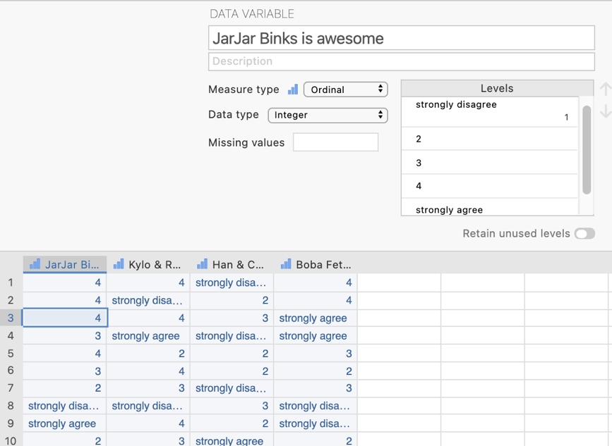
In the data spreadsheet are four columns of data representing the agreement ratings given to each of the four Star Wars opinions. Each row represents a person who has rated each of the four opinions.

Step 2 – Navigating to the correlation analysis menu.

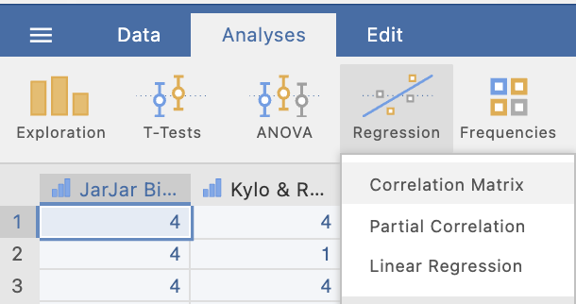
On the Analyses tab select the Regression menu, then select Correlation Matrix.
Step 3 – Selecting analysis options

In order to obtain our correlations results we need to shift our variables across from the left hand box to the right hand box in the analysis options panel.

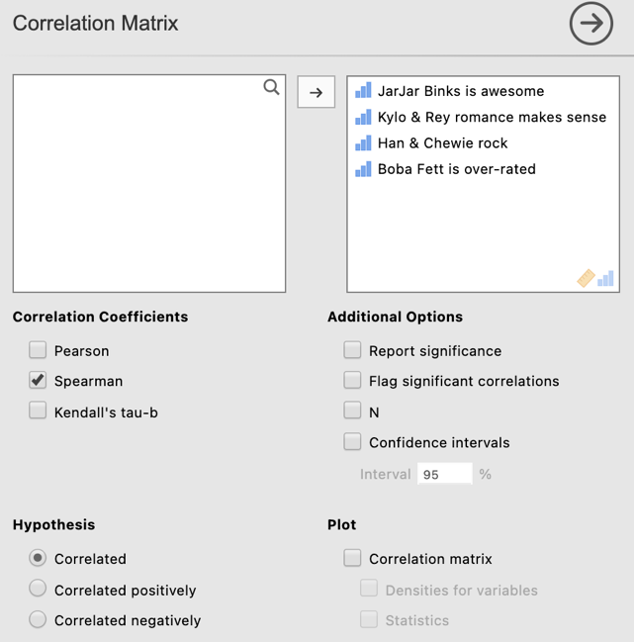
We would need to shift a minimum of two variables across to obtain a correlation. In this case we will shift all four variables across to obtain correlations between all four of our Star Wars opinions.

You’ll notice that as a default Pearson’s correlation coefficients are selected. We need to change this to Spearman’s correlations.

Report significance is also selected as a default. For this walk through we will untick this option and focus on the correlation coefficients themselves.

Having moved our four variables across to the right side box we get the following output. We have a correlation matrix showing how agreement levels with each of our four Star Wars opinions correlate with each other.

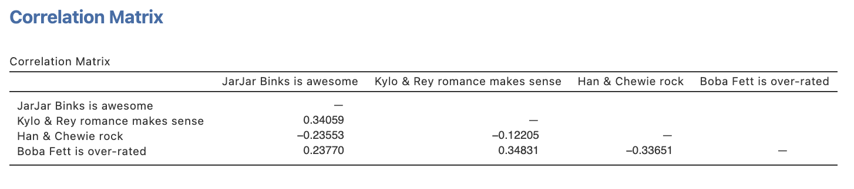
A correlation matrix provides us with a grid like table that sets out how each variable in the table or matrix correlates with the others.
Circled above is the Spearman’s correlation coefficient for the correlation between agreement that JarJar Binks is awesome and that the Kylo Ren and Rey romance makes sense. The correlation coefficient is .34 indicating a moderate positive correlation between agreement with the two opinions.

Step 4 – Finding the components for reporting.

The Write Ups:

- An example single correlation coefficient write up

A sample of 100 respondents rated their level of agreement with the generally unpopular opinions that JarJar Binks is awesome and the Kylo Ren and Rey romance makes sense within the Star Wars franchise. A Spearman’s correlation coefficient was computed and revealed a moderate positive relationship between agreement with the two opinions suggesting they are more than likely to be jointly held, r_{s} = .43.

- An example summary write up of all relationships presented in the correlation matrix

A sample of 100 respondents rated their level of agreement with several unpopular opinions (JarJar Binks is awesome, the Kylo Ren and Rey romance makes sense and Boba Fett is over-rated) and a generally accepted opinion (Han and Chewie rock) within the Star Wars franchise. When analysed via Spearman’s correlation analysis, agreement with the generally accepted opinion that Han and Chewie rock was found to negatively correlate with the three unpopular opinions, with correlations ranging from -.12 to -.34. The three generally unpopular opinions all correlated significantly with each other and were found to be positively related, with correlations ranging from .23 to .45, suggesting they are likely to be jointly held.

Created by Janine Lurie in consultation with the Statistics Working Group within the School of Psychology, University of Queensland

Based on jamovi v.1.8.4

The Statistics Working Group was formed in November 2020 to review the use of statistical packages in teaching across the core undergraduate statistics unit. The working group is led by Winnifred Louis and Philip Grove, with contributions from Timothy Ballard, Stefanie Becker, Jo Brown, Jenny Burt, Nathan Evans, Mark Horswill, David Sewell, Eric Vanman, Bill von Hippel, Courtney von Hippel, Zoe Walter, and Brendan Zietsch.
The jamovi project (2021). jamovi (Version 1.8.4) [Computer Software]. Retrieved from https://www.jamovi.org

