Outlander is an historical/science fiction/time travel television series about a woman who is transported back in time from 1945 to 1743 in Scotland and the lives she leads in both time periods. The television series is based on a book series by author Diana Gabaldon. Let’s pretend that executives at Netflix were debating whether to make the next season available all at once, or whether to continue with their existing plan of releasing episodes one at a time. They commissioned a researcher to conduct a study into whether enjoyment of the series is affected by the way in which viewers choose to watch the show. The executives were interested in whether viewers seemed to enjoy the show more if they were able to stream all the episodes all at once, and hence choose to binge-watch the show, or whether releasing episodes one at a time, hence prolonging anticipation, was associated with greater enjoyment. They were additionally interested in whether having read the Diana Gabaldon books prior to watching the television series had any impact. The researcher recruited 30 people who had not watched Outlander before and randomly allocated them into three separate groups. One group were only allowed to watch one episode per week. The second group watched several episodes in one sitting but ultimately got through the season in multiple sittings. The third and final group watched the entire season in one sitting. The researcher also randomly allocated half of the participants to read the book before watching the season.

Step 1 – Taking a look at the data.

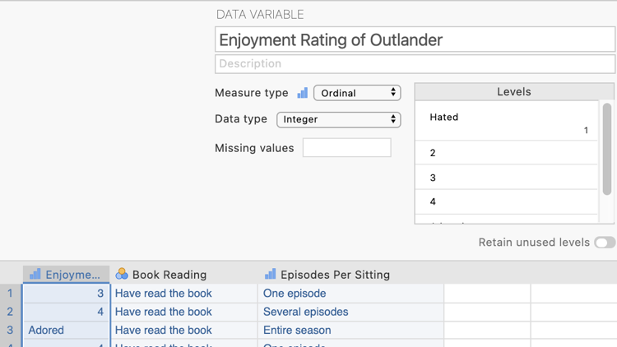
Our dependent variable “Enjoyment Rating of Outlander” has been specified as an ordinal variable in Measure type and is the first column of data. This variable is rated on a 5-point Likert scale from 1 “Hated” to 5 “Adored.”
N.B., While a Likert scale is technically ordinal, in psychology we commonly treat Likert scale variables as continuous for analysis purposes. In an ANOVA our dependent variable should be continuous.

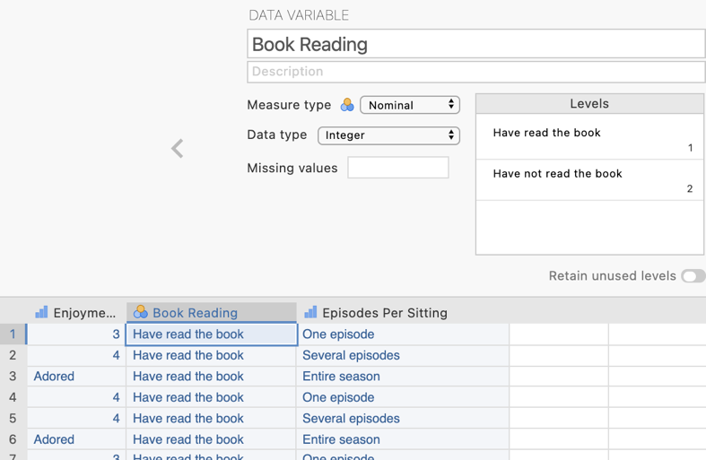
In the second column of our data spreadsheet we have a variable “Book Reading” which indicates whether the participant was randomly allocated to read the Diana Gabaldon book. The measure type has been set as nominal. There are two groups: have read the book or have not read the book.
In the third column of our data spreadsheet we have a variable “Episodes Per Sitting” which tells jamovi which viewing group the participants are in. The measure type has been set as ordinal. There are three groups as created by the researcher. In an ANOVA our independent variable can be ordinal or nominal.
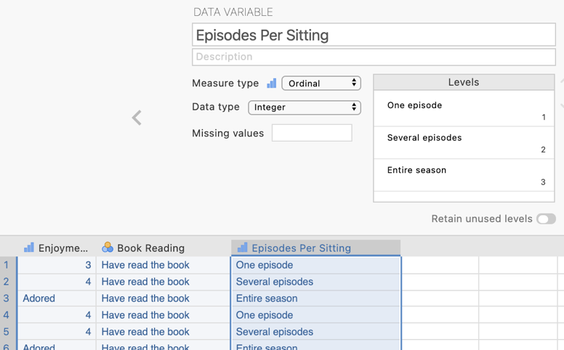

Step 2 – Navigating to the ANOVA analysis menu.

On the Analyses tab select the ANOVA menu, then select ANOVA.

Step 3 – Selecting analysis options to get the output we need for our omnibus test results.

The first thing we will do is specify our dependent and independent variables.

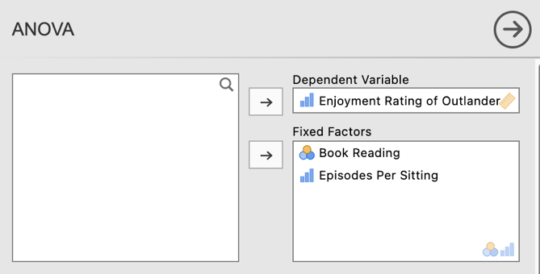
We need to move Enjoyment Rating of Outlander to the Dependent Variables box and Episodes Per Sitting and Book Reading to the Fixed Factors box. This tells jamovi we want to compare enjoyment rating means across the combinations of viewing modes and book reading.

Moving our IV and DV into place gives us our initial ANOVA result.
In our ANOVA table we have three F statistics. Two for the main effects of Booking Reading and Episodes Per Sitting, and one for the Booking Reading X Episodes Per Sitting interaction.

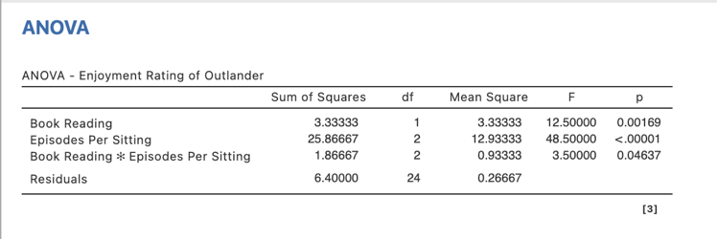
Our p values here are all less than .05. This means we have a significant Book Reading main effect, a significant Episodes Per Sitting main effect, and a significant Reading X Episodes Per Sitting interaction. We’ll need to do some further digging to uncover the specific source and pattern of these significant effects.

We can also ask for effect sizes for our ANOVA under where we specify our variables for the analysis.
You can select between $η$², $η_{p}^{2}$ and $ω$². We’ll ask for all three so we can compare them.

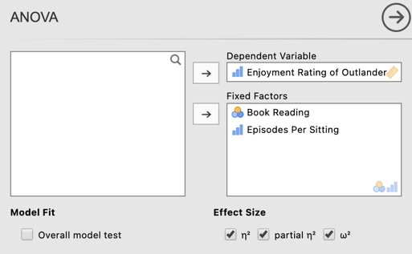
You can see that we now have the three effect sizes we requested added into our ANOVA model table. As expected $η_{p}^{2}$ is much larger than the other two. This is because $η_{p}^{2}$ is based on the proportion of variance explained in the residual DV variance. Both $η$² and $ω$² reflect the proportion of total DV variance explained, with $ω$² adjusted downwards as a population effect size estimate.

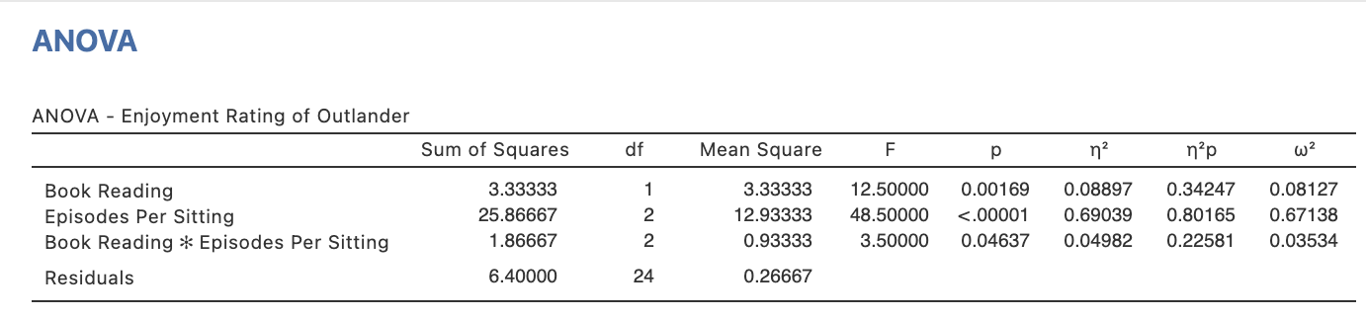

We need to ask for some additional statistics and visual aids to add to our interpretation and write up of the results. There are many options organised under five tabs as can be seen below. For our purposes we only need to use the Post Hoc Tests and the Estimated Marginal Means tabs.

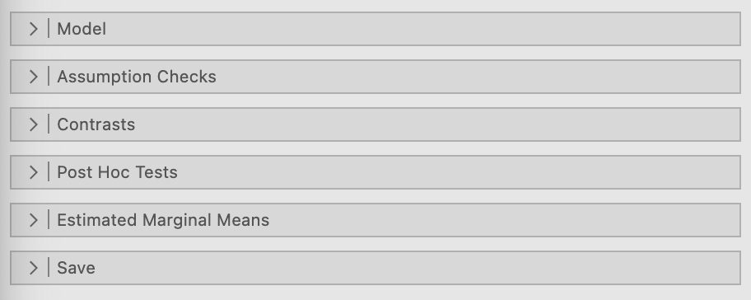

Step 4 – Following up significant main effects with main effect comparisons

Let’s walk through how to follow up a significant main effect with main effect comparisons when we have three or more levels of the main effect IV.

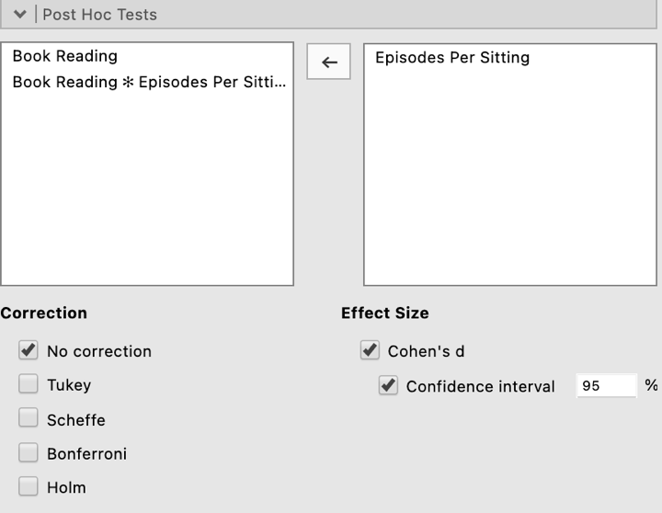
Under the Post Hoc Tests tab you will see the two main effects and an interaction term (the one with the asterisk in it) listed.

To obtain post hoc comparisons for any main effect or interaction you need to move the relevant IV across to the right hand side. Here we will move Episodes Per Sitting across as it is the IV with three levels.

Ensure that “No correction” is selected as we will report unadjusted post hoc comparisons.

Finally, ask for Cohen’s d effect sizes for our post hocs as well as their associated confidence intervals.

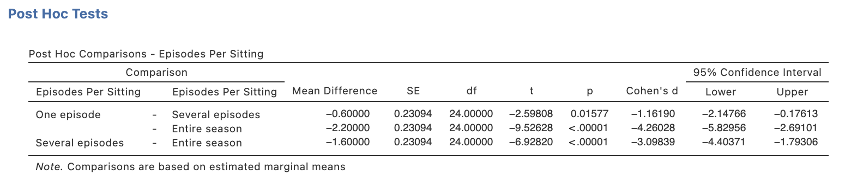

As we don’t obtain the standard deviations or marginal means that these post hoc comparisons are based on, we’ll quickly run some descriptives to get these elements for use with our write up later. Head to Descriptives under Exploration in the Analyses tab.
Under the “Statistics” drop down menu the three things we require are the Sample Size N, the mean as our Central Tendency measure and the standard deviation as our measure of dispersion. Untick all additional options and ensure just these three are selected to keep our output focussed on what we need.
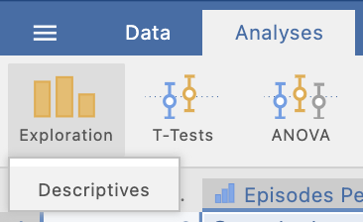
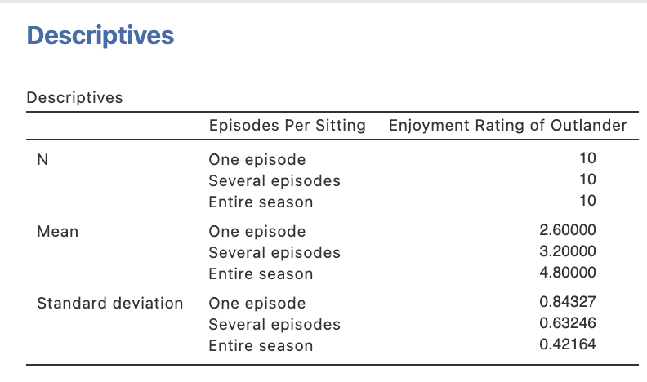
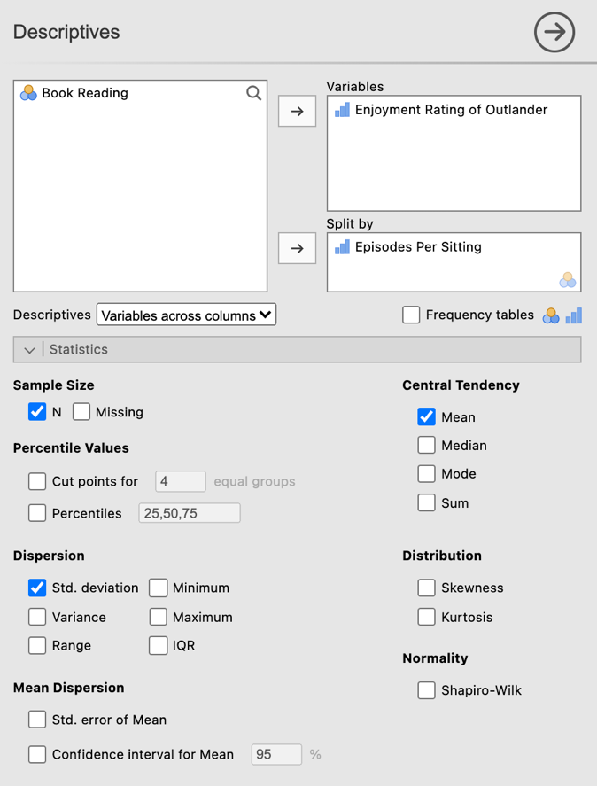
Here are the marginal means (the means associated with each viewing mode, collapsed across Book Reading levels) and their associated standard deviations. We’ll come back to these when reporting our results.

Step 5a – Following up significant interactions with simple effects

When we obtain a significant interaction the first thing we need to do is check the simple effects. In our case we are going to consider the simple effects of viewing mode when participants had read the Diana Gabaldon book and when they hadn’t (the two levels of the second IV book reading).

Within the ANOVA menus that are part of the base jamovi program, simple effects are not currently an option that can be requested (as at v. 1.6.12). However jamovi has a range of add on modules that can be activated which expand the analysis options available. One of these, the General Analyses for Linear Models in jamovi, or gamlj module, will allow us to obtain our simple effects.
In order to install an add on module you need to click on the addition icon in the top right hand corner of your jamovi window.
Go to the library tab, and scroll to find the gamlj module and click to install it.

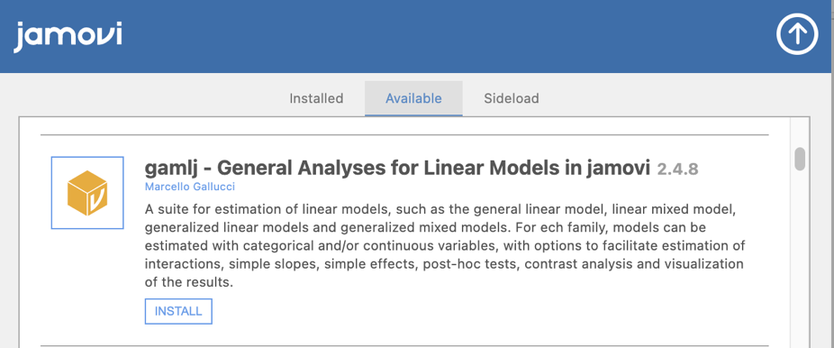

You will now see that you have an additional option on your Analyses toolbar called Linear Models.

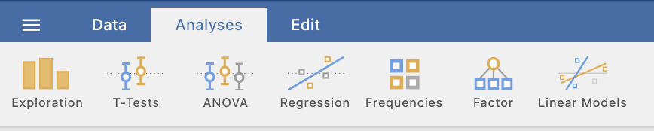

Click on Linear Models and then select General Linear Model.

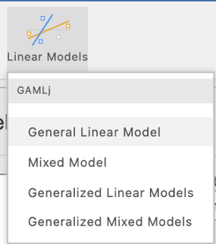

You’ll see a familiar layout to specify your DV and IV. Shift the DV and two IVs across to the Dependent Variable and Factors boxes as you did in the ANOVA menu before.

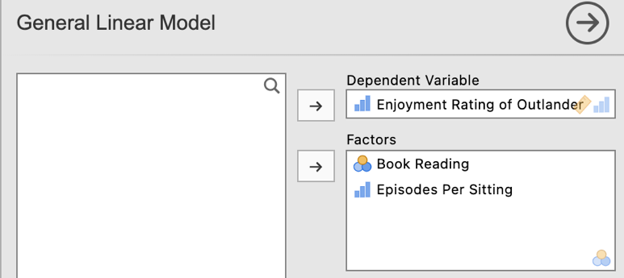

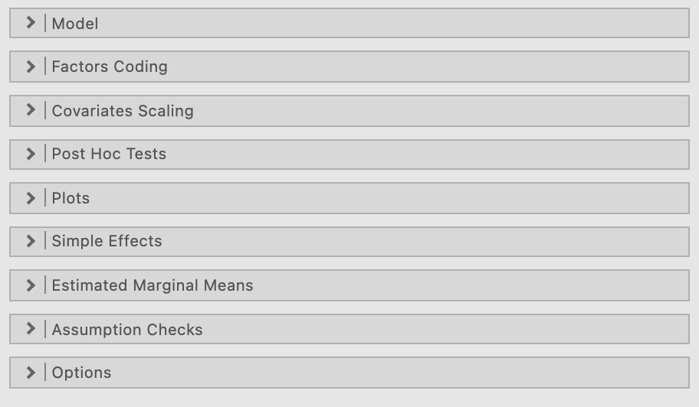
As we want to explore the simple effects of Episodes Per Sitting we move it across to the “Simple effects variable” slot.

Our Book Reading IV then moves across to the “Moderator” slot.

The “Breaking variable” slot would be of use if we had a third IV and were exploring a three way interaction.

In order to obtain our simple effects go to the Simple Effects drop down menu.

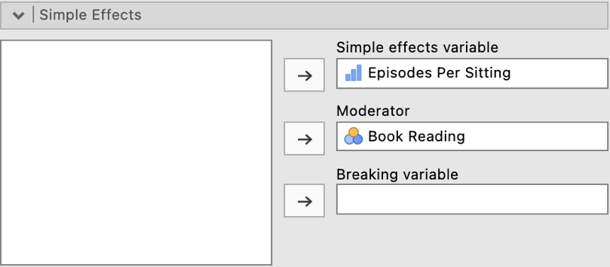

The table we are interested in in the output is the one illustrated below.

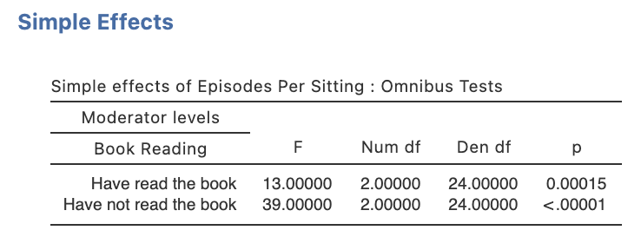
It seems the simple effect of viewing mode is significant when the book has been read and when it hasn’t been as both simple effect p values are less than .05. So we will need to explore the simple comparisons underneath each of these two simple effects.

N.B., Ideally we would also obtain an effect size for these simple effects in the form of $η$² , however there is currently no option to obtain this in jamovi (as at v. 1.8.4)

Step 5b – Following up significant simple effects with simple comparisons

To obtain our simple comparisons we can return to our ANOVA Post Hoc Tests output. This time we are going to move the interaction term across to the right hand side.

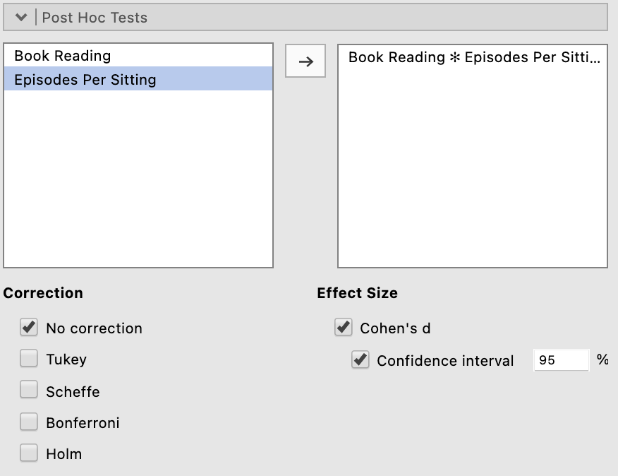

Now we are given a very large table with simple comparisons.

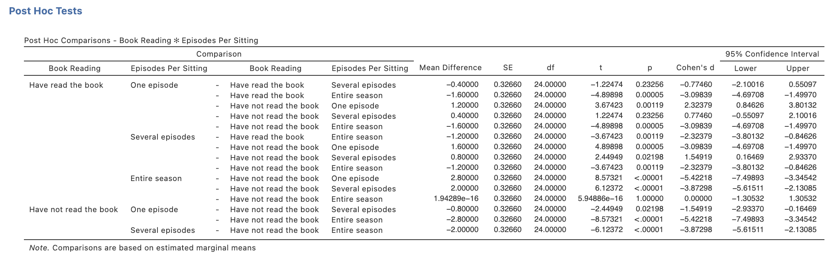

We’ll ask for descriptives to obtain our means and standard deviations for these simple comparisons.

On the Analyses tab select the Exploration menu, then select Descriptives.

Move the dependent variable, Enjoyment Rating of Outlander to the “Variables” box
and the independent variables Episodes Per Sitting and Book Reading to “Split by”

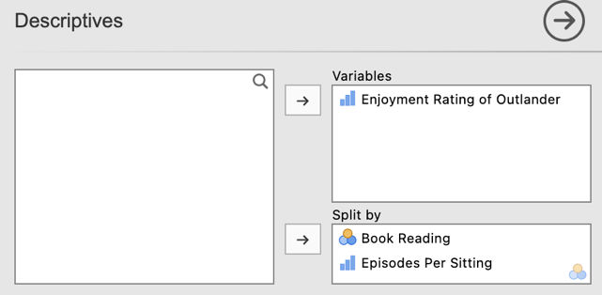

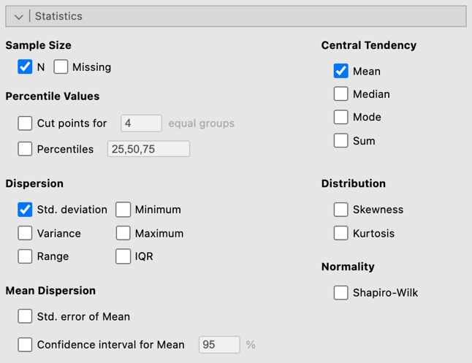
As we did before, under the “Statistics” drop down menu ensure just Sample Size N, the mean and standard deviation are selected and untick all other options to keep our output neat.

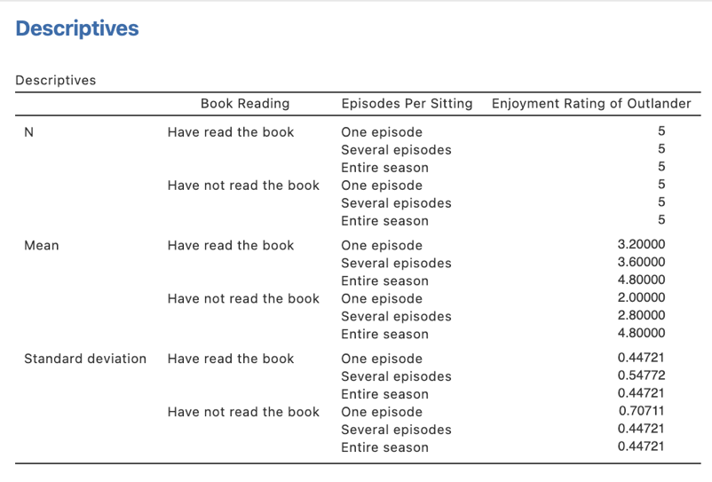
Here we have the means and standard deviations (and n for each group) that form the basis of our simple effects and simple comparisons.

Step 6 – Obtaining a plot to help us illustrate our interaction

The Estimated Marginal Means tab gives us options to obtain a plot to illustrate our results.

We can ask for plots to illustrate either of our main effects or our interaction. As our interaction is significant we’ll create a plot to help illustrate the interaction effect.

Firstly we need to move both our IVs, Episodes Per Sitting and Book Reading, under the “Term 1” heading in the Marginal Means box on the right hand side like this. Note that whichever IV we place at the top of the listed variables under “Term 1” will be the IV whose simple effect is plotted and the second IV in the list will be the IV represented by different lines (i.e., our moderator). In our example we want to see the simple effects of Episodes Per Sitting so it appears at the top of the list followed by Book Reading under Term 1 in the Marking Means box.

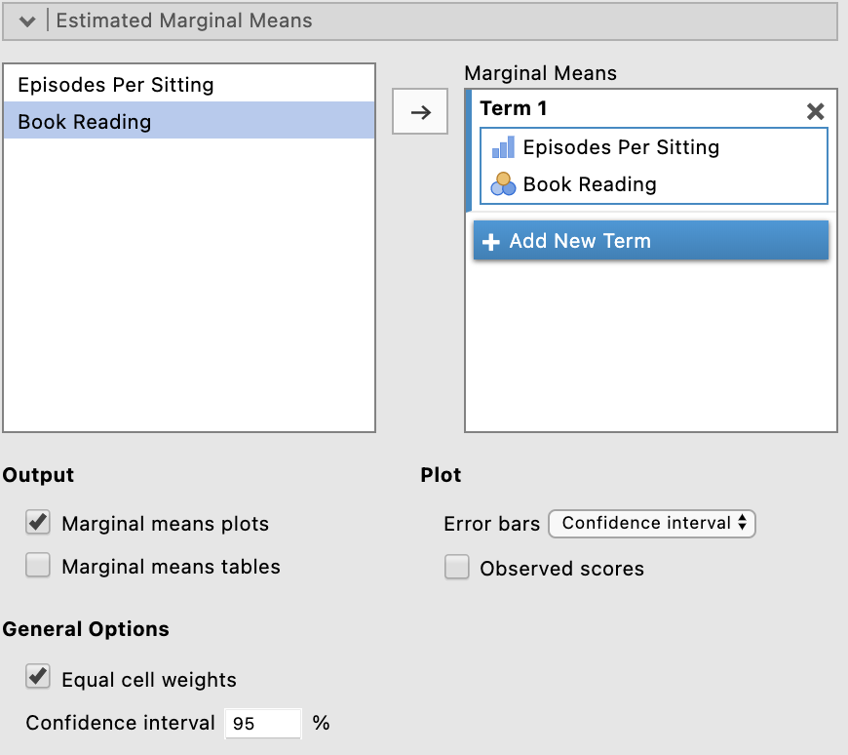

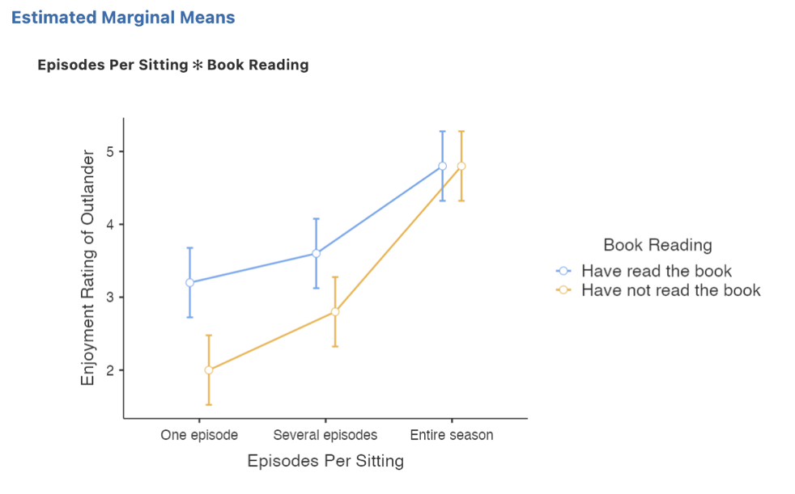
Here we have created an interaction plot that illustrates the simple effects of Episodes Per Sitting when the book has been read and not read.
Step 7a – Finding the components for reporting the omnibus results

We’ve now run all the things we need to write up our two-way between groups ANOVA results, complete with follow ups for a significant main effect or interaction. Let’s pull it all together.

Firstly, let’s report our omnibus results.

The components we obtain here are:
- The F statistic, dfs and p value – the omnibus ANOVA results for the main effects and interaction
- An effect size in the form of$η$² for the main effects and interaction.

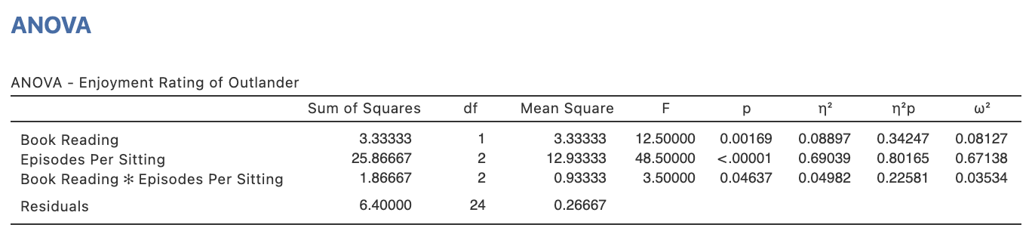

The Write Up (Part 1):

A two-way between groups factorial ANOVA was conducted to explore the potential main and interactive effects of Book Reading (Have read the book, Have not read the book) and Viewing Mode (One episode per week, Several episodes over multiple settings, All episodes in one sitting) on ratings of enjoyment of the Outlander television series in a sample of 30 participants. The main effects of Book Reading, F(1,24) = 12.50, p = .002, $η$² = .09, and Viewing Mode, F(2,24) = 48.50, p <.001, $η$² = .69, were both significant, however both main effects are qualified by a significant Book Reading x Viewing Mode interaction, F(2,24) = 3.50, p = .046, $η$² = .05.

Step 7b – Finding the components for reporting main effect comparisons to follow a significant main effect.

Next we’ll consider how you would write up the results of a main effect comparisons. Note you would not normally do this when you have a significant interaction but we will present them here for completeness of this teaching resource.

The elements needed for the main effect comparisons part of our write up are:

- Post hoc comparison results – to determine which marginal means are significant from each other. It is sufficient to report the p value for this.
- An effect size for each post hoc comparison in the form of Cohen’s d and associated confidence intervals.
- Marginal Means and standard deviations – to help describe the pattern of these differences.

The continuation of the write up (if only a main effect was obtained) could go as follows:

The Write Up (Part 2):

Unadjusted main effect comparisons revealed significant differences between each viewing mode with enjoyment ratings when the entire season was watched in one sitting (M = 4.80, SD = 0.42), significantly higher than when viewed in several multi-episode sittings (M = 3.20, SD = 0.63, p = .016, d = 1.16, 95% CI [0.18, 2.15]) which in turn yielded significantly higher enjoyment ratings than viewing one episode at a time (M = 2.30, SD = 1.25, p < .001, d = 3.10, 95% CI [1.79, 4.40]).

Step 7c – Finding the components for reporting the simple effects to follow a significant interaction.

The next step after reporting a significant interaction is to report the results of the simple effects. For our example we are going to report the simple effects of Episodes Per Sitting at different levels of Book Reading.

The components we obtain here are:
- The F statistic, dfs and p value – the omnibus ANOVA results for each simple effect.
- Note that ideally we would also report an effect size in the form of$η$² for each simple effect, however these are currently not produced by jamovi (as at v. 1.8.4)

For this we turn to the Simple Effects output we created via the gamlj add on module.

The Write Up (Part 3):

The simple effects of Viewing Mode when participants had read the Diana Gabaldon book, F(2,24) = 13.00, p < .001, $η$² = .XX, and when participants had not read the book, F(2,24) = 39.00, p <.001, $η$² = .XX, were both significant.

Step 7d – Finding the components for reporting the simple comparisons to follow a significant simple effect.

The final elements to report are the simple comparisons that underpin the significant simple effects noted above.

For these we need to refer to the cell mean descriptives we asked for earlier as well as the post hoc output for the interaction obtained within the ANOVA analysis.

The elements needed for the simple comparisons part of our write up are:

- Post hoc comparison results – to determine which cell means are significant from each other. It is sufficient to report the p value for this.
- An effect size for each post hoc comparison in the form of Cohen’s d and its associated confidence intervals.
- Cell Means and standard deviations – to help describe the pattern of these differences.

You need to have your wits about you when viewing the Post Hoc Tests table for the simple comparisons. Think about the simple effects you are following up and which comparisons are necessary to achieve this.

The Write Up (Part 4):

Unadjusted simple comparisons were conducted to follow up the simple effects of Viewing Mode at both levels of Book Reading. When participants had read the Outlander book, watching the entire season in one sitting (M = 4.80, SD = 0.45) was associated with significantly higher enjoyment ratings than viewing in several multi-episode sittings (M = 3.60, SD = 0.55, p < .001, d = 2.32, 95% CI [0.85, 3.80]) and watching one episode per week (M = 3.20, SD = 0.45, p < .001, d = 3.10, 95% CI [1.50, 4.70]), however there was no significant differentiation in enjoyment ratings between the one or several episode per sitting viewing modes (p = .233, d = 0.77, 95% CI [-0.55, 2.10]). However, when participants had not read the Outlander book prior to viewing, there were significant increments in enjoyment ratings with every increase in viewing mode, with those watching the season in one sitting (M = 2.00, SD = 0.77), rating their enjoyment significantly higher than those who viewed in several multi-episode sittings (M = 2.80, SD = 0.45, p = .022, d = 1.55, 95% CI [0.16, 2.93]) which in turn yielded significantly higher enjoyment ratings than viewing one episode at a time (M = 4.80, SD = 0.45, p < .001, d = 3.88, 95% CI [2.13, 5.62]).

Potential addition of plot:

You could also add the plot we obtained to help illustrate the pattern of results. You might add a sentence like the following if you choose to include the plot:

Figure 1 provides a visual of the interaction and associated simple effects and comparisons discussed above..

Figure 1

Differences in Enjoyment Ratings of the Outlander Television Series by Viewing Mode and Book Reading

Note. Error bars represent 95% confidence intervals.

Created by Janine Lurie in consultation with the Statistics Working Group within the School of Psychology, University of Queensland

Based on jamovi v.1.8.4

Further information about the Outlander television and book series can be found at https://en.wikipedia.org/wiki/Outlander_(TV_series)#Production.
The Statistics Working Group was formed in November 2020 to review the use of statistical packages in teaching across the core undergraduate statistics unit. The working group is led by Winnifred Louis and Philip Grove, with contributions from Timothy Ballard, Stefanie Becker, Jo Brown, Jenny Burt, Nathan Evans, Mark Horswill, David Sewell, Eric Vanman, Bill von Hippel, Courtney von Hippel, Zoe Walter, and Brendan Zietsch.
The jamovi project (2021). jamovi (Version 1.8.4) [Computer Software]. Retrieved from https://www.jamovi.org

