The work of medical entomologist Bart Knols revealed that a species of mosquito known for its penchant for sucking blood from people’s feet and ankles also quite likes the stinky German cheese, Limberger. Bemused by this discovery upon watching Dr Knols’ TED talk, a researcher decides to try to extend this research by assessing mosquito preferences for a range of stinky cheeses in the hopes of finding the ultimate cheese mosquito magnet. The researcher captures 10 mosquitoes and releases them one by one into four sealed plastic boxes, each containing four different cheese varieties for 30 seconds. Sensors built into the boxes record the amount of time each mosquito spends within a 1cm radius of the cheeses. Originally the testing was conducted with the cheeses fresh from the refrigerator. Having collected all the data and returning to the room with the cheeses still on the bench in the lab, the researcher realises that the cheeses are now much more pungent having reached room temperature. He rolls his eyes in frustration with himself and resolves to repeat the entire experiment with 10 new mosquitoes and a well thought out experiment to ensure his next data set will not have to be abandoned. The order in which each mosquito experiences each cheese and its temperature are completely randomised to control for any carry over effects. “For Science!” he exclaims as he tediously exposes each mosquito to each cheesy temperature varying condition with a clothes peg on his nose. A two-way repeated measures ANOVA is now needed to determine if there are significant main effects for Stinky Cheese Variety or Temperature, and/or if there is a Stinky Cheese Variety x Temperature interaction when determining which cheese is most attractive to mosquitoes and our researcher waits with bated breath (which is difficult with a clothes peg on your nose) for the much anticipated results.

Step 1 – Taking a look at the data.

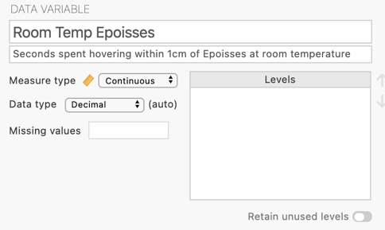
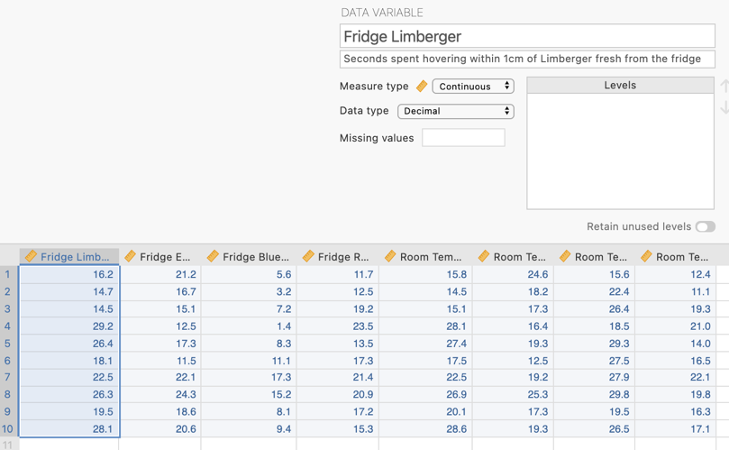
Our data takes the form of eight continuous variables that represent the number of seconds spent by each mosquito hovering within 1cm of each of four stinky cheese varieties, namely German Limberger, French Epoisses and Roquefort and British Blue Stilton, when fresh from the fridge and when at room temperature. The variables are designated continuous.

Step 3 – Navigating to the Repeated Measures ANOVA analysis menu.

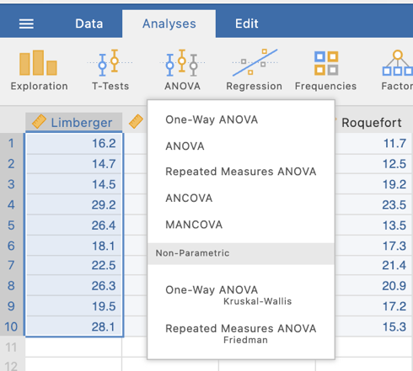
On the Analyses tab select the ANOVA menu, then select Repeated Measures ANOVA.

Step 4a – Setting up the two repeated measures factors

The first thing we will do is to let jamovi know that our eight variables represent combinations of our 4 (Stinky Cheese Variety) x 2 (Temperature) repeated measures design.

We have to firstly tell jamovi that we have two repeated measures factors, name them, and indicate and name the levels each has. This is done in the “Repeated Measures Factors Box”

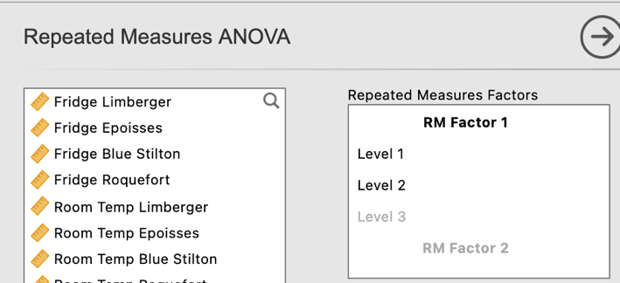
Firstly, enter in the details for our first factor, Stinky Cheese Varieties. Give the factor its name and then type in the four cheese varieties against the levels. As a default there are only slots for 3 levels however once you have typed your third level if you hit enter/return you can add further levels easily.
N.B., It has been entered as Varieties with an s but this is hidden from view once you hit enter.
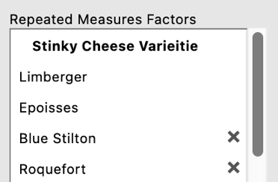

Scroll down to where you can enter the RM Factor 2 and label it Temperature. Then give the factor two level names of Room Temperature and Refrigerated.

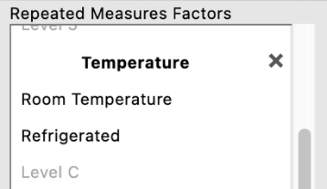

Step 4b – Lining up the variables with the “cells” of the design

Having set up our two repeated measures factors we now have to tell jamovi how our eight variables line up with the different combinations of these two factors, or the “cells” of the design. To do this we will be shifting our variables across to the “Repeated Measures Cells” box.

You’ll see that our progress so far has created some labels against the rows in the “Repeated Measures Cells” box that will help us line up where our variables need to go.

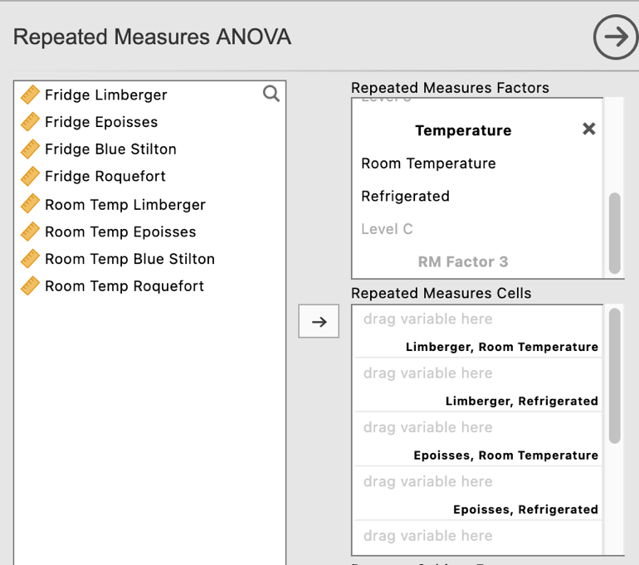
Each row has been labelled to reflect a combination of levels of our two factors. For example the first row is for the hovering time scores for the mosquitoes when they were exposed to room temperature Limberger cheese.

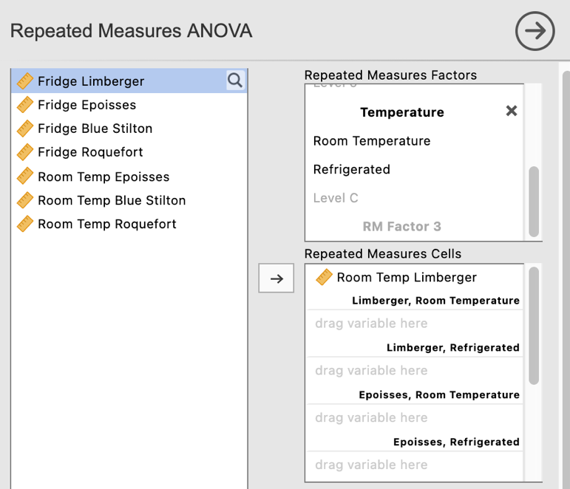
Here we have dragged the variable “Room Temp Limberger” into the “Limberger, Room Temperature” row that it corresponds to.

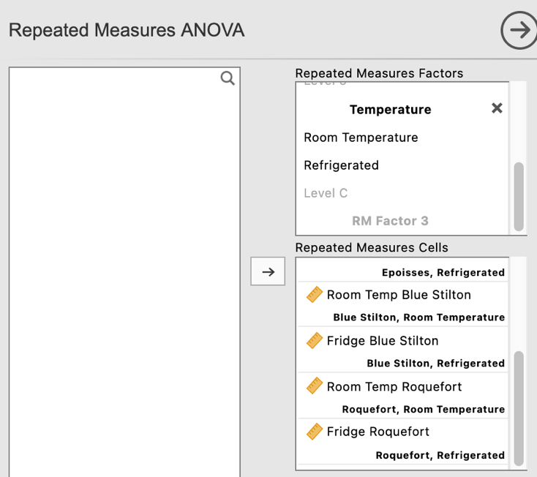
Work your way through and line up each of your variables with the factor level combinations defined for each row in the "Repeated Measures Cells” box until all have been entered. Make sure you double check that you have aligned them correctly.

You may have to scroll up and down the list to check as the boxes do not expand to make them all viewable at once.

Step 5 – Selecting analysis options to get the output we need for our omnibus test results.

At the bottom of this menu we can also give our Dependent Variable a label to neaten our output, and ask for effect sizes while we are at it.

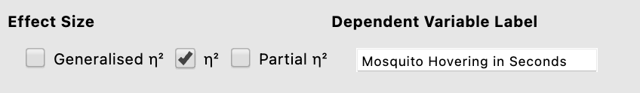

We now have some initial ANOVA output to interpret.

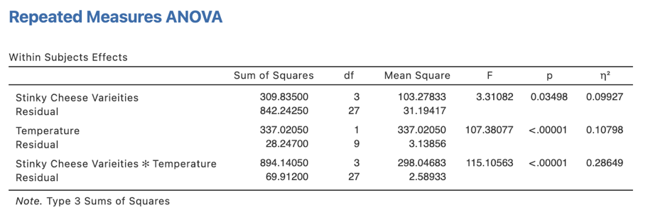
In our ANOVA table we have the components of the calculations that help us arrive at our F statistics for our two main effects and interaction (namely the SS_{treat} and SS_{error} and their associated dfs, which lead us to our MS_{treat} which we divide by the MS_{error} to get our F statistic.

Our p values for our three omnibus effects here are all less than .05. Therefore we have a significant main effect of Stinky Cheese Variety, a significant main effect of Temperature and a qualifying Stinky Cheese Variety x Temperature interaction

And hidden on the end is our $η$² effect size.

There are a couple of extra things we need to ask for from some of the drop down menus in our two-way repeated ANOVA. These are found under the Assumption Checks menu and the Estimated Marginal Means menu.

NB – We are not going to ask for our post hoc pairwise comparisons here as a pooled error term is used for all comparisons. It is preferable to use error terms that relate only to the two levels being compared. We will get to this soon.

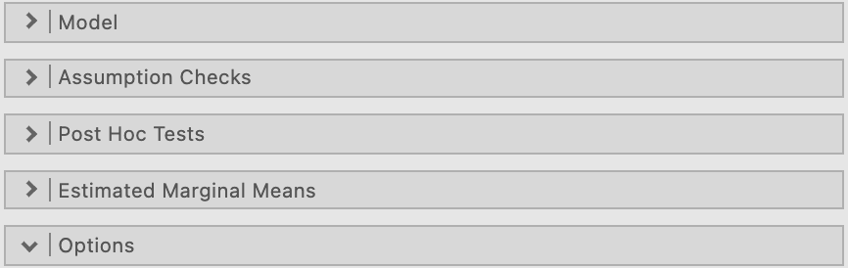

Under Assumption Checks we are going to ask for “Sphericity tests” as well as a “Greenhouse-Geisser correction” under Sphericity corrections. This will enable us to check whether the sphericity assumption has been breached and to report corrected/adjusted results if a breach is present.

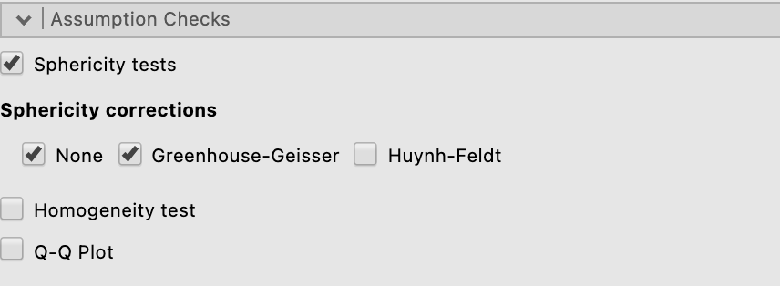

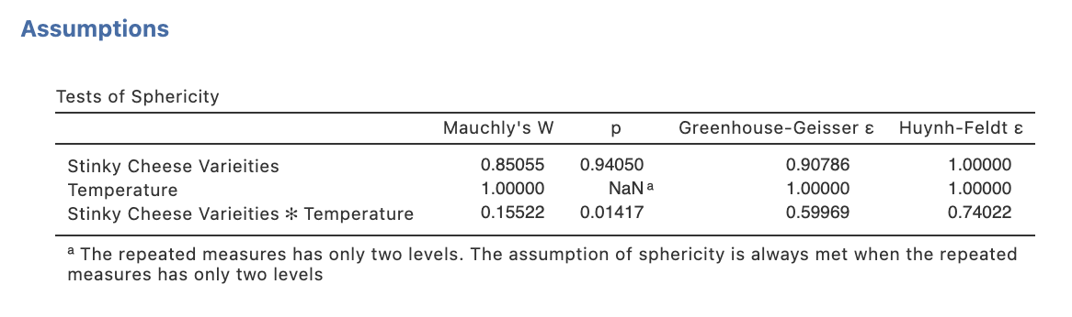
Our p value for the Mauchly’s sphericity test for the Stinky Cheese Variety main effect is greater than .05 indicating no breach. However, the p value for the interaction Mauchly test is less than .05 indicating this assumption is breached for the interaction test.

Our output now contains Mauchly’s test of sphericity. Note that this assumption only applies when there are three or more means to compare. Therefore a test is not computed for the Temperature main effect

Having requested both sphericity tests and sphericity corrected results in the form of Greenhouse-Geisser epsilon corrections in the Assumptions drop down list, our ANOVA results table now gives us corrected results for all main effects and interactions. For consistency we’ll push forward with the Greenhouse-Geisser corrected results for both main effects and the interaction. As it turns out in our case, the interpretation of the results (in terms of significance) is very similar, however where breaches are more extreme the corrected results may differ in their interpretation to uncorrected results.

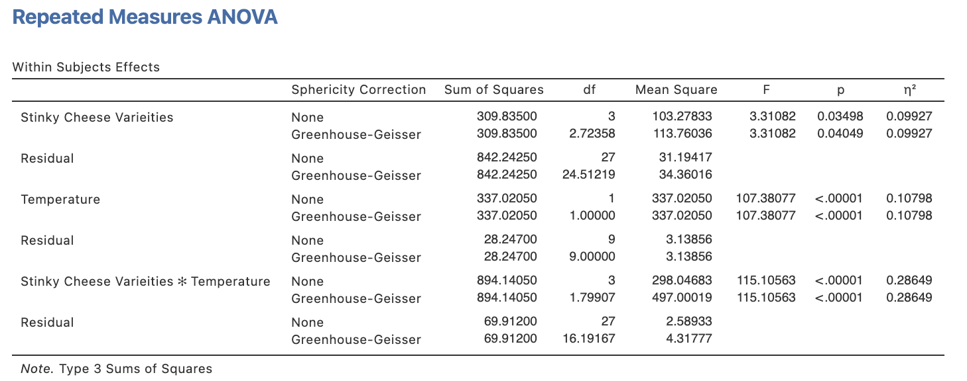

Under the Estimated Marginal Means drop down menu we can ask for a plot to help illustrate our findings. Since we know we have a significant interaction, and our main factor of interest is Stinky Cheese Variety and our proposed moderator is Temperature we want to get a plot that illustrates the simple effect of Stinky Cheese Variety at each Temperature condition.
We need to move both of our factors across to the Term 1 box on the right hand side. We’ll put Stinky Cheese Varieties at the top as this will mean that jamovi creates a plot of the simple effects of this factor with separate lines for the two temperature conditions.

Tick “Marginal means plot”. The 95% confidence interval error bars is selected as a default to appear on the plot but you can change this if you like to standard error.

We’ll also tick observed scores so that we can see where the individual data points fall in relation to the means and error bars.

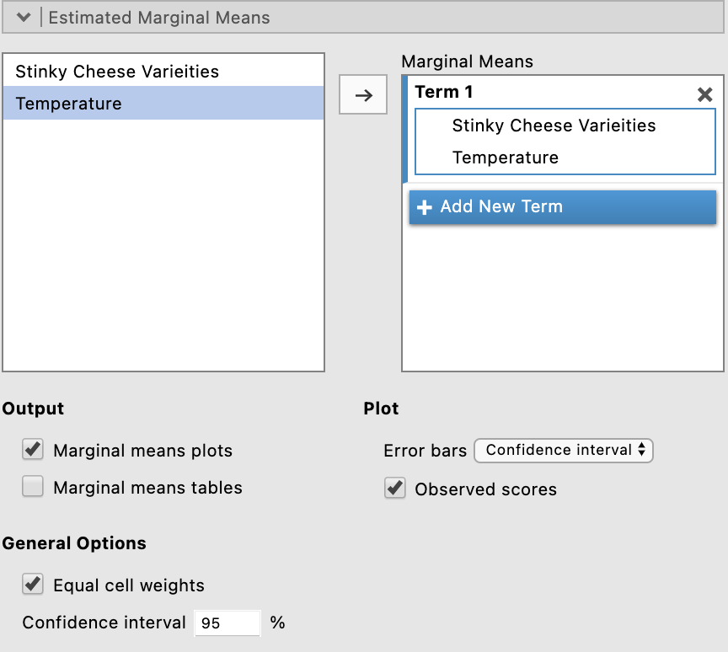

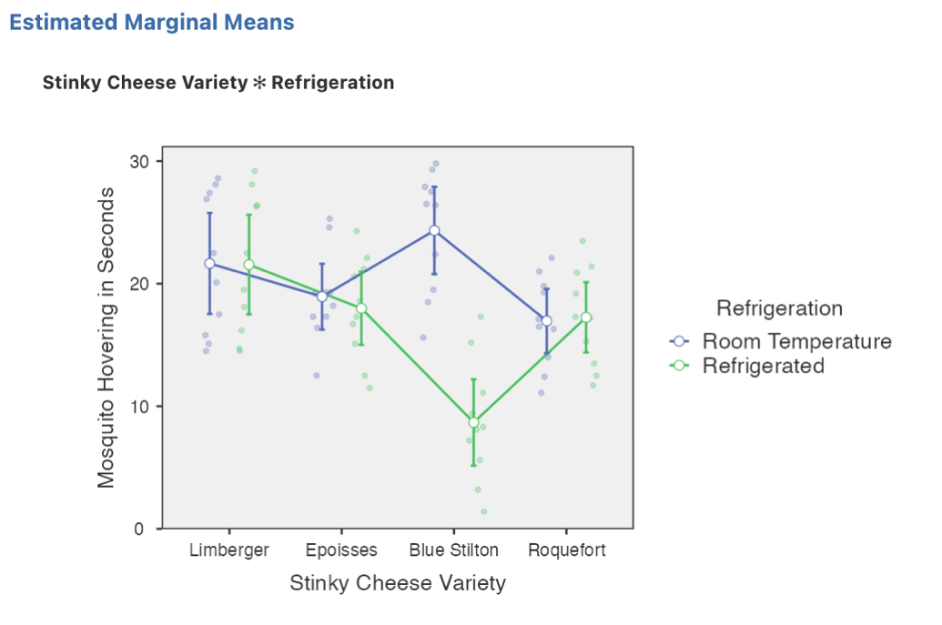
We can see visually here why there is a significant interaction. It’s clear that the mosquitoes attraction to the cheeses differs depending on their temperature. However we need to do some further post hoc analysis to find out where the significant differences are.

Step 6 – Following up significant main effects with main effect comparisons in a two-way repeated measures ANOVA

While it is possible to ask for these pairwise comparisons within the Repeated Measures ANOVA menu, the comparisons that are generated use a pooled error term (across all four of our stinky cheese conditions). However, it is preferrable to conduct these pairwise comparisons with error terms that are generated from the two levels being compared. In order to obtain these we will need to run a series of pairwise t-tests. Our first snag though is that because these need to be based on the hovering seconds for each cheese, collapsed across the two temperature levels (refrigerated and room temperature) we need to compute new variables in our data file to gives us these.

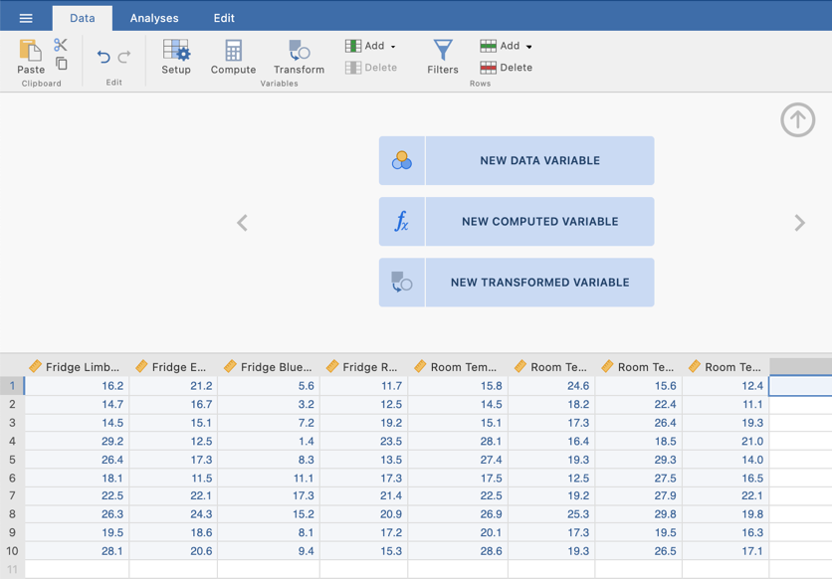
- Go to the Data Tab along the top ribbon
- Click on Setup to get into the data view in full.
- Click in the first column that does not contain any data.
- Click on New Computed Variable

4
2
1
3

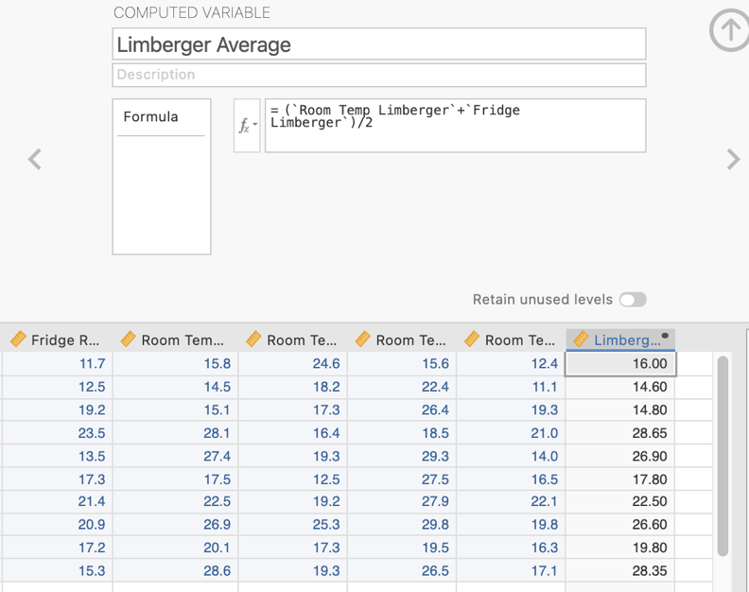
You’ll now be able to create four new variables that represent the average hovering time in seconds across each of the four Stinky Cheese Varieties, averaged across Temperature.

An example is given here to create the average for Limberger cheese.

In the formula cell create the formula that will add the scores for the two Limberger variables .. namely (Variable + Variable)/2. Note they need to have single quotation marks around their names) and divide them by 2 to average them. Give the variable an appropriate name like Limberger Average.

Do this four times to create the four variables for each cheese type. Clicking on the right arrow near the formula to add a new variable column each time.

You should now have four extra data columns in your data file looking something like this

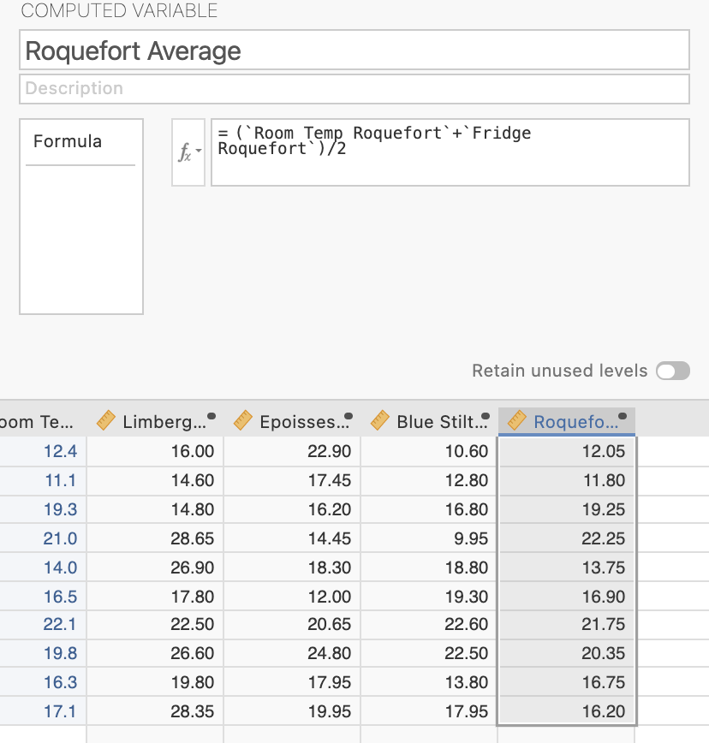

Now we can move forward to obtain our main effect pairwise comparisons. To do this we will run paired samples t-tests.

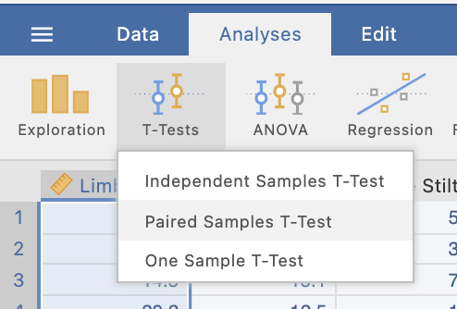
We can specify multiple paired t-tests at once by moving pairs over to the Paired Variables box. We want to create each combination of cheese comparisons to give us the set of comparisons we need. We’ll be using the new “Average” variables we created for these.
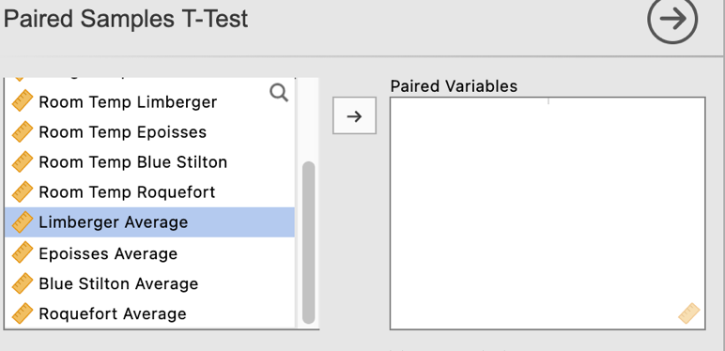

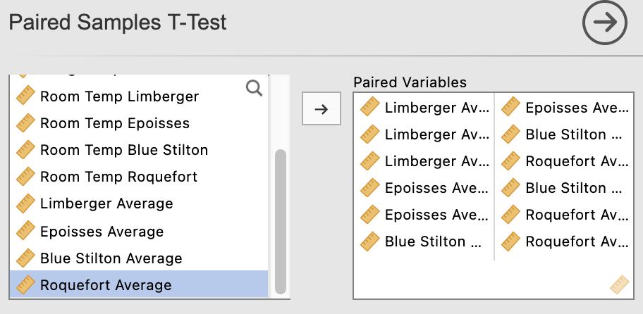
Here we have specified each possible combination of comparisons. Depending on your specific research question or hypothesis you may not need to consider every combination but they have been asked for for completeness here.
In the analysis options for the paired t-tests output we’ll select Mean difference (to illustrate a learning point only – you don’t need to select this otherwise), effect sizes and associated confidence intervals and descriptives under the “Additional Statistics” heading.

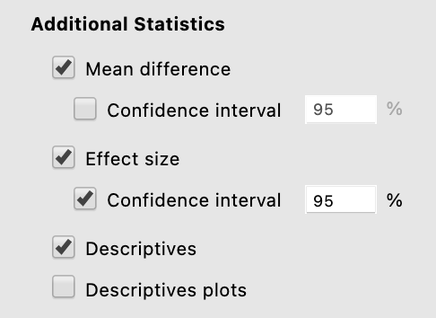
These selections will return the following output:

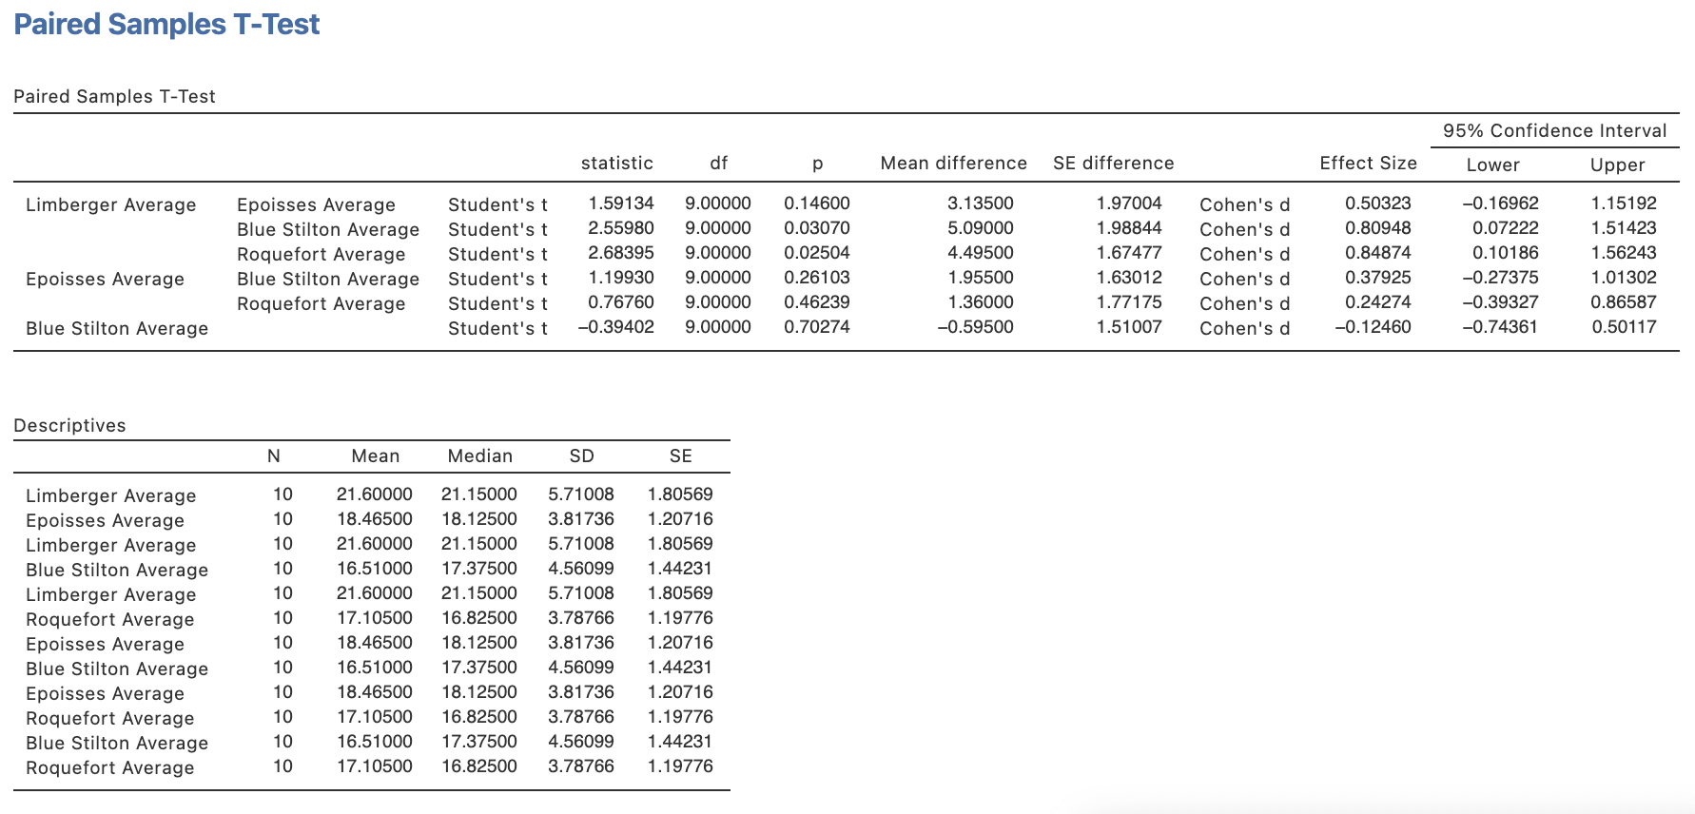
Note that having run these comparisons as separate t-tests the standard errors associated with each comparison are different. They are based on errors derived from each pairing rather than the whole model.

Step 7a – Following up significant interactions with simple effects

When we obtain a significant interaction our next step is to consider simple effects. In this instance we are going to examine the simple effects of Stinky Cheese Variety at each level of the Temperature factor (namely refrigerate and room temperature) separately. To do this we will run two separate one-way ANOVAs.

One-way ANOVA 1 – The simple effect of Stinky Cheese Variety when the cheese is refrigerated.

Back to the Analyses tab, selecting ANOVA, then Repeated Measures ANOVA

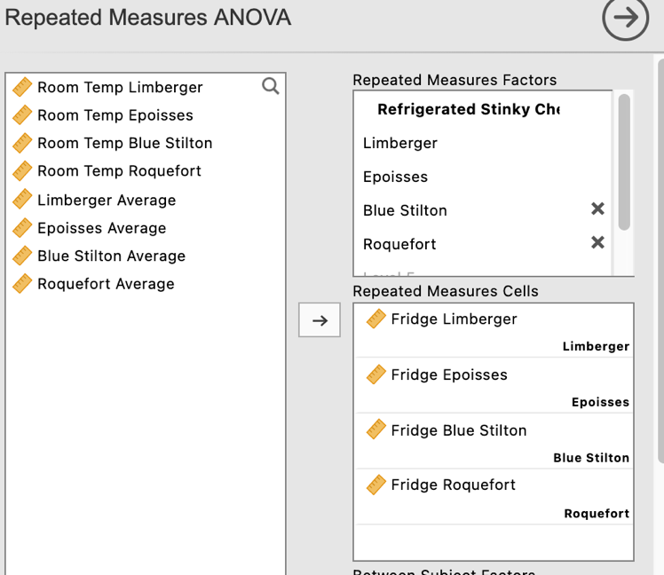
We need to specify our Repeated Measures Factor similar to before. We only need to specify one not two. Our factor is Stinky Cheese Varieties. But we are using only the data from when the exposure was to refrigerated cheese. So to help to keep our output navigable we’ll call our factor “Refrigerated Stinky Cheese Varieties.”

And then when shifting our variables across to the levels we are only using the “Fridge” versions.

Again we’ll label our DV and ask for $η$² as our effect size.

And don’t forget to head to the Assumptions Checks tab to get our sphericity tests and Greenhouse-Geisser corrected results if needed.

And we’ll repeat the process for the simple effect of Stinky Cheese Varieties when at room temperature.
This time naming our Repeated Measures Factor “Room Temp Stinky Cheese Varieties.”

Don’t forget to ask for all the same extras we did for the refrigerated version.
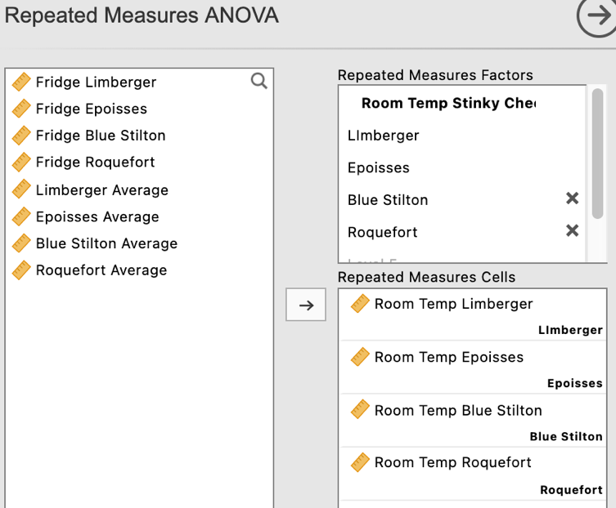
We now have two sets of one-way repeated measures ANOVA results for each simple effect of Stinky Cheese Variety at both levels of the Temperature Factor.

ANOVA 1 – Simple Effect of Stinky Cheese Varieties when refrigerated

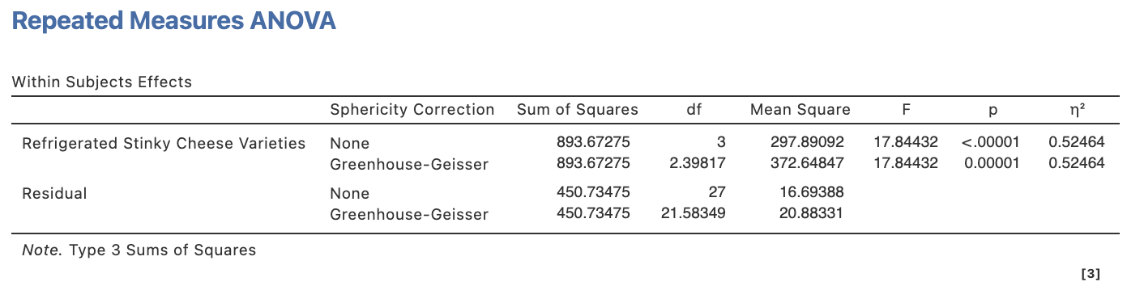
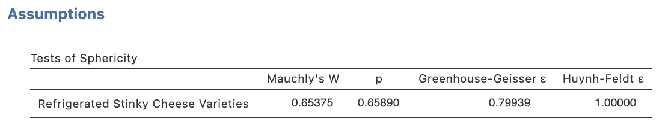

ANOVA 2 – Simple Effect of Stinky Cheese Varieties when at room temperature

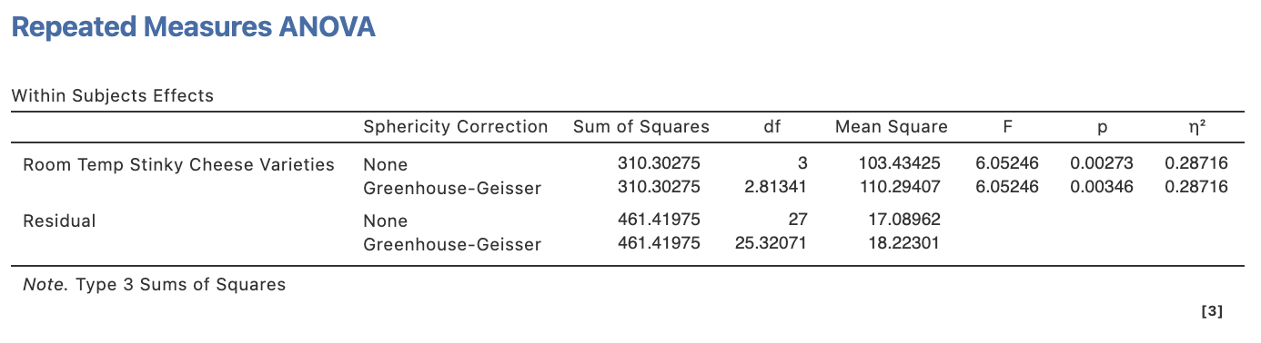

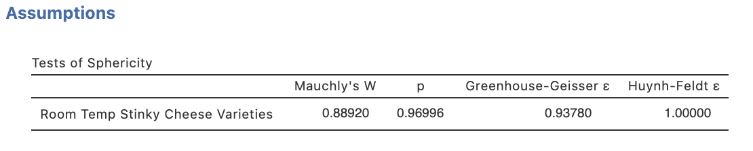

Irrespective of application of a Greenhouse-Geisser correction (if we were going to be uniform in our approach of applying it due to the breach at the omnibus level for the interaction), both simple effects are significant. And as there are four levels to this factor, yep you guessed it, we have to go further to simple comparisons for both simple effects.

Step 7b – Following up significant simple effects with simple comparisons

Just as we did earlier in exploring the main effect comparisons, we need to turn to pairwise t-tests to run our simple comparisons so that we are using the appropriate error terms.

Head back to the T-tests menu in the Analyses ribbon and select Paired Samples T-tests.

Then you need to specify two different sets of paired samples t-tests. One comparing the various levels of refrigerated cheese ratings, and another with the room temperature ratings.

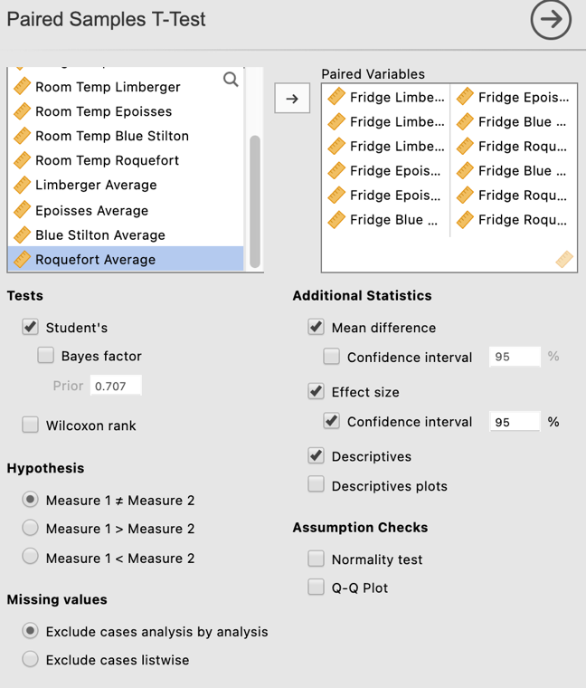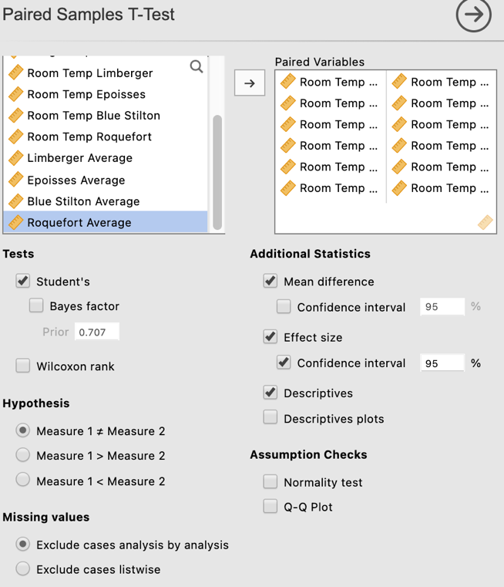

Paired samples t-tests set 1 – Simple comparisons for the simple effect of Stinky Cheese Varieties when refrigerated.

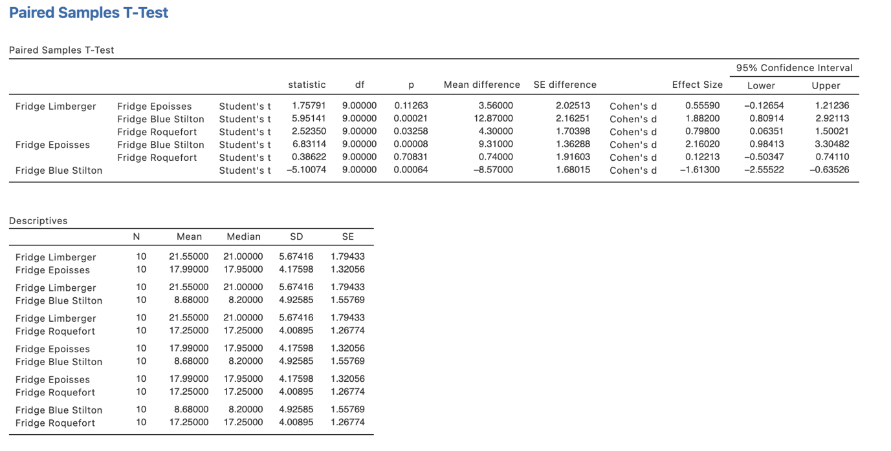

Paired samples t-tests set 2 – Simple comparisons for the simple effect of Stinky Cheese Varieties when at room temperature.

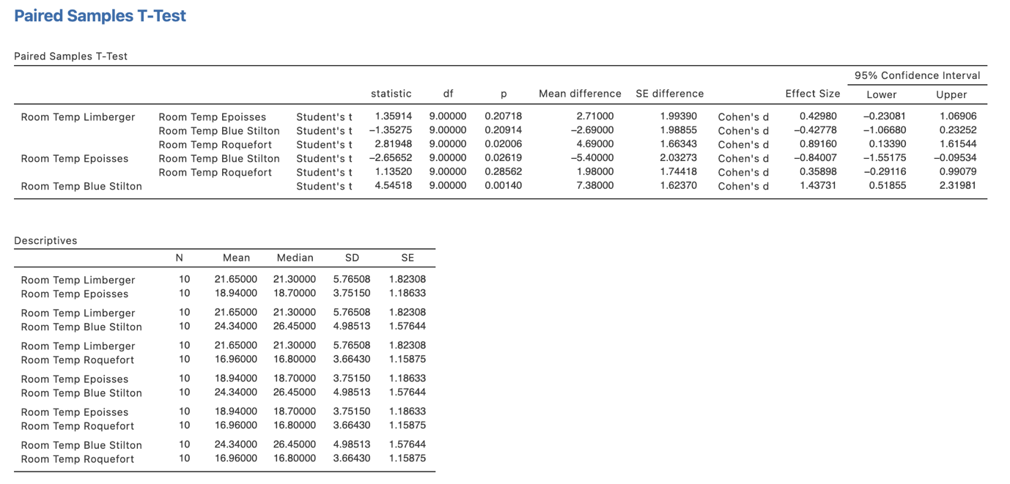

Phew! We now have EVERYTHING we need. Let’s get to reporting.

Step 8a – Finding the components for reporting the omnibus results

Firstly, let’s report our omnibus results.

The components we obtain here are:
- The F statistics, dfs, p values and Greenhouse-Geisser $ε$ (when reporting corrected results for sphericity breaches) – the omnibus ANOVA results for the main effects and interaction.
- Effect sizes in the form of$η$²

The Write Up (Part 1):

Ten mosquitoes were exposed to randomly ordered combinations of four types of Stinky Cheese (Limberger, Epoisses, Blue Stilton and Roquefort) in two Temperature conditions (refrigerated or room temperature) for thirty seconds to determine their cheese preferences and the impact of temperature on those preferences. The number of seconds within each thirty second block that the mosquitoes hovered within one centimetre of the cheese was recorded by sensors. A two-way repeated measures ANOVA was conducted to analyse the results. Mauchly’s test of sphericity indicated a sphericity breach for the interaction test (p = .014) and so, for consistency, Greenhouse-Geisser epsilon corrected results are reported for all omnibus main effects, interactions and simple effects. Both a significant main effect of Stinky Cheese Variety, $ε$ = .91, F(2.72,24.51) = 3.31, p = .040, $η$² = .10, and a significant main effect of Temperature, F(1,9) = 107.38, p < .001, $η$² = .11, were revealed, but were both qualified by a significant Stinky Cheese Variety x Temperature interaction, $ε$ = .60, F(1.80,16.19) = 115.11, p < .001, $η$² = .29.

Step 8b – Finding the components for reporting the main effect comparisons to follow a significant main effect

The next stage of the write-up is to present the main comparisons results that reveal
which particular differences in cheese hovering are significant. We’ll use the paired t-test
results with the averaged cheese hovering scores (collapsed across Temperature) that we created to put this part of our write up together. (Note we wouldn’t do this in the presence of an interaction ordinarily. We are just showing how it would be approached, if you had a significant main effect in the absence of an interaction).

The elements needed for the post hoc section of our write up are:

- Main effect comparison results – to determine which group means are significant from each other. It is sufficient to report the p value for this.
- An effect size for each post hoc comparison in the form of Cohen’s d and its associated confidence interval.
- Means and standard deviations – to help describe the pattern of these differences.

The continuation of the write up could go as follows:

The Write Up (Part 2):

Unadjusted post hoc comparisons revealed that mosquitoes spent significantly more seconds hovering over the Limberger cheese, M = 21.60, SD = 5.71, than both the Blue Stilton, M = 16.51, SD = 4.56, p = .031, d = 0.81, 95% CI [0.07, 1.51], and the Roquefort, M = 17.11, SD = 3.79, p = .025, d = 0.85, 95% CI [0.10, 1.56]. No other differences were significant (ps > .146, ds < 0.50).
Step 8c – Finding the components for reporting the simple effects to follow a significant interaction

These come from the two one-way repeated measures ANOVAs we ran for the simple effects of Stinky Cheese Variety at both levels of Temperature.

The components we obtain here are:
- The F statistics, dfs, p values and Greenhouse-Geisser $ε$ (when reporting corrected results for sphericity breaches) – the omnibus ANOVA results for the simple effects.
- Effect sizes in the form of$η$²

ANOVA 1 – Simple Effect of Stinky Cheese Varieties when refrigerated

ANOVA 2 – Simple Effect of Stinky Cheese Varieties when at room temperature

The Write Up (Part 3):

The simple effects of Stinky Cheese Varieties were explored in light of the significant Stinky Cheese Varieties x Temperature interaction. The Stinky Cheese Varieties simple effect when the cheese was refrigerated, $ε$ = .80, F(2.40,21.58) = 17.84, p < .001, $η$² = .52, and when at room temperature, $ε$ = .94, F(2.81,25.32) = 6.05, p = .003, $η$² = .29, were both significant necessitating examination of each respective set of simple comparisons.

Step 8d – Finding the components for reporting the simple comparisons to follow significant simple effects.

The end of the road write-up wise is drilling down into these simple comparisons within each simple effect.

These results come from our two sets of paired t-test results which provided us with pairwise comparisons between the four cheese varieties within the simple effect of Stinky Cheese Variety for refrigerated cheeses and a separate set for the simple effect of Stinky Cheese Variety when at room temperature.

The elements needed for the post hoc section of our write up are:

- Simple comparison results – to determine which cell means within each simple effect are significant from each other. It is sufficient to report the p value for this.
- An effect size for each post hoc comparison in the form of Cohen’s d and its associated confidence interval.
- Means and standard deviations – to help describe the pattern of these differences.

Paired samples t-tests set 1 – Simple comparisons for the simple effect of Stinky Cheese Varieties when refrigerated.

Paired samples t-tests set 2 – Simple comparisons for the simple effect of Stinky Cheese Varieties when at room temperature.

So if we put this together in a further paragraph for our write up we might write something like this.

The Write Up (Part 4):

Unadjusted post hoc simple comparisons revealed that when the stinky cheese varieties are refrigerated, mosquitoes spent significantly fewer seconds hovering over the Blue Stilton, M = 8.68, SD = 4.93, than the Limberger, M = 21.55, SD = 5.67, p = .002, d = 1.88, 95% CI [0.81, 2.92], Epoisses, M = 17.99, SD = 4.18, p < .001, d = 2.16, 95% CI [0.98, 3.30] and Roquefort cheese, M = 17.25, SD = 4.01, p = .001, d = 1.61, 95% CI [0.64, 2.56]. Additionally, the Limberger cheese was favoured with significantly more hovering than the Roquefort cheese, p = .033, d = 0.80, 95% CI [0.06, 1.50].

In contrast, when exposure was conducted with cheese at room temperature, post hoc simple comparisons revealed that the Roquefort cheese garnered significantly less mosquito hovering, M = 16.96, SD = 3.66, than Blue Stilton, M = 24.34, SD = 4.99, p = .001, d = 1.44, 95% CI [0.52, 2.32], and Limberger, M = 21.65, SD = 5.77, p = .020, d = 0.89, 95% CI [0.13, 1.62], with Blue Stilton also attracting significantly longer hovering than Epoisses, M = 18.94, SD = 3.75, p = .026, d = 0.84, 95% CI [0.10, 1.55]. No other differences were significant (ps > .207, ds < 0.43).

Potential addition of plot:

You could also add the plot we obtained to help illustrate the pattern of results. You might add a sentence like the following if you choose to include the plot:

Figure 1 below provides a visual demonstration of mosquito preference for Stinky Cheese Varieties as moderated by Temperature.

Figure 1

Mosquito Cheese Hovering as a function of Stinky Cheese Variety and Temperature
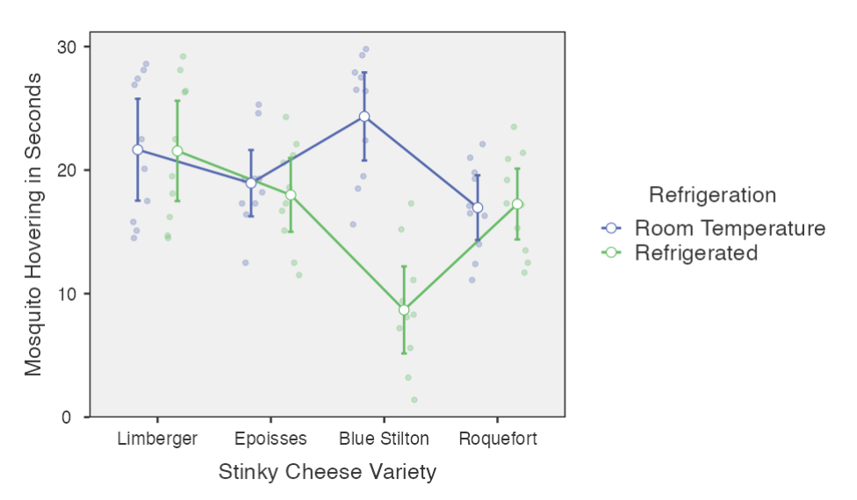
Note. Error bars represent 95% confidence intervals.

Created by Janine Lurie in consultation with the Statistics Working Group within the School of Psychology, University of Queensland

Based on jamovi v.1.8.4

You can view Dr Knols’ TED talk here https://ed.ted.com/lessons/cheese-dogs-and-a-pill-to-kill-mosquitoes-and-end-malaria-bart-knols.
The Statistics Working Group was formed in November 2020 to review the use of statistical packages in teaching across the core undergraduate statistics unit. The working group is led by Winnifred Louis and Philip Grove, with contributions from Timothy Ballard, Stefanie Becker, Jo Brown, Jenny Burt, Nathan Evans, Mark Horswill, David Sewell, Eric Vanman, Bill von Hippel, Courtney von Hippel, Zoe Walter, and Brendan Zietsch.
The jamovi project (2021). jamovi (Version 1.8.4) [Computer Software]. Retrieved from https://www.jamovi.org

